JoB description

|  |  |  |  |
| --- | --- | --- | --- |
| Position Title | Loading Bay Technician | Department | Business Support Services |
| Generic Job Title | Loading Bay Operative | Segment | Energy and Resources |
| Team Band | Unbanded | Location | London |
| Reports to | Logistics Supervisor | Office / Unit name | Shell Centre London Campus |

## ORGANISATION StRUCTURE

T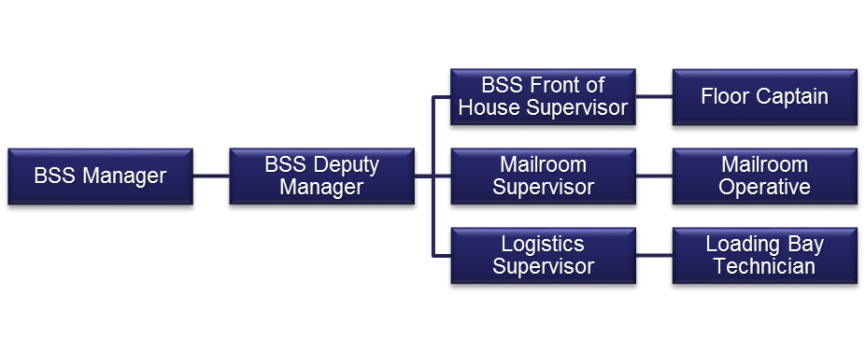ale

#### Job Purpose

* To work as a member of the loading bay team to ensure the efficient, effective and proactive running of the loading bay service.
* The loading bay operative role provides the backbone of managed loading bay service operations.
* The post holder will perform a variety of tasks related to the loading bay functions and Business Services Suport Deprtment and will flexibly and proactively respond to any client requirements as and when necessary.

#### Accountabilities or “what you have to do”

* The Technician will be professional at all times when dealing with clients and proactively represent Sodexo on site promoting Excellent Customer Service.
* Ensuring that all HSE policies and regulations are adhered to. Noting and escalation non-compliance with the Shell Loading bay rules as relevant.
* Ensure that incoming and outgoing of all goods are collected and distributed to the correct mailing and or distribution systems.
* Overseeing all deliveries and collections ensuring the correct procedures are followed at all times and administration completed correctly
* Overseeing storage and organistion of all items in the loading bay and mail areas.
* Ensure that all complaints are dealt with in the correct manner and that the Logistics supervisor is informed immediately should any service complaints be reported.
* Assisting mailroom staff, as appropriate, in sorting mail and identifying recipients.
* Ensuring all areas of the loading bay are always clean and tidy (as is practicable)
* Assist the logistics supervisor in the undertaking and documentation of all maintenance checks
* Ensure that any other reasonable tasks or requests are fulfilled to the appropriate service standards required as and when they arise.

#### Skills, Knowledge and Experience

Essential

* Mailroom/Loading Bay operations
* Customer service and complaint handling.
* Ability to communicate effectively in a variety of written and verbal formats with a wide range of people.
* Working shifts on a flexible pattern.
* Working accurately, under pressure, to tight deadlines.
* Basic IT skills- Word Processing, Spreadsheets, Databases, Email and Web.
* N.B. Operatives will be expected to undertake manual handling duties within their physical capabilities.

Desirable

* Experience of working in an environment where compliance to standards is key

**Contextual or other information**

Whilst every effort has been made to ensure the details of this job description are correct - due to the varied requirements of the catering and support services industry, this job description cannot be exhaustive. Therefore, the jobholder may be required from time to time to carry out other tasks as required by management in order to meet the operational needs of the business.