Job Description:
Seasonal Commercial Assistant

Function: |  |  | Finance
Position: |  |  | Seasonal Commercial Assistant
Job holder: |  |  | TBC
Date (in job since): |  |  | April 2017 – September 2017 (6 Months)
Immediate manager  (N+1 Job title and name): |  |  | Stewart Bennett
Additional reporting line to: |  |  | Graham Meek
Position location: |  |  | Ascot Racecourse
1. Purpose of the Job
- To assist the commercial team in preparation for race days (including cash office set-up, till set-up & concessionaires) and providing race day back-of-house support to the cash office manager & cost controller.
- To assist the finance manager with post-race activities (including concessionaire reports, invoicing & reconciliations)
- Develop and maintain key relationships within the business.
2. Dimensions – Point out the main figures / indicators to give some insight on the “volumes” managed by the position and/or the activity of the Department.
Draft. Version: 27-03-2014
3. Organisation chart – Indicate schematically the position of the job within the organisation. It is sufficient to indicate one hierarchical level above (including possible functional boss) and, if applicable, one below the position. In the horizontal direction, the other jobs reporting to the same superior should be indicated.
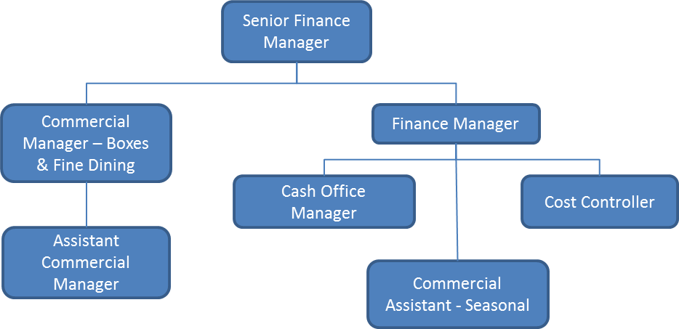

4. Context and main issues – Describe the most difficult types of problems the jobholder has to face (internal or external to Sodexo) and/or the regulations, guidelines, practices that are to be adhered to.
- To assist in the preparation for racing, including cash office & till set-up.
- To take ownership of the concessionaire process, including pre-race set-up, on the day payments from concessionaires & post-race reporting
- To assist with all aspects of the commercial department as required
- Working long race days particularly during Royal Ascot

5. Main assignments – Indicate the main activities / duties to be conducted in the job.
- Supporting cash office manager with pre-race day preparations
- Supporting cost controller with pre-race day till set-up
- Providing race-day back-of-house support in the cash office – primarily assisting the cash office manager in managing the cash-office casual staff
- Managing the commercial aspects of the concessionaire process (pre-race, race-day & post-race activities)
- Assist with post-race activities – including reporting & invoicing
- Any other reasonable request or duty that is required to support the commercial function.

6. Accountabilities – Give the 3 to 5 key outputs of the position vis-à-vis the organization; they should focus on end results, not duties or activities.
- Ensure accurate completion of the concessionaire payment details on race-days
- Post-race invoicing is completed accurately and timely – vouchers are tallied accurately and billed correctly
- Proficient knowledge of EPOS & till set-up – able to reach a point where EPOS & till set-up is managed with limited assistance from cost controller

7. Person Specification – Indicate the skills, knowledge and experience that the job holder should require to conduct the role effectively
- Working knowledge of standard accounts practice.
- Good knowledge of Microsoft excel and word.
- Previous experience of a retail and cash environment.

8. Competencies – Indicate which of the Sodexo core competencies and any professional competencies that the role requires
- Growth, Client & Customer Satisfaction / Quality of Services provided | - Leadership & People Management
- Rigorous management of results | - Innovation and Change
- Brand Notoriety | - Employee Engagement
- Commercial Awareness | - Learning & Development

9. Management Approval – To be completed by document owner
Version |  | Date
Document Owner

10. Employee Approval – To be completed by employee
Employee Name |  | Date

