Job Description: Head of Operations and Residency Living

Function: | Universities
Position: | Senior Manager
Job holder: | N/A
Date (in job since): | TBC
Immediate manager (N+1 Job title and name): | Tom Martin Contract Manager
Additional reporting line to: | N/A
Position location: | Northumbria Residential estate
Salary
1. Purpose of the Job – State concisely the aim of the job.
- Effectively manage the Accommodation team to ensure that exemplary facilities services are provided across the Northumbria Contract.
- To deliver operational FM excellence across all Northumbria / Sodexo soft services, including cleaning, security, commercial business, catering, reception and helpdesk, soft service lifecycle, management of soft services suppliers and sub-contractors.
- Manage the strategic development and operational delivery of the award winning Residency Living Program
- Effective management of the out of hour’s security team, ensuring all legislative, SIA, and Sodexo Secure requirements are met.
- Supporting other senior managers to ensure a seamless delivery of all contracted FM services
- To support with the contract P&L data, including monthly accruals and ongoing spend forecasts, and report to the Contract manager weekly
- To motivate and lead the dynamic, dedicated team to achieve high performance at all times.
- To manage and control the services to the agreed specification and to the agreed performance, qualitative and financial targets.
- To provide direction and expertise to the operating area by promoting Sodexo strategies and best business practices.
- To meet and drive our social impact approach and targets
- To deliver services in line with the business ethos, delivering innovative solutions to the client’s expectations.
- To work as part of a team ensuring high standards of service, colleague and customer satisfaction and contract retention.
- To comply with Sodexo procedures, Health and safety and all legislative requirements. Ensuring a zero harm mindset is at the forefront of everything we do promoting reporting of near misses, safety walks and safety observations.
- Maximise student satisfaction and help maintain a good working relationship with the site client representatives and customers.
- To effectively manage and develop, undertake appropriate training and staff development.

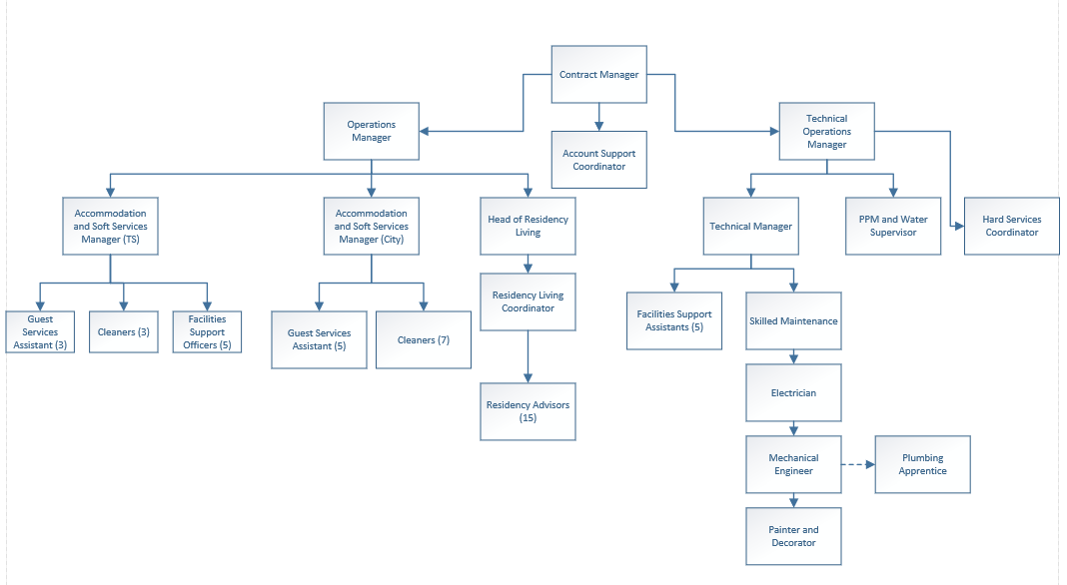
2. Organisation chart – Indicate schematically the position of the job within the organisation. It is sufficient to indicate one hierarchical level above (including possible functional boss) and, if applicable, one below the position. In the horizontal direction, the other jobs reporting to the same superior should be indicated.

3. Context and main issues – Describe the most difficult types of problems the jobholder has to face (internal or external to Sodexo) and/or the regulations, guidelines, practices that are to be adhered to.
- Manage client expectations for this prestigious contract
- Maintain high levels of communication with key site representatives
- Large volume of business, diverse activities
- Management of a large team, development plan for colleagues to further integrate
- Challenge the status-quo, look at new opportunities to enhance service delivery and improve internal/external client satisfaction
- Check with each direct report daily that all work is being carried out satisfactorily and in accordance with work schedules and to the standards required.
- To oversee the ordering of materials, managing invoices, implementing effective stock control mechanisms in accordance with agreed policy.
- To ensure all current legislative requirements are met and appropriate systems are in place.
- To ensure service standards and deliver a customer focused service as per agreed KPI. To also be responsible for determining and delivering remedial action where the satisfaction level has not achieved target.
- To recruit appropriate staff as required and ensure that contracts offered and deployment of staff meet operational needs and all relevant safer recruitment processes and legislative requirements.
- To ensure that cleaning and hygiene standards are, understood by team members and implemented at all times.
- Attend finance, operational and team briefings, client, sub-contractor meetings and any meeting as required in order to complete the designated role and its associated functions.
- To ensure that proper care is exercised in handling, operating, safeguarding and maintaining equipment and appliances under the control of the cleaning services team and maintain inventory records.

- To ensure all necessary steps are taken to ensure the security of accommodation, equipment, stock and monies within area of authority.
- To support the contract manager in ensuring contract financial targets are met.
- To undertake other duties commensurate with the scope of this role
- To ensure appropriate levels of management and operational staffing is in place across the contract and to illustrate flexibility around crisis management

4. Main assignments – Indicate the main activities / duties to be conducted in the job.
- Ensure a seamless operation across the accommodation portfolio in and out of term time
- Extensive collaborative working with other senior managers
- Pursue operational activities to obtain contract and personal tangible results
- Robustly manage all sub-contractors and suppliers under your remit to ensure seamless performance
- Ensure value for money across all areas of the operation
- Drive commercial acumen and value add across all areas of the contract
- Managing all changes to the contract specification ‘output’ as directed by the Contract Manager
- Constant site monitoring, ensuring the service is running efficiently, on budget and as per contract.
- To be responsible for all aspects of Health and Safety and the Environment on work activities to ensure actions comply in accordance with statutory and contractual requirements. Completion to the standards of; Risk Assessments, COSHH Assessments, H&S compliance and safety expected activities.
- To comply at all times with the Company's Quality Assurance and Health and Safety Procedures and to ensure that all work is undertaken in accordance with the Industry's best practices.
- To ensure that all areas in which work is undertaken are kept in a clean and tidy condition to ensure minimum disruption to the building occupants.
- Ensure clothing, uniform, tools, equipment and PPE are fit for purpose and are in safe and good working condition.
- Attend training sessions and meetings as required.
- Have a degree of flexibility to travel nationally as and when required to deputies for the Contract Manager and stand in as and when required to lead on client reporting, meetings and reviews.
- To assist in managing the contract profit and loss accounts, and support the Contract Manager in taking the lead as and when required for contract finance reviews and any other financial meetings.
- To ensure the contract is 100% compliant at all times for all services
- Compile monthly compliance data relevant to area of responsibility.

This list is not exhaustive and any reasonable request by the contract manager should be followed

5. Accountabilities – Give the 3 to 5 key outputs of the position vis-à-vis the organization; they should focus on end results, not duties or activities.
- Customer service
- Employee engagement
- Financial Growth
- Client relations
- Ensure that all services are delivered against agreed SLA’s and KPI’s
- Ensure that all services are delivered in a cost effective and efficient manner

6. Person Specification – Indicate the skills, knowledge and experience that the job holder should require to conduct the role effectively
Essential Criteria

- Experience of working in the student accommodation sector or similar hospitality setting
- Live and breathe Sodexo’s managerial behaviors
- It is essential that you have a pro-active attitude and can be flexible in relation to duties and working hours.

The job also requires someone who can demonstrate that they have strong organisational and planning skills and have the ability to priorities and manage their time effectively
- The candidate must be able to work effectively without supervision.
- The ability to communicate clearly is seen as essential
- Experience of designing and delivering to targets to achieve quality standards, customer satisfaction and profit margins
- Experience of delivering financial targets
- Experience of customer service and in particular customer relationship management
- IT & systems literate, use of IT systems to provide/monitor data within the Quality Assurance and other management reporting systems
- Experience of strategic business commerciality and growth

7. Competencies – Indicate which of the Sodexo core competencies and any professional competencies that the role requires
 | Growth, Client & Customer Satisfaction / Quality of Services provided | Leadership & People Management
 | Rigorous management of results | Innovation and Change
 | Brand Notoriety | Business Consulting
 | Commercial Awareness | HR Service Delivery
 | Employee Engagement
 | Learning & Development

8. Management Approval – To be completed by document owner
 | Version | 1 | Date | 25th March 2024
 | Document Owner | Tom Martin

