Job Description:
HR Systems Manager

Function: |  |  |  | HR
Position: |  |  |  | HR Systems Manager
Job holder:
Date (in job since):
Immediate manager  (N+1 Job title and name): |  |  |  | HR Service Manager – ER, Compliance and HR Systems
Additional reporting line to:
Position location: |  |  |  | Datacentre, 310 Broadway, Salford
1. Purpose of the Job
- To actively support the systems and processes that are key to the successful operation of HR Services, focusing on the delivery of high quality HR systems. Continually review and develop the HR systems infrastructure, policies, controls and processes to ensure that efficiencies and opportunities are identified, implemented and data integrity is maintained. Support the HR Services Manager by managing the day to day performance and service delivery of HR Systems, within the HR Shared Service Centre.

2. Dimensions
Revenue FY13: | €tbc |  | EBIT growth: |  | tbc | Growth type: | n/a | Outsourcing rate: | n/a | Region Workforce | tbc
 |  |  | EBIT margin: |  | tbc
 |  |  | Net income growth: |  | tbc |  |  | Outsourcing growth rate: | n/a | HR in Region | tbc
 |  |  | Cash conversion: |  | tbc
Characteristics |  | - Add point
Draft. Version: 27-03-2014
3. Organisation chart
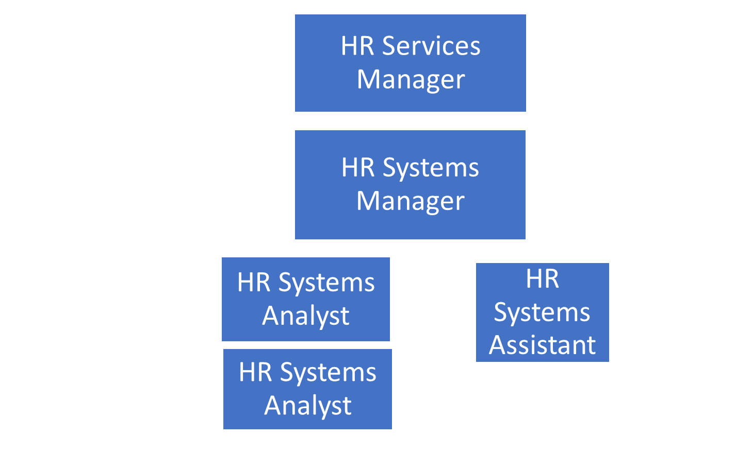

4. Context and main issues
- Monitor and manage system issues and developments
- Ensure requirements for system developments are fit for purpose, testing matrices maintained and followed
- Manage and develop HR Systems Team and educate peer group and stakeholders

5. Main assignments
- Manage the delivery of systems enhancements ensuring service delivery to the business is efficient, consistent and of high quality
- Develop and manage the provision of HR org structure maintenance service delivery to the business to support effective planning and decision making, providing an accurate and efficient service within agreed HR Shared Service timescales
- Ensure all HR Systems users are fully trained, identify and implement changes to improve system efficiency, maintain robust data and protect the integrity and quality of HR data
- Ensure the overall design and feasibility of SAP HCM, CSM, ESS/MSS and UDC Payroll systems is fit for purpose and in line with business needs
- Ensure that the development and enhancement of the systems portfolio is aligned to the HR strategic objectives
- Actively build and maintain strong relationships with appropriate external stakeholders to enhance and support the systems function
- Support HR function to define user requirements and build strong relationships with key stakeholders and specialist functions including IS&T and Payroll
- Build strong relationships with HR colleagues and business managers as required and act as subject matter expert on HR Systems including SAP HCM, UDC Payroll, ESS/MSS, case management or any other relevant systems
- Resolve technical and service delivery issues escalated from HR systems team, continually reviewing service performance and identify opportunities for improvement including identifying and mitigating risks to HR data accuracy. Escalate potential serious issues to the HR Service Manager
- Ensure that process and systems development maintains and enhances the accuracy of HR management information
- Ensure that the roles within the system align to the agreed responsibilities to the user groups i.e.: HR, Pensions, UDC etc
- Manage, motivate and develop HR Systems team and ensure optimal performance and continual delivery. Identify development needs, manage individual performance and complete PDRs
- Liaise closely with other Service Centre Managers to ensure HR Shared Service Centre is effectively resourced ensuring optimal performance, continuous service delivery and devise strategies to make improvements to service delivery. Direct resource planning, recruitment, succession planning and rotation of staff
- Positively promote the Sodexo employer brand, ensuring that IiP and staff engagement objectives and measures are incorporated into the overall focus and strategy of the HR Shared Service Centre

6. Accountabilities
- Delivery of change requests in line with requirements and within a timely manner
- Ensure that requirements are fit for purpose and align to strategic objectives
- Effective education of and communication to and management of Stakeholders and End Users
- Resources will be managed effectively, ensuring services are delivered within or exceeding agreed SLAs
- Training, skills and career development needs for individuals and team will be identified and managed, with a robust, active and up to date succession plan in place
- Customer service satisfaction will be measured and monitored, with comments and feedback used for continuous improvement
- Services will be regularly reviewed and opportunities for improvement will be identified and solutions implemented

7. Person Specification – Indicate the skills, knowledge and experience that the job holder should require to conduct the role effectively
Essential
- Significant experience of HR and Payroll systems, within a large and complex organisation
- Knowledge of SAP HCM or equivalent employee system
- Advanced IT skills including MS Excel and MS Access
- Ability to manage a busy team in a fast paced environment and with strong ability to multitask
- Strong Project management skills with proven experience of project management and implementation
- Keeps up to date with the latest HR systems developments and best practice
- Strong analytical, problem solving and decision making skills
- Excellent interpersonal, influencing, presentation and communication skills
- Highly customer service focussed
- Sound judgement and strong decision making skills

- Desirable
- Educated to degree level or equivalent / CIPD qualified
- Experience of working in a shared service environment

8. Competencies
- Growth, Client & Customer Satisfaction / Quality of Services provided
- Rigorous management of results
- Brand Notoriety
- Innovation and Change
- HR Service Delivery

I can confirm I have read the full content of my job description and understand the requirements of this role:
Employee Signature:
Date:
Please return to sender with any associated documentation

Version | 1 | Date | 10/07/2019
Document owner | Mark Goodyer

