DEFENCE & GOVERNMENT SERVICES
Job Description:
Support Services Manager

Function: |  |  |  | Defence & Government Services
Generic job:
Position: |  |  |  | Operational Support Services Manager
Job holder:
Date (in job since):
Immediate manager  (N+1 Job title and name): |  |  |  | Contract Management
Additional reporting line to:
Position location:
1. Purpose of the job
- To perform and supervise the day to day activities and delivery of soft services
- To support Contract Management and Site Leads in the planning, organisation and coordination of all soft services activity
- To ensure standards of service detailed in the service level agreement and within the schedules of the contractual terms and conditions are achieved, maintained and developed
- To grow services in order to meet client and commercial expectations whilst maintaining strict budgetary control in line with client and Sodexo expectations
2. Dimensions
Revenue | €tbc |  | EBIT growth: |  | tbc | Growth type: | n/a | Outsourcing rate: | n/a | Region Workforce | tbc
 |  |  | EBIT margin: |  | tbc
 |  |  | Net income growth: |  | tbc |  |  | Outsourcing growth rate: | n/a | HR in Region | tbc
 |  |  | Cash conversion: |  | tbc
Characteristics |  | - Year on year balanced scorecard improvement in health & safety; environment; risk; client satisfaction; and quality  - Operational excellence in labour management and performance  - Employee engagement  - Well-developed internal and external network  - Continued professional development in industry sector

Draft. Version: 27-03-2014
3. Organisation chart
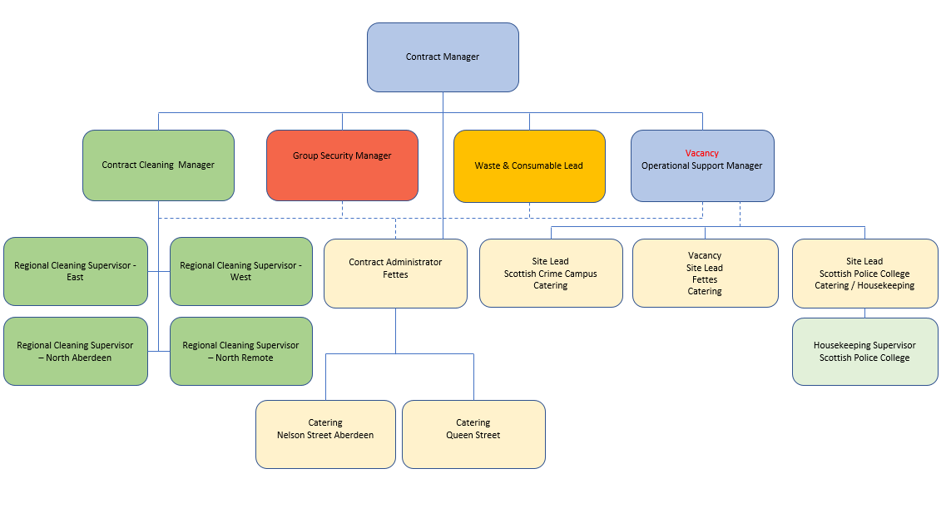

4. Context and main issues
- Comply with all legislative requirements
- Adhere to any local client site rules and regulations
- Role model safe behaviour
- Travel and overnight stay may be required to undertake training and other business requirements
- Unsociable hours in line with business requirements maybe required
- Flexibility on work schedule and location maybe required
- Collaboration with all Contract Management and Site Leads to ensure the effective management of the sites
- Effective collaborative working with Sodexo external partners,
- Ensure all practices are in line with Sodexo policies and procedures and those set out within Health and Safety and Food safety guidelines/legislation

5. Main assignments
- To perform and supervise the day to day activities
- To continue to develop one’s own skills and knowledge within the position, including any required training courses
- To maintain excellent client/customer relationships
- To attend team briefs, huddles and meetings as required
- To attend your EPA to discuss and agree job performance, objectives and development activities
- To maintain professional work standards at all times
- To care for all company equipment and ensure that any faults are reported to management
- To act as duty manager ‘on call’ and holiday cover as directed by line manager
- To work in conjunction with other General Services managers to plan, organise and coordinate service activity within own assigned operational business area and across the business
- To ensure daily standards of service in assigned operational areas, as detailed in the service level agreement, within the schedules of the contractual terms and conditions and in line with applicable Sodexo service offer standards are achieved, maintained and developed
- To contribute to the growth of services in order to meet client and commercial expectations whilst maintaining strict budgetary control in line with client and Sodexo expectations
- To continually monitor all H&S and FS standards in all service operations and ensure they are maintained at the required level
- To drive performance through adherence to all promotional activity and marketing initiatives
- To contribute to the achievement of site budget performance as determined by segment business objectives
- To work in conjunction with other department managers to ensure operational excellence within assigned operational business area with specific responsibility for labour management and performance of a defined group of employees.
- Develop and maintain a positive internal and external network
- Continued professional learning and development in soft FM services
- To carry out any other reasonable tasks and/or instructions as directed by management

6. Accountabilities
- Achieve gross margin targets
- Pass all internal and external audits
- Achieve sales target

Leadership and people
- Role holders will role model the company values and ensure they are reinforced at every opportunity. The role holder will support their line manager to drive employee engagement and team performance. This will include effective communication and the application of Sodexo HR policies and procedures as directed by their line manager

Risk, governance and compliance
- The role holder will ensure that these processes are fully applied, complied with and adhered to within their assigned operational business area. Where applicable cash and stock company procedural compliance is a requirement.

Financial management
- The role holder is required to contribute to the financial performance of their business area. This is achieved through effective control of all equipment and supplies as well as payroll.

Relationship management client and team
- The role holder is responsible developing and maintaining good business relationships with clients and customers. The role holder must seek to resolve any concerns or complaints raised and escalate to their line manager as appropriate.

Operational management
- The role holder will be responsible for overseeing their assigned operational business area and managing compliance with legal, regulatory and company requirements including the quality management system (QMS).

Service excellence
- The role holder will be responsible for driving all aspects of service excellence across their operational business area including brand integrity, quality, compliance, Sodexo’s corporate social responsibility and service standards. The role holder will ensure that work is appropriately recognised.

Continuous development
- The role holder should look for improvements and efficiencies at every opportunity to increase sales and/or reduce costs. These should be reviewed with their line manager to establish feasibility and create a plan of action.

7. Person Specification
Essential
- Demonstrate experience of working in a similar role within the service industry at a comparable level in a company
- Good numerical and communication skills, must be able to demonstrate effective verbal and written communication
- Management knowledge of health & safety and food safety
- Able to work on own initiative within a team environment
- Able to demonstrate working knowledge of MS Office (Word, Excel and Outlook)
- Proven experience in soft services delivery
- Able to demonstrate attention to detail and adherence to standards
- Analyse problems analytically, develop opportunities and implement innovative solutions

Desirable
- IOSH and CIEH qualifications or equivalent
- Proven experience of managing client relationships
- Proven track record of leading, managing and developing a team

8. Competencies
- Growth, client and customer satisfaction, quality of services provided | - Industry acumen
- Rigorous management of results | - Analysis and decision making
- Leadership and people management | - Planning and organising
- Innovation and change
- Brand notoriety

9. Management Approval – To be completed by document owner
Version | 1 | Date | 21st August 2018
Document Owner

