Job Description:
Head of Strategic Analysis

Function: |  |  |  | Global Strategy
Position: |  |  |  | Head of Strategic Analysis
Job holder:
Date (in job since):
Immediate manager  (N+1 Job title and name): |  |  |  | SVP Strategy, Investments and Contract Management
Additional reporting line to:
Position location: |  |  |  | Salford
1. Purpose of the Job – State concisely the aim of the job.
- Responsible for the provision of strategic analysis and recommendations directly for the Global Government Senior Leadership team – a EUR1.4bn business that operates in seven countries currently - and is actively involved in and provides an input into the global segment’s strategic planning process. The analysis and insight provided assists in and influences business development and developing business strategy at the highest level.
2. Dimensions – Point out the main figures / indicators to give some insight on the “volumes” managed by the position and/or the activity of the Department.
Revenue : | €1.4bn |  | EBIT growth: |  | Tbc | Growth type: | n/a | Outsourcing rate: | n/a | Region Workforce | tbc
 |  |  | EBIT margin: |  | Tbc
 |  |  | Net income growth: |  | Tbc |  |  | Outsourcing growth rate: | n/a | HR in Region | tbc
 |  |  | Cash conversion: |  | Tbc
Characteristics
Draft. Version: 27-03-2014
3. Organisation chart – Indicate schematically the position of the job within the organisation. It is sufficient to indicate one hierarchical level above (including possible functional boss) and, if applicable, one below the position. In the horizontal direction, the other jobs reporting to the same superior should be indicated.
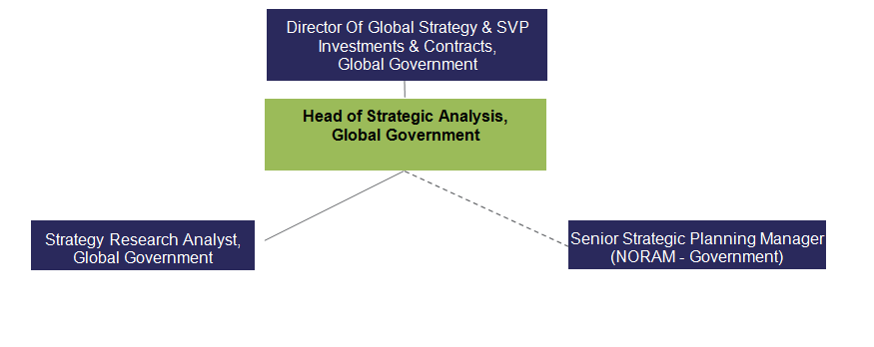

4. Context and main issues – Describe the most difficult types of problems the jobholder has to face (internal or external to Sodexo) and/or the regulations, guidelines, practices that are to be adhered to.
- Government markets are extremely competitive and our competitors are constantly evolving to remain competitive and it is crucial to our growth to ensure that the business and its key decision makers are aware of key market/competitor developments and our current position vs the competition– this is my responsibility and, as part of this, I am responsible for the assessment of Sodexo’s capabilities/performance vs our competitors (often in support of our most significant bids), outlining key weaknesses to identify areas which require attention as well as key strengths, allowing us to understand the areas in which the business can gain a competitive advantage. To gain this level of understanding and to allow me to provide accurate assessments and trusted recommendations, a great deal of research and analysis needs to be undertaken, often within very short timeframes and while juggling a number of other priorities e.g.in-depth competitor analysis to support Hestia bid, which has so far proved fruitful.
- In contract bidding where Sodexo lacks capability, it is my responsibility to identify/assess the attractiveness of potential partners, sometimes in markets in which my understanding and knowledge is limited. I use my extensive research/analysis skills and utilize my global relationships across the business to help me identify suitable partners, allowing us to bid on contracts which we would otherwise not be able to bid e.g. assessment of technical services partner for Danish defence bid.
- Managing and controlling the research external budgets, appointing, and managing consultants and contracts for specific projects.
- Supporting all members of the Global Government leadership team, all of which, by the nature of their roles, have urgent and business-critical requests. Be able to prioritize their needs and be able to manage both their expectations in relation to the resource I am able to provide and their different requirements to ensure that I am able to effectively support all parties. I also need to ensure that unfavourable assessments of our own positioning vs competitors, is delivered in a constructive and effective manner to ensure that audiences remain engaged and open to implementing recommendations put forward.

5. Main assignments – Indicate the main activities / duties to be conducted in the job.
- Responsible for identifying and assessing key white space opportunities for the Global Government segment, putting forward recommendations and presenting the conclusions to the Global Government leadership team for consideration
- Responsible for the detailed design, delivery and project management of a wide range of insightful and strategic research and analysis projects for the Global Government Senior leadership team to support key bids and gain a wider understanding of existing and new markets (including detailed market sizing and market share analysis), as well as enhance knowledge of key competitors in each of our markets.
- Regular one-to-one meetings with Global Government leadership and other senior management personnel (e.g. Global Director of Business Development for Justice) to ensure I am aware of their key and current priorities and to find out how best I can support them.
- Responsible for delivering briefings at Global Government Comex and RLC meetings on competitor/ market analysis.
- Acts as a senior representative for the Global Government segment in group wide initiatives and forums e.g. attendance at the Big Data conference, and member of Group-wide Market & Competition network.
- Input into the development of our Global segment’s strategic plan, challenging the financial and market sizing assumptions submitted by the different government regions and helping define our global segment’s future short, medium and long-term strategy.
- Management of the delivery of competitor/ market monitoring and production / circulation of government related newsletters to ensure the content remains useful, timely and informative to ensure our global segment’s primary decision makers are kept up to date on key and current issues
- Responsible for defining and updating the global government segmentation and key account attributes, with input from the Global Government leadership team, and in collaboration with the Global CRM team. This involves liaising with key stakeholders around the business, including the Global CRM team and Global government employees, to drive continuous improvement in the way we collectively capture information and in support of our digital transformation.

- Manages the Strategy Research Analyst, as well as providing guidance, direction and support to the Senior Strategic Planning Manager based in NORAM to ensure both a high level of engagement and a high quality of work.
- Responsible for the design, development and lead on creating and deploying innovative, new and auditable methodologies for all research and analysis projects undertaken, with these methodologies being shared and used by senior Sodexo employees in other countries (e.g. Global Strategy SVP, Sports and Leisure) for their own analytical projects and leading to a greater understanding of their own markets.

6. Accountabilities – Give the 3 to 5 key outputs of the position vis-à-vis the organization; they should focus on end results, not duties or activities.
- An effective global government strategy that translates to profitable growth
- Identification and successful entry into attractive white space markets, driving further growth in the segment.
- Successful meetings with the Global Government Senior Leadership team to discuss recommendations resulting from my analysis, with a high level of engagement, debate and insight provided to equip them with valuable knowledge to grow their area of the business.
- A well informed Global Government leadership team, who, as a result of the strategic analysis, possess in-depth knowledge of our key competitors/markets and a clear understanding of our strengths and weaknesses vs competitors, leading to continued segment success.
- A high level of Global Government segment engagement in group-wide initiatives (e.g. global CRM, digital transformation).
- Established and effective relationships with key stakeholders across the Sodexo Group to ensure the sharing of best practice, knowledge and competitive insight.
- An engaged and highly motivated Strategy Research analyst that provides a valuable contribution and demonstrates an increase in skills, competencies and output over time.

7. Person Specification – Indicate the skills, knowledge and experience that the job holder should require to conduct the role effectively
- Ability to think strategically
- Excellent interpersonal skills with the ability to communicate clearly and persuasively, orally and in writing, with all levels of staff, including Global Segment leadership members and Group level executives.
- Excellent organisational and planning skills, with experience of project management.
- Team Management skills
- Advanced analytical skills and the ability to problem solve, with experience of putting forward actionable recommendations to senior management based on this analysis.
- Good Presentation skills
- Advanced research skills
- Editorial skills
- Excellent attention to detail
- Ability to work under pressure and to tight deadlines
- Dynamic and flexible approach according to business needs
- Advanced Microsoft Excel skills
- Detailed knowledge of PPT, with experience of creating strategy presentations for Senior Management
Desirable
- FM or catering background.
- Public sector background.

8. Competencies – Indicate which of the Sodexo core competencies and any professional competencies that the role requires
- Growth, Client & Customer Satisfaction / Quality of Services provided | - Leadership & People Management
- Rigorous management of results | - Innovation and Change
- Brand Notoriety | - Commercial Awareness

9. Management Approval – To be completed by document owner
Version |  | Date | 2017
Document Owner

