Job Description
CAPEX Programme: Sodexo PMO Support (DWP)

Function: |  |  |  | Government Services
Position: |  |  |  | CAPEX Programme: Sodexo PMO Support (DWP)
Job holder: |  |  |  | (To be completed by HR)
Date (in job since): |  |  |  | (To be completed by HR)
Immediate manager  (N+1 Job title and name): |  |  |  | Simon Smiles, CAPEX Programme Director, Sodexo
Additional reporting line to: |  |  |  | James Wood, Head of Programme Management, Sodexo
Position location: |  |  |  | Multiple locations across the United Kingdom.
1. Purpose of the Job – State concisely the aim of the job.
- The DWP CAPEX Programme is a significant programme of Capex works that need to be undertaken over the next 3-5 years at multiple locations across England and Wales, including: Birmingham; Bristol; Hastings and Cardiff, together with a number of projects at other locations. In addition to the property works required, there is a significant amount of people and digital (IT) change to be undertaken to enable workplace transformation at many of these locations. The People and Digital related activities are being undertaken and delivered by DWP teams however their activities will need to be co-ordinated and reported by the Sodexo Capex Programme team. Each of these projects will range from c£1m-10m in value, and require significant senior stakeholder engagement.

- The scope of the property works required will differ from project to project, however will cover the full end-to-end process, including: acquisition; planning & design (including workplace transformation); fit-out; people / business relocations, decommission and asset disposal.

- The scope of the Digital works will include IT infrastructure design and fitout, desktop and peripherals installation and IT decommission activities at the exit properties. The works will be procured and delivered by the DWP Digital Team and their nominated supply chain, however their activities will need to be co-ordinated and reported by the Sodexo Capex Programme team.

- The scope of the People activities will include staff consultation and communications; TU engagement and management of the associated change activities, however these activities will need to be co-ordinated and reported by the Sodexo Capex Programme team.

- Develop processes, procedures and good working practices to support the development of the wider programme management team.
2. Dimensions – Point out the main figures / indicators to give some insight on the “volumes” managed by the position and/or the activity of the Department.
Revenue FY13: | €tbc |  | EBIT growth: |  | tbc | Growth type: | n/a | Outsourcing rate: | n/a | Region Workforce | tbc
 |  |  | EBIT margin: |  | tbc
 |  |  | Net income growth: |  | tbc |  |  | Outsourcing growth rate: | n/a | HR in Region | tbc
 |  |  | Cash conversion: |  | tbc
Characteristics |  | - Large c.£1-10m multi-site programmes involving acquisitions and disposals. Management of significant construction contracts. Delivering value to the client through enhanced working environments. Co-ordination and reporting of the Digital and People activities, which are being delivered by DWP. Development of programme management processes and practices.
Draft. Version: 27-03-2014
3. Organisation chart – Indicate schematically the position of the job within the organisation. It is sufficient to indicate one hierarchical level above (including possible functional boss) and, if applicable, one below the position. In the horizontal direction, the other jobs reporting to the same superior should be indicated.
- The CAPEX programme structure is described below and comprises a single senior leadership group, the CAPEX Programme Steering Group (CPSG) and multiple CAPEX planning and delivery workstreams, which, where required, breakdown into Major Project Implementation Teams (MPITs). The CPSG reports into the DWP Property Board. The CAPEX Programme PMO Support will lead the programme office to provide and enable management information, financial reporting, change management, resource planning, decision making and recruitment.
- The specific role of Sodexo CAPEX Programme PMO Lead is highlighted in red and is responsible for financial management; maintaining risks, issues, assumptions and action logs; resource forecasting; change control; dependency management and project/programme reporting.

CAPEX Programme structure:
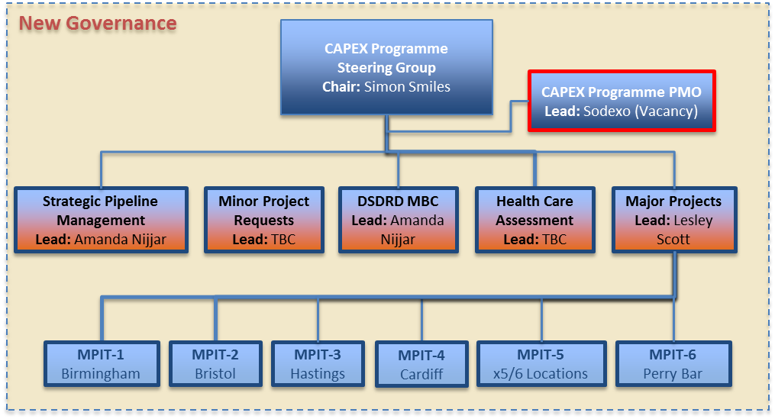

4. Context and main issues – Describe the most difficult types of problems the jobholder has to face (internal or external to Sodexo) and/or the regulations, guidelines, practices that are to be adhered to.
- Context and main interest, the role holder will need to:
  - Support the adoption and implementation a project management toolkit (under development)
  - Understand and support the implementation of the CPAR process, the DWP’s approval gateway approach
  - Understand and support the implementation, as required, the DWP end to end process (under development)
  - Understand and work alongside the Lifecycle PMO to ensure alignment, consistency and synergies between the two portfolio programmes.

- The main issues the role holder will face include:
  - Managing the CAPEX Programme’s PMO activities to challenging timelines driven by DWP’s ambitious CAPEX Programmes strategy and ensuring timely and accurate reporting to support this
  - Managing a constantly changing scope of projects that will often emerge with little or no warning.
  - Managing multiple internal and external stakeholders
  - Ensuring the alignment of other, DWP work-streams (Digital and People)
  - Implementing new project processes and procedure that have not been used within DWP previously and so will need careful and pragmatic implementation
  - Managing in a fast moving and often changing environment

5. Main assignments – Indicate the main activities / duties to be conducted in the job.
- Professional Responsibilities & Reporting:
  - Day-to-day accountability for the CAPEX Programme PMO
  - Ensure the successful implementation of the PMO’s strategy, responsibilities, services and deliverables.
  - Ensure the necessary reporting and assistance the CAPEX Programme Director to report to the senior stakeholder via both the CAPEX Programme Steering Group and other ad-hoc requests that are received.
  - Establish frameworks and standards for CAPEX project programme management.
  - Manage and compile programme related financial and KPI information.
  - Oversee project costs and ensure finances are well managed.
  - Provide and maintain capacity planning and resource tracking across the programme.
  - Update and maintain the RAID Log.
  - Work with DWP Finance teams to provide financial reporting.
  - Ensure cross programme (LCW / CAPEX) dependencies are managed and accurately maintained.
  - Line manage PMO staff, as required.
  - Build cohesion within the PMO team and motivate them to produce quality work.
  - Prepare regular status reporting to all levels of the project organization.
  - Ensure efficient change control.
  - Provide project planning and milestone management.
  - Define and embed project controls and governance.

- Finance:
  - Work with the Finance Business Partner to support in the production of financial trackers and reporting
  - Support in the coordination and collation of business case inputs, e.g. Building Assessment Report inputs, as required by the Finance Business Partner
  - Include financial reports in CAPEX Programme Steering Group meeting pack

- Information Management:
  - Ensure that project information and documentation is securely stored on the agreed systems and is easily accessible by users.
  - Ensure timely and accurate provision and sharing of information.

6. Accountabilities – Give the 3 to 5 key outputs of the position vis-à-vis the organization; they should focus on end results, not duties or activities.
- Key Relationships:
  - CAPEX Programme Director; Sodexo Capex Business Partner; individual CAPEX project Programme Managers and PMO; External delivery Supply Chain Representatives (Tower providers / Lot2/3 contractors / CCS framework suppliers); External stakeholders (including, but not limited to Landlords / other government departments, i.e. HMRC); Lifecycle Programme Director and PMO team.

- CAPEX Programme Values:
  - Take pride in what they do – strive for highest standards on own work and challenge colleagues to do the same Strive to be the best – in terms of governance & teamwork
  - Act with integrity - work with integrity and be trustworthy, be accountable for own work
  - Respect others – CAPEX Programme team members, delivery supply chain, internal and external stakeholders, colleagues and customers. Actively give and receive feedback.

7. Person Specification – Indicate the skills, knowledge and experience that the job holder should require to conduct the role effectively
- The Sodexo CAPEX PMO Support role requires excellent people, organisation, communication and financial management skills coupled with strong project management skills to ensure the integrity of the individual projects that are within the scope of the CAPEX Programme. The individual will need to have credibility within the CAPEX Programme Steering Group and wider CAPEX Programme. They will need to be able to influence others and to develop and maintain robust relationships with all members of the CAPEX Programme team and wider Sodexo and DWP staff.

8. Competencies – Indicate which of the Sodexo core competencies and any professional competencies that the role requires
- Client & Customer Satisfaction / Quality of Services provided
- Rigorous management of results
- Commercial Awareness
- Leadership & People Management
- Innovation and Change
- Employee Engagement

9. Management Approval – To be completed by document owner
Version | v.02 | Date | 18/10/18
Document Owner | MDH

