Job Description
Programme Manager- DWP

Function: | Government Services
Position: | Programme Manager - DWP
Immediate manager  (N+1 Job title and name): | Head of Programme Management , DWP
Additional reporting line to:
Position location: | TBC
1. Purpose of the Job
- To deliver the programme management office and project management function of in-flight projects to ensure the expected levels of governance, control, and reporting leading in accordance with the delivery model.
- Management of multiple varied projects programmes, projects or portfolio of work within DWP estate to meet identified business needs – assigning works, monitoring performance and ensuring safe practices through the use of the Authority supply chain
- Ensure suitable management and communication through the project lifecycle.
Draft. Version: 27-03-2014
2. Organisation chart
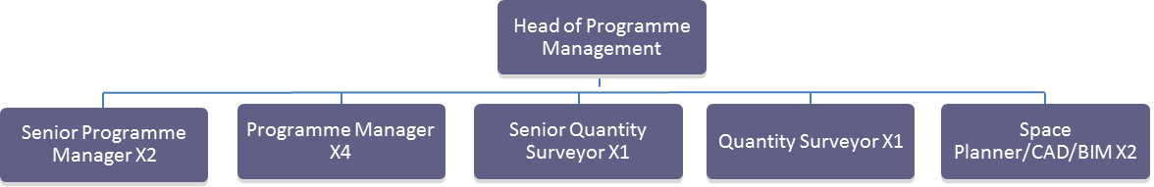

3. Main assignments
- Development and successful implementation of a programme management function which is aligned to DWP priorities and will ensure the effective delivery of capital works and life cycle projects.
- Delivery and execution of the programme management detailed solution in accordance with DWP values and behaviours
- As directed by the Head of, produce and maintain an annual programme management detailed solution for DWP which details all anticipated, forecasted and planned projects and recommendations.
- Use set process for communicating progress on projects – including: project reporting tools, expenditure, status reports on capital works assets
- Ensure programme and projects are managed to ensure minimal disruption to Authority business
- Management of projects in line with Sodexo framework
- Effective engagement with key stakeholders to ensure they are aware of programme and project, key milestones and initiate corrective action where required.
- Ensure all project programmes are fully planned with project plans, dependencies and reporting procedures
- Deliver protocol for production initiation documentation
- Ensure processes and procedures are delivered for effective risk management - risk logs, mitigating actions, establishment of contingency plans and robust escalation processes internally and externally
- Input into progress and project control reports for the steering group in accordance with governance requirements
- Deliver in accordance with project governance, administration and communication plans liaising with key stakeholders to ensure project documentation is fit for purpose and line with Authority requirements.
- Effectively manage third party relationships with the supply chain including designers, contractors and equipment and material providers. Ensure contractors engaged within the supply chain are rigorously assessed on the basis of quality and value to DWP.
- Manage relationships with third party contractors to ensure compliance and delivery of programmes to a high standard.
- Ensure any statutory and mandatory requirements are met in relation to all life cycle and capital works projects.
- Co-ordinate and review projects to ensure any efficiencies are realised across the supply chain and that all interdependencies are met.
- Assist in the review of Authority design standards to make any recommendations or enhancements
- Ensure all projects meet required health and safety standards and that any security requirements are met
- Develop and implement an audit and review mechanism of all projects

4. Person Specification
- Educated to Degree level or equivalent by experience
Incorporated Engineer or Surveyor or Holds a professional Project Management qualification egPMI (PMP), PMI (PMPg) or APM
NEBOSH Construction Certificate
Comprehensive experience in a full lifecycle project management role
- Good knowledge of best practice and standards such as, ISO9001,CDM and relevant British and Regulatory Standards
- Evidence of delivery of Programme and Capital Projects in large corporate environments and working with customers at all levels
- Excellent communication skills both written and verbal
- Demonstrable experience of forward planning, problem solving, analytical thinking
- Consultancy background
- Knowledge of CAFM systems
- Experience of Managing Agent or Integrator Model preferable

