Job Description:
CAD Specialist

Function: |  |  |  | Government & Agencies, Integrator
Job: |  |  |  | CAD Specialist
Position: |  |  |  | CAD Specialist
Job holder:
Date (in job since):
Immediate manager  (N+1 Job title and name): |  |  |  | Head of Asset Management
Additional reporting line to:
Position location: |  |  |  | Hybrid Belfast and Home Based
1. Purpose of the Job – State concisely the aim of the job.
- As a CAD specialist you will be a core member of the Asset Management Team responsible for creating and implementing space, facility management/project requirements and solutions within client site locations and potential locations
- The CAD function will be responsible for providing the following activities:
  - Manage the Client’s CAD processes and information
  - Update all recorded information to reflect ongoing changes in the Estate
  - Support the Asset Management Team in relation to managing all drawing related matters
  - Support moves, recruitment and change programs by creating Concept layout plans
  - Occasional travel to client sites to complete surveys create as built layout plans, attend meetings with the client/key stakeholders and Professional Teams
  - Facilitate excellent communication with clients, stakeholders and team members.
  - Provide CAD planning/space planning solutions
  - Liaise with other CAD specialists (internal and external) to deliver core services
  - Provide CAD support to Maintenance and Projects team
2. Dimensions – Point out the main figures / indicators to give some insight on the “volumes” managed by the position and/or the activity of the Department.
Revenue FY13: | €tbc |  | EBIT growth: |  | tbc | Growth type: | n/a | Outsourcing rate: | n/a | Region Workforce | tbc
 |  |  | EBIT margin: |  | tbc
 |  |  | Net income growth: |  | tbc |  |  | Outsourcing growth rate: | n/a | HR in Region | tbc
 |  |  | Cash conversion: |  | tbc
Characteristics |  | - Accountable for over 180,000 assets  - Portfolio of over 150 buildings/locations  - 3-year contract + 1 + 1 optional extension  - Over c.290,000m sqm GIA across the Client’s estate

Draft. Version: 27-03-2014
3. Organisation chart – Indicate schematically the position of the job within the organisation. It is sufficient to indicate one hierarchical level above (including possible functional boss) and, if applicable, one below the position. In the horizontal direction, the other jobs reporting to the same superior should be indicated.
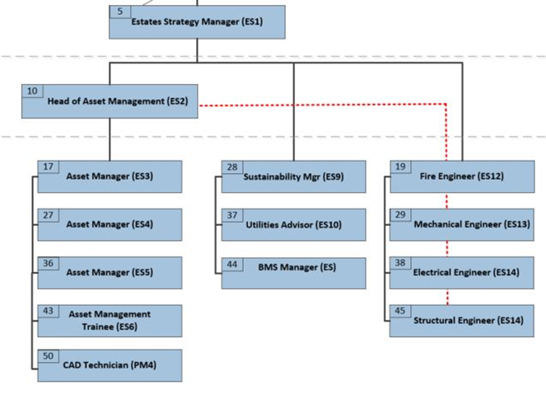

4. Context and main issues – Describe the most difficult types of problems the jobholder has to face (internal or external to Sodexo) and/or the regulations, guidelines, practices that are to be adhered to.
- The position is within Sodexo Government and Agencies - Integrator
- The majority of the varied workload is in support of the client Estates Services team. Additionally, requests will emerge via Work Orders and the Sodexo Field Team.
- The estate currently comprises c.70 buildings and around 294,000 sqm of built space and 83 telecommunication sites. The estate is held by the client predominantly on a freehold basis.
- The client provides a number of different services, requiring a variety of spatial solutions. The specifications for these solutions are set out in design standards, published by the client. Due to the high number and variety of buildings, often the design standards will need careful, well thought out interpretation during the creation of new spatial layouts.
- Being able to balance often opposing priorities from a variety of stakeholders in a calm productive manner is essential.
- The Estate is unique in nature and infrastructure is complex requiring a thorough understanding of different types of building layouts and construction.
- Legacy drawing information and recent survey reports require focus and programme to bring these to a new level of standard.
- Due to the complexity of the Estate and urgent Client change requests, workload can increase significantly and very rapidly, the ability to manage under pressure is essential.

5. Main assignments – Indicate the main activities / duties to be conducted in the job.
- You will prepare drawings, diagrams, and documents using CAD software (AutoCAD). This includes developing CAD files from site visits, notes, sketches, fire plans, technical guides, occupancy information and pdf files.
- Attend site to meet with key stakeholders to obtain and develop project briefs
- Attend site to undertake building surveys to complete Concept drawings and/or to ensure drawings are an accurate representation of those buildings
- Develop project-level and portfolio-level solutions based on interpretation of the customer requirements – following collaboration with the customer through site visits, meetings, by email and over the phone. Prepare multiple options and recommendations.
- You will maintain accurate drawing information and registers for all of the client’s buildings. The drawings will provide an accurate representation of structure, furniture, Space Type, Sub Space types, purpose and asset locations using both CAD and other relevant systems.
- You will ensure CAD files are properly maintained, updated stored in line with data protection for each project including as-built plans for completed construction projects
- Consider future systems for implementation to support, such as FOCUS, CAFM and CADM systems.
- Produce space analysis and feedback to enable refinement of space standards and design guidance.

6. Accountabilities – Give the 3 to 5 key outputs of the position vis-à-vis the organization; they should focus on end results, not duties or activities.
- Accurate as built record drawings
- Layout plans which optimise space and requirements
- Accurate data inputs into relevant systems
- Updating drawings and systems to necessary standards

7. Person Specification – Indicate the skills, knowledge and experience that the job holder should require to conduct the role effectively
- Bachelor’s degree in CAD design OR an acceptable combination of education and experience.
- Excellent knowledge of CAD software, quality assurance best practices and methodologies.
- Good working knowledge of automated Asset Management/CAFM/CADM systems
- Excellent communication oral & written skills
- Strong knowledge of architectural drafting standards, as well as blueprint and specification reading skills.
- Experience in Facility Management or construction industry.
- Strong Knowledge of project management
- Strong project management and excellent organisational skills with the ability to analyse multiple sets of data and drive decision making in a problem-solving atmosphere.
- Proven results and success in developing, planning, managing, and implementing workplace plans and space solutions within a dynamic corporate environment. Strong understanding of business and financial impacts to workplace options.
- Knowledge of applicable data privacy practices and general health and safety regulations.
- Excellent knowledge/experience of space planning, knowledge of and ability to apply associated legislation in the space planning field and a good understanding of building construction and fitting out.
- Full Driving licence

8. Competencies – Indicate which of the Sodexo core competencies and any professional competencies that the role requires
- Growth, Client & Customer Satisfaction / Quality of Services provided | - Leadership & People Management
- Rigorous management of results | - Innovation and Change
- Brand Notoriety | - Business Consulting
- Commercial Awareness | - Learning & Development
- Employee Engagement

9. Management Approval – To be completed by document owner
Version | 001 | Date | 09/07/2021
Document Owner | RM

10. Employee Approval – To be completed by employee
Employee Name |  | Date

