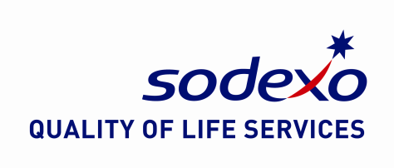

Accountabilities: “What you have to do”
- To carry out Sodexo cleaning in specific areas and on job specific tasks to the required standard established by the Service Level Agreement
- To be multi skilled in order to cover areas of the Service Level Agreement including office cleaning and toilet cleaning. This may also include specialist cleaning areas.
- To effectively undertake all cleaning tasks to the required service level agreement, carry out daily, weekly, quarterly and annual tasks.
- To effectively undertake day cleaning duties to include; recycling, confidential waste, litter picking, the cleaning of staff restaurant, changing rooms, reception, Housekeeping, car parks and entrances, building lifts, stair wells, offices, classrooms; to respond and efficiently react to any spillages or customers/client request such as carpet cleaning.
- To have full working knowledge of all cleaning equipment, materials and chemicals and the use of cleaning equipment as directed by cleaning Supervisor, only after correct training has been given.
- Report any maintenance issues immediately to include equipment that is faulty or any risk or hazards identified.
- To ensure that the appropriate safety signage is used at all appropriate times e.g. wet floor signs to “warn” customers where possible.
- To ensure that cleaning cupboards stores are kept clean and tidy and equipment is stored correctly and safely at all times.
- To ensure a high standard of personal hygiene is maintained at all times and that uniform provided and specified is worn with care to being cleaned and ironed.
- To take part and effectively engage in employee training and having a full understanding of Health & Safety, COSHH, cleaning methods, cleaning training and site specific procedures.
- To deal with any complaints/issues from customers immediately and report directly to your Supervisor.
- To participate actively within team meetings in order to develop ideas to enhance service offer.
- To perform miscellaneous cleaning tasks as instructed by the cleaning Supervisor.
- To be flexible to work additional hours in order to cover holiday and sickness within the tea
Key Performance Indicators (KPI’s): “What it will look like when you are doing the job well”
- Standard of cleanliness achieves the Service Level Agreement, monitored by weekly and monthly client audits.
- Compliance with Health & Safety Legislation and Sodexo procedures
- Compliance with Site Specific Client Procedures.
- Developing and implementing new ideas.
- Responsive to training and new site procedures.
- Ability to respond to additional tasks in a timely manner & manage work load throughout the day.
- Building client and customer relationships.

