Job Description:
Sales Manager

Function: |  |  |  | Peyton Events
Position: |  |  |  | Sales Manager
Job holder:
Date (in job since):
Immediate manager  (N+1 Job title and name): |  |  |  | Head of Peyton Events Sales & Strategy
Additional reporting line to: |  |  |  | none
Position location: |  |  |  | Peyton Events Head Office
1. Purpose of the Job – State concisely the aim of the job.
To work directly with the Head of Peyton Events Sales & Strategy and the wider sales and operations team to develop and maintain all aspects of the Peyton Events offer, ensuring we remain at the forefront of the industry and lead with innovation and brand relevance.

Through creativity, innovation, and client engagement, this role is responsible for creating and maintaining excellent and constantly developing client relationships with venues and clients alike. We encourage personal initiative to actively seek new business and enhance existing customer experiences. Taking the client through the full customer journey with Peyton Events from concept to service delivery we seek to inspire guests and provide excellent food, drink and service at all points.

The role suits a professional and experienced manager who strives to constantly over-achieve results, actively participate in forming strategies and implement such by constantly seeking new leads and routes for development. Excellent time management and organization skills are required within this fast-paced ever-changing environment to be able to deliver the customer visions whilst maintaining Peyton Events ethos and brand awareness and adhering to strict Health & Safety/Site client regulations and requirements.
2. Dimensions – Point out the main figures / indicators to give some insight on the “volumes” managed by the position and/or the activity of the Department.
Revenue FY13: | €tbc |  | EBIT growth: |  | tbc | Growth type: | n/a | Outsourcing rate: | n/a | Region Workforce | tbc
 |  |  | EBIT margin: |  | tbc
 |  |  | Net income growth: |  | tbc |  |  | Outsourcing growth rate: | n/a | HR in Region | tbc
 |  |  | Cash conversion: |  | tbc
Characteristics |  | - Add point
Draft. Version: 27-03-2014
3. Organisation chart – Indicate schematically the position of the job within the organisation. It is sufficient to indicate one hierarchical level above (including possible functional boss) and, if applicable, one below the position. In the horizontal direction, the other jobs reporting to the same superior should be indicated.
See overleaf
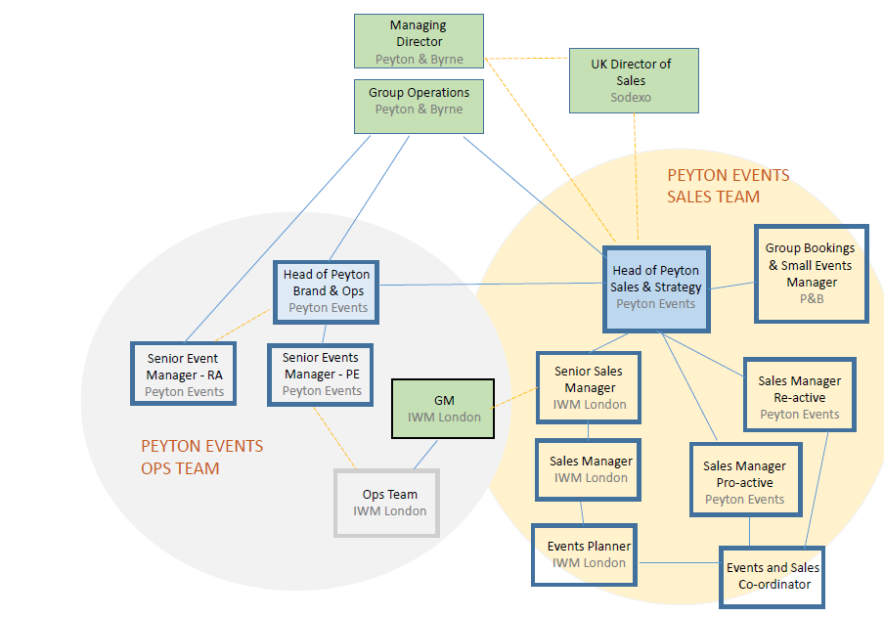

4. Context and main issues – Describe the most difficult types of problems the jobholder has to face (internal or external to Sodexo) and/or the regulations, guidelines, practices that are to be adhered to.
EXCELLENCE
- Challenging ourselves to meet our own high expectations and supporting each other to deliver against them in all areas:
    - Service Standards
    - Design
    - Product Provenance
    - Craft Skill
  - Having respect for the customer, listening to their needs and always delivering value at their price point

COMMITMENT TO PEOPLE
- Providing real development, learning and benefits
- Being open and honest with each other. Demonstrating respect for our differences and skills, fostering equality throughout the Company
- Providing an open, engaging, fun and rewarding work environment
- Delivering on what we promise

CREATIVITY AND INNOVATION
- Leading the market, always seeking to spearhead new developments
- Never being complacent, always striving to improve on what we do
- Using creative thinking and innovative ideas to solve problems and develop new solutions

5. Main assignments – Indicate the main activities / duties to be conducted in the job.

Service, Client & Guest Care:
- Help organise and deliver event business plans, strategies and relevant projects to ensure the business continues to grow, develop and remain at the forefront of the industry
- Bespoke your service delivery depending on client and event location requirements
- Continuously maintain and develop relationships with clients to demonstrate a deep understanding of client as well as location requirements, expectations and limitations
- Work with the client and the operations team to ensure that all events, contracts and project work, matches ambition and promise
- Take initiative to develop and implement strategies that will lift standards and raise the overall reputation and growth of Peyton Events
- Work with the whole team to ensure high customer satisfaction through understanding client needs, high product quality, consistently excellent service and high environmental standards
- Keep up to date on local and wider market trends to ensure Peyton Events remain innovative and relevant
- Understand and deliver an agreeable outcome of conflicting requirements between client, customer, and company
- Manage projects and compile business plans, sales strategies and proposals as required
- Constantly work to improve the business and encourage a culture of innovation
- Regularly interact and communicate effectively with current and potential clients including venues and stakeholders
- Design and deliver client briefs and presentations, ensuring that all requirements are exceeded and showcase Peyton Events services in a professional and timely manner
- Initiate pro-active selling of Peyton Events products and services to key target markets; performance measured by agreed set of KPI’s
- Professionally represent Peyton Events at various face to face sales and marketing events on a regular basis

Leadership & People:
- Be an advocate and ambassador for Peyton Events, developing strong positive relationships across all areas of Peyton and Byrne and with clients and suppliers
- Ensure that business activity is communicated effectively and in a timely manner throughout the Company and to all personnel
- Take responsibility of the Health & Safety of employees and customers at all times and across every aspect of the business
- Ensuring adherence to all relevant legislations to your day to day activities
- Promoting exemplary personnel management within company
- Work closely with the senior management team to ensure good working relations are maintained and that the best interests of the company are always the priority
- Work with the management team to ensure the agreed procedures and policies are faithfully followed
- Create and maintain excellent client and venue relationships

Managing Standards and Quality
- Keep abreast of developments and changes in the Events, Restaurant and wider Catering Industries to develop and implement strategies to keep Peyton Events and the `Group at the forefront of the industry
- Ensure all event briefs are clearly constructed and all parties are fully briefed to enable the smooth planning and implementation of events logistics
- Work with your line managers and peers in the development, setting and maintenance of the image of Peyton Events across all of the company activity
- Ensure all presentational material (both printed and electronic) is of the highest standard and accurately reflects the business and complies with company brand standards
- Represent Peyton Events at various forums within the industry
- Work with all relevant parties to feedback customer and client comments to help develop the our events offering across each piece of the business
- Set a high personal standard for the Peyton Events team
- Have appropriate level of knowledge of Food Hygiene and Health and Safety Standards

Financial Management:
- Be commercially minded in every aspect of the business and day to day activity
- Work with your key stakeholders and other company peers to help compile Peyton Events budgets and forecasts
- Work with key stakeholders and peers to develop an integrated strategy aimed at winning and retaining business
- Report sales figures and forecasts on a weekly basis in an accurate and timely manner
- Consistently work with the operations team to manage event costs in line with budget and business need
- To ensure that each activity achieves its required profit margins, and to chart this information
- Compile and utilise financial information in a constructive and beneficial way
- To understand, interpret, explain and act on the implications of financial information

6. Accountabilities – Give the 3 to 5 key outputs of the position vis-à-vis the organization; they should focus on end results, not duties or activities.
- Using initiative and acumen to support the development of the Peyton Events brand
- Leading and supporting the wider team to ensure company success
- Draw on financial management and commercial awareness to drive growth

7. Person Specification – Indicate the skills, knowledge and experience that the job holder should require to conduct the role effectively
- A minimum of 5 years’ experience working in the UK events industry
- Strong personal contact network within London venues, agencies and corporate companies
- Industry acumen and knowledge of external catering developments & innovations
- Diverse Contract and Events Catering experience
- Strong financial understanding and demonstrable budgeting management
- Experienced in adhering to and driving company initiatives and strategies
- Knowledge of working in public event spaces and listed buildings
- Personal innovation and passion for food and beverage
- Demonstrative customer focus and excellent service skills
- Strong communication and negotiation skills
- Excellent organizational and time management skills
- Solid experience in using CRM systems

8. Competencies – Indicate which of the Sodexo core competencies and any professional competencies that the role requires
- Growth, Client & Customer Satisfaction / Quality of Services provided | - Leadership & People Management
- Rigorous management of results | - Innovation and Change
- Brand Notoriety | - Business Consulting
- Commercial Awareness | - HR Service Delivery
- Employee Engagement
- Learning & Development

9. Management Approval – To be completed by document owner
Version | V.1 | Date | 10/07/17
Document Owner | Cecilia Lavin

10. Employee Approval – To be completed by employee
Employee Name |  | Date

