EXPERTISE
Job description

Function: | GROUP SUPPLY MANAGEMENT
Position: | SENIOR GLOBAL CATEGORY BUYER - PROFESIONNAL SERVICES
Job holder: | CPO- MICHEL FRANCESCHI
Date (in job since): | 2013
Immediate manager  (N+1 Job title and name): | VP GLOBAL SUPPLY MANAGEMENT - INDIRECT AND IS&T
Additional reporting line to: | NO
Position location: | Solar House, Kings Way, Stevenage, Hertfordshire, SG1 2UA, UK

1. Purpose of the Job – State concisely the aim of the job.
Contribute to Group SG&A costs and supplier spend reduction in cooperation with key stakeholders and business/ spend owners in the respective functional departments (Finance, Communication, Legal) for a new and growing portfolio of categories and initiatives : consulting and intellectuals services ( communication, PR, legal, strategy, training.), Real Estate, Consumer Payments, Banking Services, Insurance,
Objectives are:
- To deliver cost reduction & value for the business
- To contract the right level of quality for the products, services and solutions bought
- To standardize supplier contract globally and consolidate countries spend under global contracts

2. Dimensions – Point out the main figures / indicators to give some insight on the “volumes” managed by the position and/or the activity of the Department.
Characteristics | Categories spend value : As Is : 20 M€ - To Be (over 5 years): 200 M€  Countries covered : 7 core (top spend) / additional 10  Cost reduction target : 2.4 M€ over 3 Fiscal Years ( AS IS) as from FY17

Draft. Version: 27-03-2014
3. Organisation chart – Indicate schematically the position of the job within the organisation. It is sufficient to indicate one hierarchical level above (including possible functional boss) and, if applicable, one below the position. In the horizontal direction, the other jobs reporting to the same superior should be indicated. Please show the job titles not the actual people doing the role, i.e. Finance Manager, Project Manager
This is a job creation in the new Global Supply Management organization implemented Jan 2016

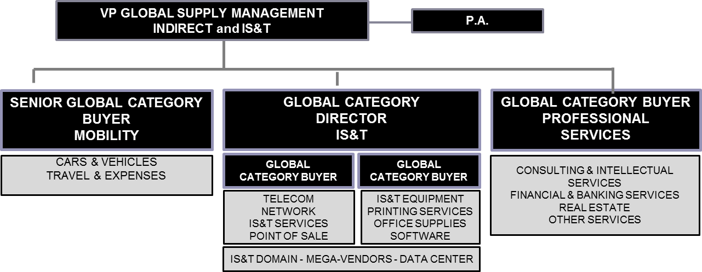

4. Context and main issues
- Liaise and work with Group and Regionals spend owners and stakeholders to investigate, identify, and build cost reduction plans: Purchasing, Finance. HR, Legal, communication…
- Build key stakeholder engagement in areas that Global Supply Management have previously not been involved
- Collect data from different sources about existing contracts, spend and specifications needed
- Identify and manage a network of multiple decision-makers in different countries, from different functions without direct report
- Standardize global or multi-regional solutions to meet local needs and bring value to Business Units
- Manage change and obtain the on-boarding of required decision-makers and enablers
- Work in a multicultural environment (country culture, technical culture, other functions culture…)
- Understand supplier market – suppliers decision process / negotiate with some monopolistic supplier

5. Main assignments – Indicate the main activities / duties to be conducted in the job.
- Liaise with group and regional key stakeholders / spend owners to capture/ define business needs
- Coordinate a network of regional / country Stakeholders
- Analyse & watch supplier market capacities and opportunities , including innovation
- Recommend and Implement category plans with cost reduction objectives
- Launch or Co-launch and manage or Co-Manage purchasing initiatives/ tenders/ negotiations with key business owners
- Draft & manage international supplier’s contracts and SLA’s
- Deploy the supply management risk policy to international suppliers
- Manage and deliver the Supply Management Business Plan (Gross savings, Broker fees,… )
- Define & deploy a procurement process & governance model to qualify needs, consolidate volumes and organise competition/ negotiations with suppliers based on optimal timing & task allocation
- Coach & train key stakeholders on procurement best practices & behaviours

6. Accountabilities – Give the 3 to 5 key outputs of the position vis-à-vis the organization; they should focus on end results, not duties or activities.
- Define purchasing strategy based on Group strategy, suppliers market & Sodexo business needs
- Lead or Co-Lead international cost reduction / purchasing projects to select the best suppliers and deliver optimized value
- Manage the internal network of countries’ users, Business Unit stakeholders & experts involved
- Manage the relations with the suppliers at global level (contract, implementation, performance, innovation)
- Build the tools, process & indicators to value the actual savings & other benefits delivered

7. Person Specification – Indicate the skills, knowledge and experience that the job holder should require to conduct the role effectively
- Significant international experience and expertise in Purchasing professional services as described above
- Robust experience in negotiating and managing international contracts
- Proven multi-vendor and comprehensive multi cycle agreement negotiation experience
- Mega vendor agreement governance experience including multi region enrolments deployment and management
- Audit management and dispute resolution
- Strong client / business acumen
- International profile / orientation
- Fluent in both English and French language
- Bachelor’s Degree or equivalent experience
- Background : Successful achievements on previous position
- Additional/second experience in Consulting or Finance would be an advantage

8. Competencies
- Fluency in English and French is a MUST An additional language would be an advantage
- Knowledge of procurement principles, theories and processes
- Effective leadership and influencing skills and project management skills with a proven ability to drive cross-functional project teams in a matrix organisation
- Self-starter with capability to identify opportunities and the drive and tenacity to ensure they can be achieved
- Ability to work in a multicultural and technical environment (experts, engineers, ..) and to establish strong partner networks in order to streamline systems and processes.
- Ability to work on complex procurement problems and provide innovative solutions
- Good Negotiation skills.
- Very good sales, verbal and written communication, presentation
- Strategic vision and tactical capabilities
- Good financial data management and analytical skills, problem solving and reporting
- Continuous improvement mind set and methodology

