Job Description:
Head of Asset Management

Function: |  |  |  | Integrator, Government & Agencies
Position: |  |  |  | Head of Asset Management
Job holder:
Date (in job since):
Immediate manager  (N+1 Job title and name): |  |  |  | Head of Estates Strategy
Additional reporting line to:
Position location: |  |  |  | Belfast
1. Purpose of the Job – State concisely the aim of the job.
As Head of Asset Management, you will be responsible for leading the Asset Management Team in the delivery of the asset management services for the contract.
The post holder will engage with and influence across the Contract Leadership Team and Operational Management Team ensuring that Asset Management policy and process influences strategic thinking and investment decisions.
The aim of this role is to ensure the client’s assets provide value and support to their core business. This will be achieved through the development, deployment, management and continual improvement of asset performance initiatives.

Initiatives may include interventions in the following key areas; PPM, lifecycle, asset data, condition monitoring and failure analysis. The results will be improved performance of assets across the client’s estate, ultimately measured by increased uptime of critical assets.

The use of data to influence key investment decisions will be critical and the postholder is expected to lead and also support the Head of Estates Strategy in developing programmes of work.

To ensure the implementation of the Client’s Estate Strategy through development of relevant programmes and actions plans to meet organisational transformation goals.

The post holder will assist the Head of Estate Strategy in managing Technical Assurance roles and Asset Management functions for the Client and play a key role bring the Asset and Energy functions together whilst also ensuring lateral team work across all areas of the contract.

2. Dimensions – Point out the main figures / indicators to give some insight on the “volumes” managed by the position and/or the activity of the Department.
Revenue FY16: |  |  | EBIT growth: |  |  | Growth type: | n/a | Outsourcing rate: | n/a
 |  |  | EBIT margin:
 |  |  | Net income growth: |  |  |  |  | Outsourcing growth rate: | n/a
 |  |  | Cash conversion:
Characteristics |  | - Accountable for over 180,000 assets  - Portfolio of over 150 buildings/locations  - 3-year contract + 1 + 1 optional extension  - Over c.290,000m sqm GIA across the Client’s estate
Draft. Version: 27-03-2014
3. Organisation chart – Indicate schematically the position of the job within the organisation. It is sufficient to indicate one hierarchical level above (including possible functional boss) and, if applicable, one below the position. In the horizontal direction, the other jobs reporting to the same superior should be indicated.
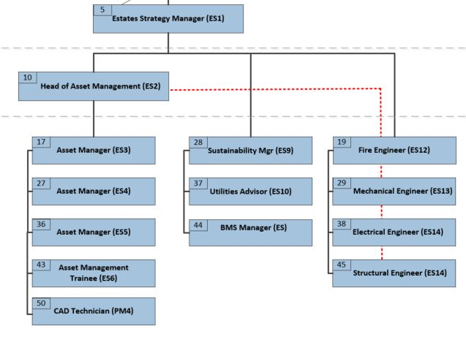

4. Context and main issues – Describe the most difficult types of problems the jobholder has to face (internal or external to Sodexo) and/or the regulations, guidelines, practices that are to be adhered to.
Under a 3-year contract, Sodexo will operate as property portfolio manager and will integrate the capital, real estate and FM functions (horizontal), and the delivery supply chain (vertical). As well as managing the supply chain, Sodexo will develop and execute property strategies to deliver the sponsors business and property objectives.

The main areas of focus and challenge for the role will be:

- Developing, deploying and maturing an Asset Management solution through the client and supply chain organisations.
- Ensuring standardisation of approach and delivery of asset management across multiple supply chains.
- Creation of value adding knowledge from multiple data sources, some of which may be initially incomplete
- Use all available data to make recommendations for Client investment across the Estate
- Developing and implementing Asset Management Plans in line with contractual commitments across the Estate in consultation with all key Stakeholders

5. Main assignments – Indicate the main activities / duties to be conducted in the job.
- Work with data analysts to establish trends and failure modes
- Identify root causes of recurring failures and establish a plan to reduce failures
- Identify delays or process failures that contribute to long repair times
- Review maintenance performance and specifications in relation to high risk asset types
- Working with the client and independently, develop a register of critical assets
- Work with operational teams and SMEs to understand key asset performance issues
- Attend supply chain meetings to define expectations and challenge expectations
- Establish plans and initiatives to improve uptime of critical assets
- Review the maintenance strategy and develop proposals for improvement
- Produce reports and presentations to demonstrate asset performance improvements
- Manage and develop the Asset Management Team
- Coordinate Asset Inspections and ensure all asset data is maintain across a range of systems
- Play a lead role in developing key Strategic and Operational reports and plans
- To implement contract obligations for Asset Management and Technical Assurance
- Complete an annual benchmarking exercise for the built estate

6. Accountabilities – Give the 3 to 5 key outputs of the position vis-à-vis the organization; they should focus on end results, not duties or activities.
- Improve asset performance, measured by critical asset uptime (MTBF, MTTR)
- Review maintenance tasks and performance to develop improvements
- Carry out Root Cause Analysis of critical failures
- Review failure data and failure modes to help develop reliability strategies
- Development and deployment of asset performance improvement strategies to support ISO55001
- Development of robust Asset Management processes and plans for each key area of the Client’s operations

7. Person Specification – Indicate the skills, knowledge and experience that the job holder should require to conduct the role effectively
- Recognised technical/engineering qualification to level 4 as a minimum
- Must be a member of CIOB, RICS, CIBSE, IAM, IWFM or relevant body
- Demonstrable experience in Asset Management/Reliability Engineering
- Significant experience within a complex and mature Asset Management environment
- Experience of developing and implementing asset performance improvements
- Experience of condition monitoring, maintenance optimisation or reliability centered maintenance
- Understand analytical processes (Root Cause and Failure Mode analysis, etc)
- Developing and managing relationships to ensure desirable outcomes
- Ability to work across functions and with client and suppliers to achieve outcomes
- Highly numerate with financial skills
- Excellent planning and organisational skills
- Competent using spreadsheets and writing reports

Desirable
- Understanding of Facilities Management
- Strong technical skills
- Strong Influencing skills
- Strong communication skills
- Level 6 qualification

8. Competencies – Indicate which of the Sodexo core competencies and any professional competencies that the role requires
- Employee Engagement
- Brand Notoriety
- Rigorous management of results
- Growth, Client & Customer Satisfaction / Quality of Services provided
- Change and Innovation
- Client relationship management

9. Management Approval – To be completed by document owner
Version | 2.3 | Date | 17-06-2021
Document Owner | Roland Moore

10. Employee Approval – To be completed by employee
Employee Name |  | Date

