EXPERTISE
Job description

Function: | Sports & Leisure
Position: | MAJOR EVENT OPERATIONS manager
Job holder:
Date (in job since):
Immediate manager  (N+1 Job title and name): | Account Manager, Linzi Purves
Additional reporting line to:
Position location: | South Queensferry

1. Purpose of the Job – State concisely the aim of the job.
The Event operations manager will support the Open Championship team in all aspects of event management for the 147th Open Championship In Carnoustie and future championships thereafter. The post holder will lead on the creation, planning and delivery of key aspects including event planning, governance & performance, health & safety and event delivery.

Key objectives
- Support the partnership between Sodexo and the R&A by driving innovation and providing creative ideas on how to grow the catering operation at the Open Championship
- Identify key personnel to deliver the event and pull on our Sodexo stakeholders to support the overall operation
- To effectively schedule, plan, coordinate & execute all areas of Sodexo’s operation at The Open Championship

2. Dimensions – Point out the main figures / indicators to give some insight on the “volumes” managed by the position and/or the activity of the Department.
Revenue FY18: | £5.5M |  | EBIT growth: | tbc | Growth type: | n/a | Outsourcing rate: | n/a | Region Workforce | tbc
 |  |  | EBIT margin: | tbc
 |  |  | Net income growth: | tbc |  |  | Outsourcing growth rate: | n/a | HR in Region | tbc
 |  |  | Cash conversion: | tbc
Characteristics |  | - Add point:

Draft. Version: 27-03-2014
3. Organisation chart – Indicate schematically the position of the job within the organisation. It is sufficient to indicate one hierarchical level above (including possible functional boss) and, if applicable, one below the position. In the horizontal direction, the other jobs reporting to the same superior should be indicated. Please show the job titles not the actual people doing the role, i.e. Finance Manager, Project Manager
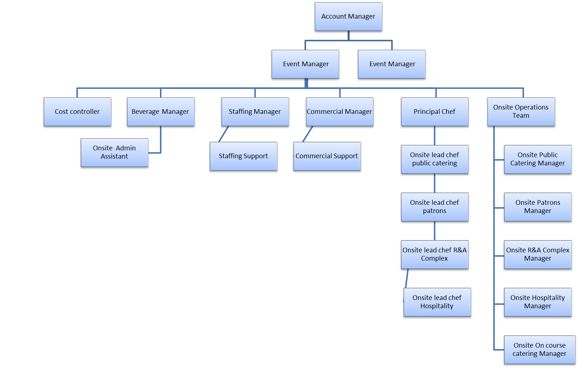

4. Context and main issues – Describe the most difficult types of problems the jobholder has to face (internal or external to Sodexo) and/or the regulations, guidelines, practices that are to be adhered to.
- Management of multiple stakeholders, internal and external
- Management of cost control during planning & onsite
- Ensure that a consistent high standard of service is achieved throughout the delivery of the event
- Ensure that all of our operations embody the zero-harm and total food safety culture that Sodexo strives to achieve.
- Deliver large scale event with a 90% casual management and chef operations team – ensure all employees are engaged, knowledgeable and appointed the correct operating role to ensure both Sodexo and the R&A values and expectations are met

5. Main assignments – Indicate the main activities / duties to be conducted in the job.
- Adhere to project management timeline and manage all internal stakeholders to ensure they deliver on their responsibilities
- Support the financial performance of the account through sales delivery, cost control and reconciliation to achieve the expected results for both Sodexo and The R&A
- Support in creative design and innovation of project management, assisting in the planning and design of all catering areas, both FOH & BOH, working with internal team members and site contractors to agreed schedules
- Work with staffing representatives to recruit, induct, train and manage a team of staff that will deliver the exceptional service required
- Line manage members of the wider team installing relevant KPI’s where appropriate
- Liaise with colleagues across Sodexo UK to create an operating team that can deliver to the best of the company’s ability
- Share best practice, knowledge and resource with other teams within our division including Ascot and UK Events.
- Work with our craft team to design innovative food offers for all areas of The Open
- Continually review our operations and those of our competitors to identify opportunities for positive change and improved service delivery
- Ensure compliance with all Sodexo and client policies, site rules and statutory regulations throughout the planning and delivery of The Open
- Work with Safegard and Health & Safety representatives to deliver an event that models the zero-harm and total food safety culture Sodexo targets

6. Accountabilities – Give the 3 to 5 key outputs of the position vis-à-vis the organization; they should focus on end results, not duties or activities.
Financial performance
- Deliver budgeted top line sales revenue for all four accounts and work with event management team to drive a further 3% of additional sales once on site in public retail
- Budget, forecast, review and monitor all controllable costs within the account to ensure bottom line profit is protected in line with sales revenue
- Support the staffing manager in the recruitment, training and on boarding of the operational team, create efficiencies within the workforce and react to flash sales & labour reports with an aim of saving a further 3% in labour costs on site
- Identify organic growth opportunities through innovation and initiatives within the current contract and support in contract tender process where applicable

Service Excellence
- Ensure all project planning milestones are met & signed off without movement in line with contract scheduling
- Support both Sodexo’ s and the R&A’s Brand integrity by connecting with the relevant bodies, following brand guidelines and communicating expectations to the full team and ensuring fully compliant at all times
- Support the R&A’s sustainability charter by reviewing our current corporate & social responsibility plan and further developing this through Sodexo’ s better tomorrow
- Continue to develop contractors SLA’s in order to promote growth in our product, people and overall performance
- Maintain the momentum in delivering an unrivalled spectator experience supported by positive customer feedback via the independent 2 circles evaluation

Compliance
- Support the staffing manager in updating our agency service level agreements, ensuring that employee engagement, staff retention, staff consistency, communication, welfare and training are all adhered to via the operational commitment register.
- Work with the supply management chain in order to ensure the safe purchase and delivery of quality products at pre-agreed cost prices.

SEMS
- Support the H&S consultant in the effective pre event planning, staff training and monitoring on site activity to ensure a Green Safegard audit is achieved for the entire site
- Promote a zero-harm culture onsite by actively identifying risks, taking action and ensure a safe working environment is achieved by seeing a 5% reduction yoy in incident reporting.

7. Person Specification – Indicate the skills, knowledge and experience that the job holder should require to conduct the role effectively
- Skills
- Employment experience in operational planning and delivery of major events, preferably with retail & logistics background
- Strong understanding of information technology and operating systems
- Ability to work effectively with a range of stakeholders within hierarchies
- Effective time management & strong organisational skills
- Experience in budget management and cost control
- Customer satisfaction and results driven
- Excellent communication, presentation & interpersonal skills
- Highly structured, organised with strong attention to detail & exceptionally high standards

- Result delivery
- Skilled in organising resource, activities and events to ensure project goals are met within agreed timescales and budgets
- Ability to prioritise own work & direct reports work based upon business needs
- Create a good team spirit and motivate others while effectively influencing people
- Strong commercial acumen with experience in managing budgets, forecasts and operational costs

- Leadership
- Advise and direct team members so they clearly understand what expectations are and how their performance impacts upon results
- Welcome and support team members innovations and proposals
- Ability to recognise when others need support and offer suitable guidance
- Recognise team members skill set and ability when allocating work load
- Improve your team’s performance as well as meeting your own personal goals

- Service excellence
- Clear understanding of client expectations and how to deliver desired results
- Effectively communicate and share of information so full team working towards the same end goal
- Deliver, review and recognise need for improvement in event operations

- Personal effectiveness
- Share relevant key information with your team, on time and follow up as required
- Effectively and tactfully manage difficult situations when they arise, monitor results and offer support as required
- Use your own knowledge and skill set to assess and manage risk
- Ability to make sensible decisions, confident in decision making and consulting with a diplomatic approach
- Involve team at appropriate time in decision making process, value input and provide feedback

- Willingness to travel and work away from home throughout the year and be based away from home for long a long period during the Open Championship.

8. Competencies – Indicate which of the Sodexo core competencies and any professional competencies that the role requires
- Growth, Client & Customer Satisfaction / Quality of Services provided | - Leadership & People Management
- Rigorous management of results | - Innovation and Change
- Commercial Awareness | - Employee Engagement

