Job Description:
Prisoner Employment Support Coordinator

Function: | Sodexo Government - Justice
Job: | Prisoner Employment Support Coordinator
Immediate manager  (N+1 Job title and name): | Prison Employment Lead
Additional reporting line to: | Head of Learning and Skills
Position location: | HMP Northumberland
Job terms: | 3-Year Fixed Term Contract
1. Purpose of the Job – State concisely the aim of the job.
- The job holder will provide administrative support for the pathways and assist in reducing reoffending by prisoners through the provision of opportunities from reception to release.
- The job holder will be based within the Employment Hubs and report to the Prison Employment Lead.

2. Dimensions – Point out the main figures / indicators to give some insight on the “volumes” managed by the position and/or the activity of the Department.
The Coordinator will support the Prison Employment Lead to contribute to two significant Prison Outcome Focused Key Performance Indicators in the area of Training, Skills and Work.

These are:
- KPI 7 - Employment on release: Percentage of offenders with employment on the date 6 weeks after release.
- KPI 11b- Number of prisoners on ROTL. Number of prisoners on ROTL

There are approximately 100-150 prison leavers each month. The role will ensure that prisoners, where needed, leave with the relevant identification and a bank account to contribute to their employability.

Draft. Version: 27-03-2014
3. Organisation chart – Indicate schematically the position of the job within the organisation. It is sufficient to indicate one hierarchical level above (including possible functional boss) and, if applicable, one below the position. In the horizontal direction, the other jobs reporting to the same superior should be indicated.
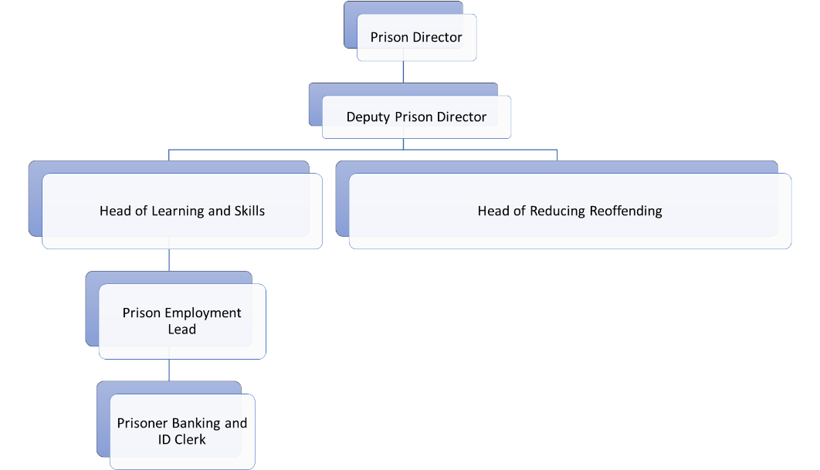

4. Context and main issues – Describe the most difficult types of problems the jobholder has to face (internal or external to Sodexo) and/or the regulations, guidelines, practices that are to be adhered to.
- Administration actions will be completed accurately and in a timely way and will satisfy all appropriate audit requirements.
- Team members will be supported effectively.
- Management information provided accurately and within specified deadlines.
- All records maintained accurately and completed within specified legal requirements where appropriate and in accordance to any prison service order and instructions where applicable
- To work in accordance with all Sodexo policies and procedures

5. Main assignments – Indicate the main activities / duties to be conducted in the job.
The responsibilities of the new, dedicated ID and Banking Administrators will include:

- Helping prepare prisoners to take up Release On Temporary Licence work placements and/or prison leavers take up employment on release. This will include through delivering the Prisoner Banking Programme and ID programme; and supporting colleagues to match job vacancies with potential candidates. Duties will involve:

  - Assessing the need of prisoners who require ID and/or a basic bank account and keeping records as per approved templates.
  - Supporting prisoners with applications via the Prisoner Banking Programme and ID programme. This includes following the relevant procedures, managing enquiries, and acting as the Single Point Of Contact for applicants and programme partners.
  - Seeking out prisoners prior to release to offer the services
  - Using approved templates to maintain financial records as necessary, collect relevant management information and report on these as required.
  - Supporting Prison Employment Leads in their capacity to identify and match candidates to job opportunities.

The duties/responsibilities listed above describe the post as it is at present and is not intended to be exhaustive. The job holder is expected to accept reasonable alterations and additional tasks of a similar level that may be necessary to support this area of work.

6. Accountabilities – Give the 3 to 5 key outputs of the position vis-à-vis the organization; they should focus on end results, not duties or activities.
- Maintain all appropriate records and documentation.
- Assist in the production of management information, regular reports, establish trends and patterns from information received.
- Monitor and oversee all filing and ensure that record systems are kept up-to-date and stored securely.
- Responsible for all administrative duties as required by the Manager, ensuring the function is run efficiently and cost effectively when performing work as required and planned.
- To work closely and co-operate with colleagues in other areas to ensure the safe and smooth running of the prison.

7. Person Specification – Indicate the skills, knowledge and experience that the job holder should require to conduct the role effectively
- Good Communication and Organisational Skills
- Experience working in a similar environment or role
- Able to operate relevant IT applications
- Have good resilience and take full responsibility for planning and outcomes.

8. Competencies – Indicate which of the Sodexo core competencies and any professional competencies that the role requires
- Working with others | - Continuous Improvement
- Planning & Organising | - Results Orientated
- Resilience

9. Management Approval – To be completed by document owner
Version | V.1 | Date | 27/05/2022
Document Owner | Sarah Phillips

