JoB description

Position Title | Mailroom Operative | Department | Business Support Services
Generic Job Title | Mailroom Operative | Segment | Energy and Resources
Team Band | Unbanded | Location | London
Reports to | Mailroom Supervisor | Office / Unit name | Shell Centre London Campus

ORGANISATION StRUCTURE
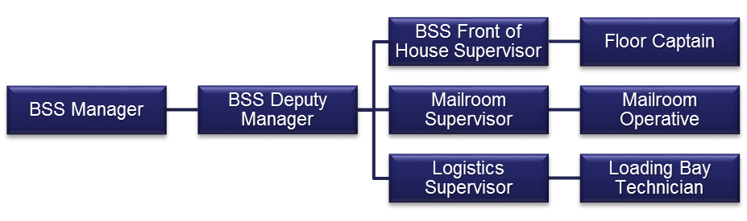

Job Purpose

- To offer a personalised high end service to the Shell Campus staff and their visitors should they require any assistance or any other support.
- The upkeep and maintenance of all mailroom service areas and customer service points to a high standard.
- Work with the BSS opperatives and loading bay and the provide support cover when required.

Accountabilities or “what you have to do”

- The oppertive will be professional at all times when dealing with clients and proactively represent Sodexo on site promoting Excellent Customer Service.
- Ensuring that all HSE policies and regulations are adhered to and ensuring use of safety signs and barriers. Noting and escalation non-compliance as relevant.
- Dealing direct with facility users and resolving any issues efficiently.
- Maintain the upkeep of mailroom service areas and customer service points and liaising with other Sodexo service teams as required
- Ensuring the allocated areas and environments are clean, tidy and presentable at all times.
- Mail sorting and distribution; same day and overnight courier services and any other post services; collection of post and couriered items from relevant areas; stationery supply handling, storing and delivering as required
- Provision of mail, courier services and vcustomer services, assisting BSS and loading bay staff, as appropriate, in sorting mail and identifying recipients.
- Upkeep mail room related equipment.
- Maintain stock levels of stationery in customer service points.
- Maintain stock levels of stationery and packaging in Mailroom areas .
- Overseeing storage and organistion of all items in mailroom areas and customer service points.
- Undertaking and documentation of all maintenance checks
- Complete all records as directed accurately and in timely manner
- Provision of portering service
- Occasional basic cleaning duties and ad hoc day cleaning as an when required
- Ensure that all complaints are dealt with in the correct manner and that the Logistics supervisor is informed immediately should any service complaints be reported.
- Report any incidents of accident, fire, theft, loss, damage, unfit food or other irregularities to line manager, taking appropriate action where possible
- Attend any training and meetings as requested some of which may be outside your normal working hours or at a place which is not your normal place of work
- To cover different shifts and departments where practicable, some which may be short notice
- Cross trained on all aspects of the services Sodexo provides and assisting and being part of the efficient operation of the “One Team” and actively support and promote this ethos, providing internal cover in other departments, taking initiative in colleagues absence from work area and covering when required.
- Ensure that any other reasonable tasks or requests are fulfilled to the appropriate service standards required as and when they arise.

Key Performance Indicators (KPIs) or “What it will look like when you are doing the job well”

- All customer requests and support completed on time
- Any task tickets are attended to and completed within specified SLAs.
- All incoming and outgoing postal services completed within required time frames
- Deliver a consistent level of service, within the Company's standards, to the contract specification and agreed performance, qualitative taargets
- A positive working environment where the ‘One Team’ culture is evident and actively followed
- Work to and comply with all Shell KPIs.

Skills, Knowledge and Experience

Essential
- Mailroom/Loading Bay operations
- Basic Audio visual experience
- Customer service and complaint handling.
- Presentable and personable
- Ability to communicate effectively in a variety of written and verbal formats with a wide range of people.
- Working shifts on a flexible pattern.
- Working accurately, under pressure, to tight deadlines.
- Basic IT skills- Word Processing, Spreadsheets, Databases, Email and Web.

N.B. Operatives will be expected to undertake manual handling duties within their physical capabilities.

Desirable
- Experience of working in an environment where compliance to standards is key

Contextual or other information

Whilst every effort has been made to ensure the details of this job description are correct - due to the varied requirements of the catering and support services industry, this job description cannot be exhaustive. Therefore, the jobholder may be required from time to time to carry out other tasks as required by management in order to meet the operational needs of the business.

