Job Description:
Event Manager

Function: |  |  |  | Sports & Leisure – Major Events
Job: |  |  |  | Operations
Position: |  |  |  | Event Manager
Job holder: |  |  |  | Vacant
Date (in job since): |  |  |  | 5th August 2021
Immediate manager  (N+1 Job title and name): |  |  |  | Head of Events – Julie Bromage
Additional reporting line to:
Position location: |  |  |  | Ascot Racecourse & Various event sites
1. Purpose of the Job – State concisely the aim of the job.
- To lead the operational management of specific major events operated by Sodexo Sports & Leisure.
- To project lead tenders and new business development plans.
- To be confident in building, signing off and over delivering on annual and by event specific budgets.
- To maximise sales opportunities and in turn profitability of specified event accounts.
- To role model, lead and motivate a high performing team in operational excellence and account management.
- To use and drive forward with industry trends and innovative concepts to enhance the product offers across the events business.
- To be the face of Sodexo in client discussions, meetings and decision making.
- To foster deep and meaningful long term relationships with our clients in such a way that contracts are both renewed and our clients cannot see anyone else best placed to manage the contract (Client for life partnership)
- To work with the staffing team to recruit, induct and manage the very best managers and staff for major events within the agreed budget spend.
- To work with the training and staffing team to develop and implement training programmes specific for event sites.
- To foster positive and productive partnerships with key suppliers to deliver reliability, quality and flexibility that aids our ability to stage excellent events.
- To deliver exceptional standards for all events and ensure Sodexo Sports & Leisure are the trusted and capable partner for the clients.
- To actively drive increased employee engagement by role modelling and embedding the Focus on Five behaviours into everyday working practices.
- To support and challenge the operation of an event and the practices to deliver tangible difference both operationally and financially.
- To actively identify risks and take appropriate actions in order to demonstrate the drive to a “zero harm” culture whilst adhering to, maintaining and embedding the requirements of the Corporate Safety and Environmental Management System (SEMS).
- To lead the events business with implementation of policy and procedures specifically related to H&S on event sites

2. Dimensions – Point out the main figures / indicators to give some insight on the “volumes” managed by the position and/or the activity of the Department.
Revenue FY21: | £2m |  | EBIT growth: |  | tbc | Growth type: | n/a | Outsourcing rate: | n/a | Region Workforce | tbc
 |  |  | EBIT margin: |  | tbc
 |  |  | Net income growth: |  | tbc |  |  | Outsourcing growth rate: | n/a | HR in Region | tbc
 |  |  | Cash conversion: |  | tbc
Characteristics |  | - Add point
Draft. Version: 27-03-2014
3. Organisation chart – Indicate schematically the position of the job within the organisation. It is sufficient to indicate one hierarchical level above (including possible functional boss) and, if applicable, one below the position. In the horizontal direction, the other jobs reporting to the same superior should be indicated.
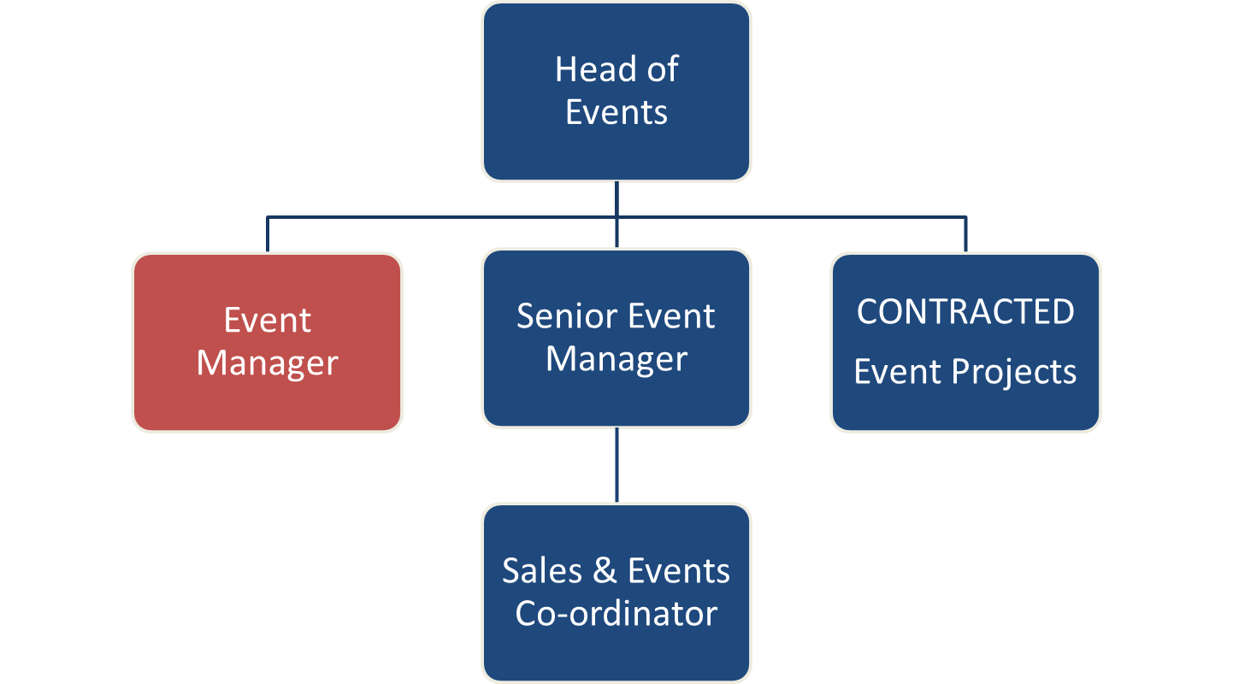

4. Context and main issues – Describe the most difficult types of problems the jobholder has to face (internal or external to Sodexo) and/or the regulations, guidelines, practices that are to be adhered to.
- This job description is intended to give the post holder an appreciation of the role envisaged and the range of duties and responsibilities to be undertaken. It does not attempt to detail every activity. Specific tasks and objectives will be agreed with the post holder at regular intervals. The post holder will be required at all times to perform any other reasonable task, as requested by the Line Manager in order to meet the operational needs of the business.
- The role requires the individual to manage onsite operations at events around the country during peak season. This can include working long hours over consecutive days including weekends
- We may operate over bank holidays.
- Be continually thinking up new ideas and schemes to deliver the best possible service.
- Due to the nature of the role, an appropriate level of confidentiality, performing all duties in a courteous, respectful and professional manner is required.
- To relieve and assist in other establishments in certain circumstances.
- To attend meetings and training courses as requested.
- Management of multi-site operations during peak periods of the year with events running simultaneously

5. Main assignments – Indicate the main activities / duties to be conducted in the job.
- Identify organic growth opportunities through innovation and new initiatives within existing contracts
- Manage clients expectations both internal and external, working with the client and Sodexo teams to design and deliver exceptional catering offers.
- Ensure your account is performing within the agreed SLAs at all times to meet Sodexo commitments
- Take overall responsibility for ensuring that specific accounts are operated within budget.
- Ensure that clients receive best in class service delivered within contractual terms and in a cost effective manner
- Develop and retain existing client relationships through monthly meetings and quarterly reviews, using the full CFL process
- Monitor KPI reporting for your account, reviewing contents of client meetings and delivering actions
- Deliver Clients for Life development plans as necessary for your account
- Oversee recruitment for specified events and ensure the motivation of a strong team supporting creative recruitment methods and incentive schemes.

6. Accountabilities – Give the 3 to 5 key outputs of the position vis-à-vis the organization; they should focus on end results, not duties or activities.
- To Stage Outstanding Events
  - Establish a strong working relationship with all clients, their colleagues and contractor partners.
  - Articulate the client requirements and align these with Sodexo’s financial and operational capabilities and business expectations.
  - Plan and specify operational standards for hospitality, retail and client catering as appropriate.
  - Effectively communicate with all members of the Events Team and other interested parties and provide the, necessary information relating to the event, e.g. start dates, catering offers, logistics and event specific details.
  - To fully understand and be able to communicate the intricate details of each assigned event.
  - Be incredibly organised and pro-active to achieve outstanding performance
  - Manage the on-site operation to the highest possible standards and to the clients’ total satisfaction.
  - Manage change and operational efficiencies whilst driving innovation within the staging and catering offer of each event.
  - Listen to clients and deliver a service solution
  - Adhere to deadlines and wherever possible exceed expectation

- To be Commercially Astute
  - Management of individual account P&L
  - Analyse and report the forecasted event costs, including management, chefs, direct/agency staff, subsistence, transport, accommodation, uniform and expenses for allocated events.
  - Develop and maximise pricing opportunities.
  - Calculate, confirm and report actual event costs, accruing accurate costs for outstanding invoices.
  - Authorise invoices as correct and process to commercial

- To Support and Challenge
  - Lead innovation and explore new and fresh ways of staging the event to drive greater customer service, additional sales, cost reduction and financial gain for Sodexo
  - To be thorough, confident and reasoned to challenge both colleagues and suppliers to ensure the best possible result – operationally and /or financially
  - To support colleagues with their events when required, offer your individual expertise to develop colleagues, un-prompted.
  - Directly support the senior management team with business projects and team development.
- To Role Model (the very best behaviours)
  - Always actively demonstrate the values of Sodexo – Team Spirit, Service Spirit and Spirit of Progress.
  - Promote and practice Sodexo’s commitment to Diversity and Inclusion.
  - Be an approachable and engaging member of the Events Team and as such be the first and most important contact with all those who work with the Events Team (staff, suppliers and clients).
  - Role model the very best staffing and welfare behaviours, even when under operational pressure
  - Work continually to ensure the high consistency and retention of employees for the event season
  - Always look to assist colleagues – both in the Events Team and in the wider Sodexo. This may be within the scope of your role or operationally to ensure the success and business performance of the Events Team.
  - Maintain high standards of appearance and personal effectiveness
  - Demonstrate a proactive attitude to continuous improvement and ensure this is visible with regular meetings to ensure whole team is engaged.
- To Ensure all legislation is adhered to, minimising any risk to Sodexo
  - H&S Ambassador and Event lead for business specific H&S policy and procedures, ensuring implementation across all events sites
  - Adhering to the following legislation within this role and at every event:
    - Health & Safety at Work Act 1974
    - The Food Safety and Hygiene (England) Regulations 2013
    - Licensing Act 2003
  - Accident reporting procedures are adhered to, both correctly and in a timely manner.
  - Provide all staff receive with appropriate health and safety training/briefing prior to the event.

7. Person Specification – Indicate the skills, knowledge and experience that the job holder should require to conduct the role effectively
Essential
- Experience in events, hotels, contract catering (in a food service environment), catering and/or hospitality industry
- Good understanding of budget management and good numeracy skills
- Excellent interpersonal, communication and organizational skills.
- Ability to negotiate, work with flexible schedule and changing priorities is essential
- Proficient with MS Word, Excel and Outlook
- Proven track record in operational management in a similar environment
- Achieve set, standards and operate to performance criteria; for example health and safety, hygiene
- Experience in training casual floor staff to a 5* service standard
- Excellent communication skills
- Self-motivated and able to work on own initiative within a team environment
- Ability to interpret and utilise financial and commercial information
Desirable
- Bachelor's Degree in Business Related field or equivalent experience
- Personal Licence (for sale of alcohol)
- First Aid Certificate
- Basic (or Advanced) Food Hygiene Certificate
- Full Driving Licence
- H&S Certification – IOSH or similar

8. Competencies – Indicate which of the Sodexo core competencies and any professional competencies that the role requires
- Client Growth and Customer Satisfaction | - Innovation and Change
- Rigorous Management of Results | - Brand Notoriety
- Leadership and People Management | - Planning and Organising
- Analysis and Decision Making | - World Class Service
- Industry Acumen

9. Management Approval – To be completed by document owner
Version | V1 | Date | 03/08/21
Document Owner | Julie Bromage

