on-site services
JoB description

Employee |  | Department | Hospitality
Generic Job Title | Hospitality Service Coordinator | Segment | Universities
Team Band | Un banded | Location | University College London
Reports to | Assistant Hospitality Managers | Office / Unit name

ORGANISATION StRUCTURE
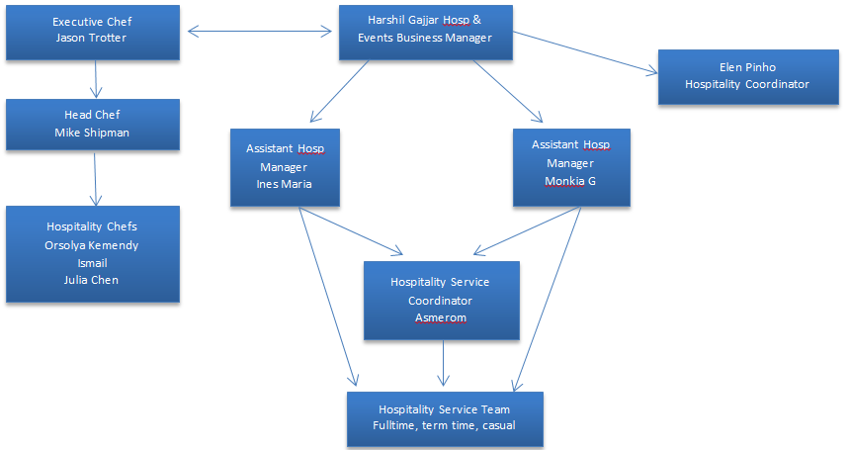

Job Purpose
- To deliver a World Class Service to our client and customers in line with our Standard Operating Procedures and promote our Brand through excellent customer service.

Accountabilities or “what you have to do”
- To be efficient and organized, and should treat customer service and customer care as a priority
- To ensure all hospitality services are efficiently served and delivered within the agreed time scales
- To respect customers and their confidentiality at all times including collections.
- Comply with all Company and Client policies and procedures, statutory regulations relating to your work place, this will include but is not limited to Fire Safety; Health & Safety; Personal Hygiene; Working Safely; Manual Handling, Food Safety and COSHH.
- Ensure the safety and security of company and client property and money.
- To ensure and check all service equipment and furniture is clean, undamaged and ready for service.
- Assign, manage and assist with daily delivery allocations.
- Assist when necessary in ordering stock, stock takes and receiving the deliveries & returns including any breakages, etc.
- Assist/act as gatekeeper in recording all delivered services and collection items.
- Be fully accountable for, control and supervise Hospitality stock using the FIFO principal.
- Complete accurate consumption sheets, hospitality delivery allocation & collections, stock take records in a timely manner.
- Be flexible and able to work different shift patterns and in different locations
- Follow closing procedures to ensure Hospitality area is clean and tidy before the end of business day.
- Promote good team work and work in a friendly, efficient manner. Actively take part and host briefings, Team Huddles & monthly team meetings.
- Identify areas for improvement and potential for new business.
- Ensure that all equipment used is in safe working order, checked regularly and any faults reported to management, ensure equipment is not used until safe.

Site specific duties
- Ensure that all catering offerings and delivery services are to service standards agreed in the client’s contract/ Banquet Event Order.
- Deputize in the absence of the Assistant Hospitality Managers when required to lead Hospitality functions & events in all areas of UCL estate.
- Follow the company’s Health & Safety regulations including COSHH and licensing laws at all times.

Key Performance Indicators (KPIs) or “What it will look like when you are doing the job well”
- Catering and food service within UCL Kitchens delivered consistently and within the Company's.
- Standards, to the contract specification and agreed performance targets, both qualitative and financial.
- Positive feedback from customers, colleagues and key stakeholders.
- Cleaning schedules completed and duties performed correctly, safely and to the required standards.

Skills, Knowledge and Experience
- An interest in own self-development with previous experience in conferencing, hotels and events.
- Personal license holder
- Full UK driving license
- Complaint Handling
- Good level of communication and spoken/written English
- Strong levels of personal hygiene and presentation
- Experience of working in a team & of being a “team player”
- Basic food hygiene qualification
- Basic Health and Safety qualification
- COSHH knowledge

Contextual or other information
- Flexibility in hours worked would within the original contract of work be required as some business need may be outside of normal / routine working hours.
- Weekend work is not the norm.
- Bank Holidays are not usually working days
Version | 1.3 | Date | 15.03.2018
Document owner | Jason Trotter / Neil Whittle

