Job Description:
Regional Engineer / Surveyor

Function: |  |  |  | Regional Engineer / Surveyor
Job: |  |  |  | Regional Engineer / Surveyor
Position: |  |  |  | Regional Engineer / Surveyor
Job holder: |  |  |  | Ian Thomas
Date (in job since): |  |  |  | April 2018
Immediate manager  (N+1 Job title and name): |  |  |  | Senior Building Surveyor – Glen Keeble
Additional reporting line to:
Position location: |  |  |  | Home Worker
1. Purpose of the Job – State concisely the aim of the job.
- To undertake structured surveys of the client’s property estate and to accurately and concisely record and budget proposed asset replacement for future years for each element within both an individual property and at property portfolio level.
- To develop lifecycle plans for each property within the regional portfolio in accordance with ISO 55000
- To provide technical and financial advice to both the client and the internal teams to allow decision making to take place on an informed basis
- To be the lead for Asset within the specified Region
- To report on Asset function, progress and strategy at Regional Governance meetings
- To undertake reports on behalf of the Asset Management team on an Ad Hoc basis
- Attend handover meeting on projects of significant investment or technical complexity
- Asset capture and future lifecycle investment on new acquisition properties
- Review and production of mini business cases for emerging / unplanned projects within lifecycle delivery year not previously planned for
- Ensure all data delivered meets the requirement of the client(s) both internal and external
- Inspection and report of statutory certification as part of due diligence
- The candidate will be multi skilled and have a core competency in either building surveying or M & E but will be expected to have a good knowledge of the complimentary building services or fabric
- Extensive awareness of legislative requirements in respect of building services installations
- Experience within a property environment

2. Dimensions – Point out the main figures / indicators to give some insight on the “volumes” managed by the position and/or the activity of the Department.
Revenue FY13: | €tbc |  | EBIT growth: |  | tbc | Growth type: | n/a | Outsourcing rate: | n/a | Region Workforce | tbc
 |  |  | EBIT margin: |  | tbc
 |  |  | Net income growth: |  | tbc |  |  | Outsourcing growth rate: | n/a | HR in Region | tbc
 |  |  | Cash conversion: |  | tbc
Characteristics |  | - Add point

Draft. Version: 27-03-2014
3. Organisation chart – Indicate schematically the position of the job within the organisation. It is sufficient to indicate one hierarchical level above (including possible functional boss) and, if applicable, one below the position. In the horizontal direction, the other jobs reporting to the same superior should be indicated.
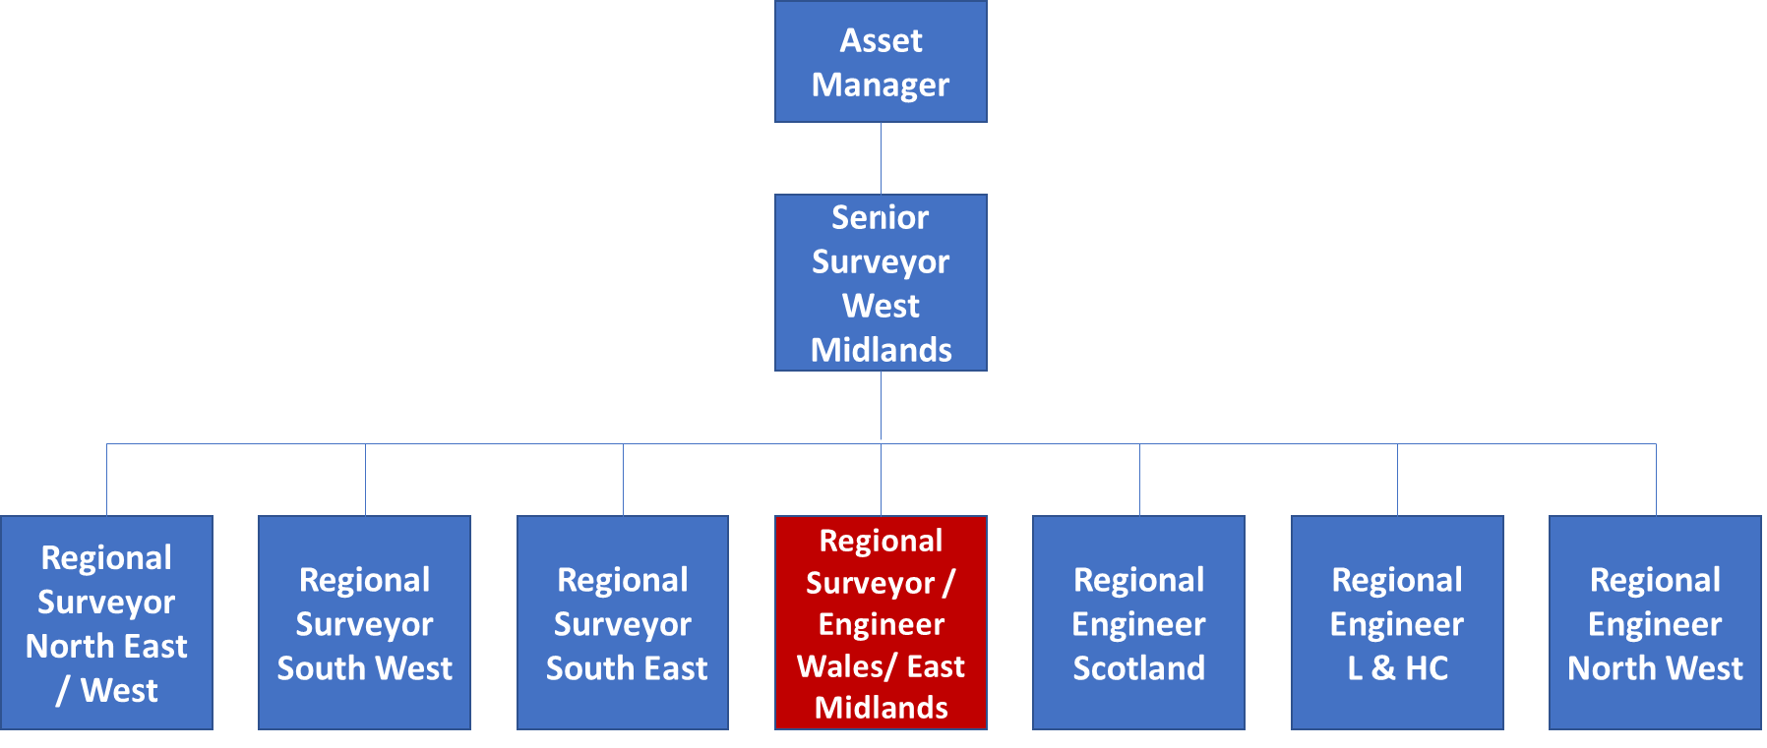

4. Context and main issues – Describe the most difficult types of problems the jobholder has to face (internal or external to Sodexo) and/or the regulations, guidelines, practices that are to be adhered to.
- Time Management – there will be pressures from more than one side of the business which need to be assessed and dealt with accordingly and therefore the candidate needs to be flexible in their approach
- Finance – limited budgets mean that not all asset replacement will be possible as planned so the Engineer / Surveyor shall have to risk assess each proposed replacement and prioritise
- Project delivery – whilst not directly involved the surveyor needs to be cognizant of ongoing projects which will affect the planning activity
- Client Management – the candidate will have direct interaction with the client must be able to communicate effectively, whilst maintaining the core activity objectives

5. Main assignments – Indicate the main activities / duties to be conducted in the job.
- Surveying of DWP Estate
- Accurate budgeting and alignment of asset within plans
- Production of a three-year lifecycle plan
- Provide Technical Support to the client and the internal teams
- Ad hoc requests which can vary from production of high quality reports to attending sites to offer advice to the Field Team
- Attend handover meeting on projects of significant investment or technical complexity

6. Accountabilities – Give the 3 to 5 key outputs of the position vis-à-vis the organization; they should focus on end results, not duties or activities.
- Programming of Annual Survey Programme
- Completion of Annual Survey Programme
- Auditor completion and upload
- Reports & recommendations to other teams within Sodexo in an non-technical format
- Completion of unplanned business cases
- Review of proposed Asset Replacement via IFM Reactive Works

7. Person Specification – Indicate the skills, knowledge and experience that the job holder should require to conduct the role effectively
- Graduate calibre, with degree in M & E discipline or Building Surveying
- The candidate will be multi skilled and have a core competency in either building surveying or M & E but will be expected to have a good knowledge of the complimentary building services or fabric
- Experience and knowledge of lifecycle planning / ISO 55000.
- Membership of a professional body or be working towards accreditation
- Geographically mobile / Driving license
- IT literate – experience of using MS Office
- Familiar with ISO55000/550001
- Ability to communicate with all levels of client management
- Attention to detail, quality driven approach
- Work on own initiative and manage own time
- Working individually and part of a wider team
- The region is based in Wales and the West midlands so the candidate should be geographically aligned to these areas

8. Competencies – Indicate which of the Sodexo core competencies and any professional competencies that the role requires
  - Growth, Client & Customer Satisfaction / Quality of Services provided
  - Rigorous management of results
  - Brand Notoriety
  - Leadership & People Management
  - Innovation and Change
  - Commercial Awareness

9. Management Approval – To be completed by document owner
Version | 1.00 | Date | 15/3/2019
Document Owner | Ian Tulleth

