



**EXPERTISE**

**JOB DESCRIPTION**

|  |  |
| --- | --- |
| Function: | Artworking |
| Position: | **ARTWORKER** |
| Job holder: |  |
| Date (in job since): |  |
| Immediate manager  (N+1 Job title and name): | Candice-Lee Devenish, Senior Graphic Designer (Food) |
| Additional reporting line to: | Creative Team Lead |
| Position location: | Remote working |

|  |
| --- |
| **1. Purpose of the Job** – State concisely the aim of the job**.** |
| * Responsible for supporting the Food Platform creative team, within SOCreative, on the delivery of brand refresh work and campaigns through preparing, producing, and reviewing quality artwork and design. * Work closely with graphic designers and leads to format and prepare POS material and layouts for production across a range of format deliverables in chosen media to meet tight deadlines. * Perform retouching, typesetting and formatting tasks, along with taking on artwork updates and amends. * Management and maintenance of image library |

|  |  |  |  |  |  |  |  |  |  |
| --- | --- | --- | --- | --- | --- | --- | --- | --- | --- |
| **2. Dimensions** – Point out the main figures / indicators to give some insight on the “volumes” managed by the position and/or the activity of the Department. | | | | | | | | | |
|  |  | EBIT growth: | tbc |  |  | Outsourcing rate: | n/a | Region Workforce | tbc |
| Revenue FY13: | €tbc | EBIT margin: | tbc | Growth type: | n/a |
| Net income growth: | tbc | Outsourcing growth rate: | n/a | HR in Region | tbc |
|  |  | Cash conversion: | tbc |  |  |
| Characteristics | | * Flexible to work outside of normal working hours on weekdays when required * Growth: support the increase and growth rate of the business by 50% | | | | | | | |

**3. Organisation chart** – Indicate schematically the position of the job within the organisation. It is sufficient to indicate one hierarchical level above (including possible functional boss) and, if applicable, one below the position. In the horizontal direction, the other jobs reporting to the same superior should be indicated. Please show the job titles not the actual people doing the role, i.e. Finance Manager, Project Manager

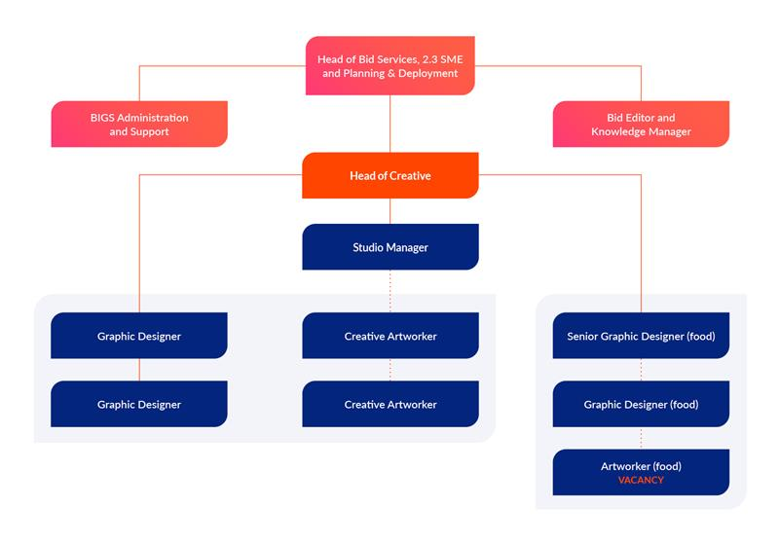

|  |
| --- |
| **4. Context and main issues** – Describe the most difficult types of problems the jobholder has to face (internal or external to Sodexo) and/or the regulations, guidelines, practices that are to be adhered to. |
| * Ability to understand and translate creative ideas to high quality visual and creative solutions for inclusion in campaigns / brand documents / collateral / presentations / specified formats and POS for print and digital. * Manage time booked in to ensure deadlines are met and adherence to studio processes with open and transparent communication * Close attention to detail and version control of proofs of proposals, ideation documents and presentations * Support for collating and formatting “off the shelf” brand and design responses using various research capabilities and tailoring to Food Platform and client requirements * Maintain and update the image library for both print and digital assets * Maintain relations with internal and external print and digital suppliers |

|  |
| --- |
| **5. Main assignments** – Indicate the main activities / duties to be conducted in the job. |
| * Read and understand brand guides and documentation * Support the review process prior to completion/deadlines to ensure a complete and high-quality final solution is delivered * Provide technical artworking and print production support to the Food Platform team and stakeholders following discussions with the graphic designer(s) * Support the creative, visual and artwork development of FP design solutions, with guidance from both the Senior Creative and Graphic Designer(s) * Close liaison with internal stakeholders to ensure all information is accurate * Identify and implement process improvements * Support and help facilitate workshops with the Senior Creative to develop win themes, story boards and document structure that help the team to produce clear, consistent and complete collateral * Ensure design and artworked documents are printed/uploaded to the agreed quality and timescales * Develop and maintain Food Platform’s branding and creative design templates/collateral in line with the specific food branding or the agreed format with the Senior Creative and in conjunction with the graphic designer(s) * Manage collaborative workspace * Work with the Senior Creative and Food Platform team to ensure continuous refreshment of the food brands library of design work, with the latest content and examples of best practice * Work as required with the Senior Creative and/or Creative Lead to support the team with completing projects that may sit outside the defined role |

|  |
| --- |
| **6. Accountabilities** – Give the 3 to 5 key outputs of the position vis-à-vis the organization; they should focus on end results, not duties or activities. |
| * Formatting and typesetting of designed artwork to a high standard ready for presentation or production * Ensure design visuals / artwork / documents are amended and retouched ready for print or upload, to the agreed quality and timescales, and support on presentations as needed * Supporting Food Platform and the FP creative team on digital platforms to keep content and library current |

|  |
| --- |
| **7. Person Specification** – Indicate the skills, knowledge and experience that the job holder should require to conduct the role effectively |
| * Experience in working with senior management to manage delivery of timelines and outputs * Experience of working in a creative agency and corporate/business focused environment * Proven track record of successfully delivering multiple projects on time * A minimum of 1 year relevant professional experience in supporting business development * Proven capacity to effectively work within parameters of brand guides and processes * Demonstrated achievement in the production of mood boards, presentations and marketing collateral * Strong organisational skills and ability to manage small to medium sized projects, precise scheduling and multiple and shifting priorities. * Excellent proficiency in the Adobe CC suite of packages, specifically InDesign, Illustrator, Photoshop and Acrobat, and very good working knowledge of MS Office (e.g. Word and PowerPoint) * A keen eye for design and attention to detail are a must * Skills and knowledge in Illustration, Animation, Video, Digital and 3D design are desired but not essential |

**8. Competencies** – Indicate which of the Sodexo core competencies and any professional competencies that the role requires

|  |  |
| --- | --- |
| * Growth, Client & Customer Satisfaction / Quality of Services provided | * Employee Engagement |
| * Brand Notoriety | * Learning & Development |
|  |  |

**9. Management approval** – To be completed by document owner.

|  |  |  |  |  |  |
| --- | --- | --- | --- | --- | --- |
|  | Version | 1.0 | Date | 13/01/23 |  |
|  | Document owner | Food Platform Director | | |  |