Job Description:
Night Porter

Function: |  | Security Officer
Position: |  | Night Porter (Security Officer)
Job holder:
Date (in job since):
Immediate manager  (N+1 Job title and name): |  | Chyna Vesey – General Manager
Additional reporting line to: |  | David Fordyce – Account Manager
Position location: |  | Riverside Student Quarter, Canterbury
1. Purpose of the Job – State concisely the aim of the job.
Part of a team that provides a secure and safe environment for residents staff and general public, a central contact for resident enquiries, post and parcel collection, arrival and departure, log and where appropriate attend to soft maintenance requests, key control, grounds maintenance, cleaning and first line emergency response. Post holder must hold a valid front line Security Guard SIA License.

2. Dimensions – Point out the main figures / indicators to give some insight on the “volumes” managed by the position and/or the activity of the Department.
Expectations | Safe and Secure Site |  |  | Activity | Secure property | Customer Service
 | Excellent standard of cleanliness
 | Well-ordered site |  |  |  | Team working | Health and Safety
Draft. Version: 27-03-2014
3. Organisation chart – Indicate schematically the position of the job within the organisation. It is sufficient to indicate one hierarchical level above (including possible functional boss) and, if applicable, one below the position. In the horizontal direction, the other jobs reporting to the same superior should be indicated.
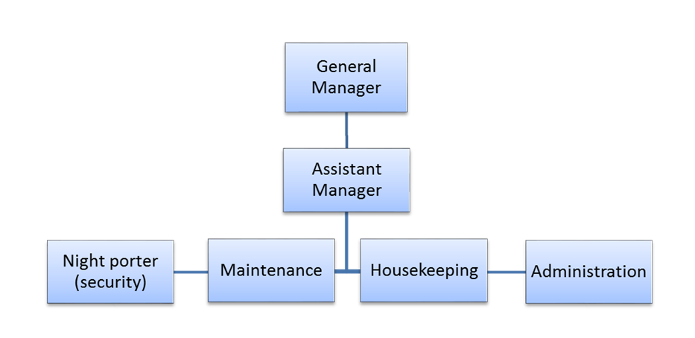

4. Context and main issues – Describe the most difficult types of problems the jobholder has to face (internal or external to Sodexo) and/or the regulations, guidelines, practices that are to be adhered to.
- To present a smart, calm and courteous response to reception and general enquires.
- Maintains the property safe and secure through managing access control.
- Carry’s out routine patrols on foot and via CCTV to ensure the safety of the property and its users.
- To maintain the tidiness of the general site areas and to maintain the site in a clean and tidy state.
- Carry’s out cleaning tasks, daily, weekly, periodic and one off tasks to the standard detailed within the cleaning standards manual.
- To maintain/stock and control issue and use of cleaning materials and equipment.
- To have a good working knowledge of all buildings on site.
- To liaise with and assist Facilities Technician / Accommodation staff as required.

Accurately maintain customer information / database and provide customer information/ database information to support the Accommodation Assistants.

Deal with all arrivals and departures, students and summer business.
- Control and issue of keys.
- To issue mail and parcels to agreed procedures.
- To answer telephone enquiries and take messages as required.
- To maintain resident, staff and client confidentiality.
- Act as first aid point. (after training)
- Respond to Emergency situations and to Fire alarms and liaise with emergency services as required.
- Attend all incidents and occurrences as required.
- Where appropriate works to and complies with “lone workers” standards of operation

Planning and Organising
- Manage workload in line with customer needs and management targets.
- Works in an organised manner, within health and safety guidelines

Training
- Attend all nominated training courses, both in-house and external to meet the development needs of the post and post holder

Health and Safety
- Maintains strict controls on hazardous materials, in storage and in-use, observes all COSHH regulations and manufacturer’s instructions.
- Ensures that energy, resources and equipment are used in a correct, safe and economical manner in accordance with Company policies and legal requirements.
- Ensures that all accidents and near misses are recorded appropriately.
- Ensure all fire activations and routine checks are recorded appropriately.

Problem Solving
- Reacting positively to requests for assistance including critical and all urgent issues with or without input from others
- Is able to prioritise requests for assistance in order to maintain a safe, sound and secure property

Decision Making
- Use discretion when dealing with fellow tenants
- Decision making within the parameters laid out by the General Manager

Key Performance Indicators or “What it will look like when you are doing the job well”
- Good team worker
- Effective communicator
- Site is maintained clean, safe and secure
- Cleaning schedule is up to date and cleaning is to the required standard
- Site is free from rubbish / graffiti
- Refuse collection is well managed to maximise recycling and minimise financial impact
- Compliance with Sodexo policies and procedures
- Monitoring is effective in minimising tenant damage and recovering costs

5. Main assignments – Indicate the main activities / duties to be conducted in the job.
- Site is Secure
- Standard of Cleanliness
- Health and Safety
- Customer Service
- Team working
- Attention to detail

6. Accountabilities – Give the 3 to 5 key outputs of the position vis-à-vis the organization; they should focus on end results, not duties or activities.
- Safe and Clean Property
- Happy tenants
- Re-booking rates are as expected

7. Person Specification – Indicate the skills, knowledge and experience that the job holder should require to conduct the role effectively
Essential

- SIA License
- Cleaning Experience
- Good Communication Skills

Desirable
- COSHH training
- H&S Training

