Function: |  | Sodexo Live!
Position: |  | EVENT LEAD CHEF
Job holder:
Date (in job since):
Immediate manager  (N+1 Job title and name): |  | Head of Events London (James Hurworth)
Additional reporting line to: |  | Regional Operations Manager (Alessandro Soro)
Position location: |  | London – Royal Academy of Arts
1. Purpose of the Job – State concisely the aim of the job.
- To deliver the culinary and food safety elements for the London business including client tastings, chef briefings, food safety compliance and operational standards and event delivery
- To ensure the timely and efficient preparation and service of all food offers to Sodexo Live! and the
- clients’ satisfaction
- To demonstrate an exceptional culinary skill set, have the ability to manage junior members of the team and ensure that all the kitchen daily duties are carried out
- To plan, execute and monitor exceptional Food Safety and Health and Safety standards across the London business.
- To carry out any other reasonable tasks as directed by your line manager or any senior member of the craft team. This can include supporting events within Cultural Destinations

2. Dimensions – Point out the main figures / indicators to give some insight on the “volumes” managed by the position and/or the activity of the Department.
Characteristics | Financial Purchasing spend is controlled by the Head of Events HPL alongside the Commercial Manager  Staff Offer delivery is primarily supported by the on-site team plus casual workforce.  Other Purchasing of products only from Sodexo nominated suppliers

Draft. Version: 27-03-2014

Job Description:

3. Organization chart – Indicate schematically the position of the job within the organization. It is sufficient to indicate one hierarchical level above (including possible functional boss) and, if applicable, one below the position. In the horizontal direction, the other jobs reporting to the same superior should be indicated.
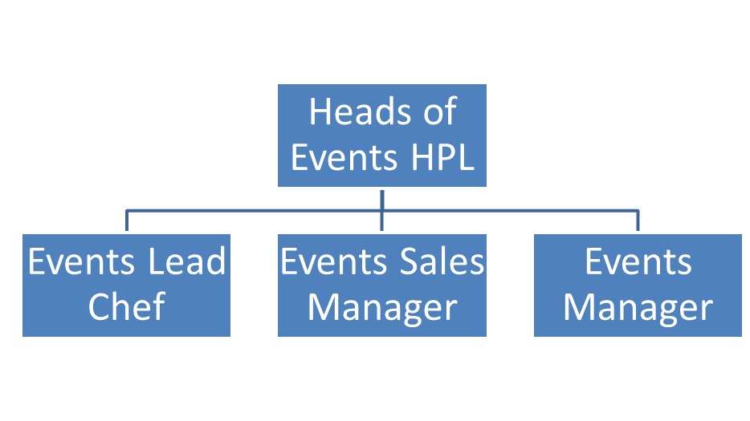

4. Context and main issues – Describe the most difficult types of problems the jobholder has to face (internal or external to Sodexo) and/or the regulations, guidelines, practices that are to be adhered to.
- Management of casual workforce
- Diverse client base, multiple offers running simultaneously
- Quality and consistency
- Time management during peak season, April, May, June, July – September, October, November, December
- Onsite and offsite logistics
- Innovation, offer delivery, management of client expectation
- Cost/overhead management

5. Main assignments – Indicate the main activities / duties to be conducted in the job.
- To understand and demonstrate the vision of the Sodexo Live – Heritage Portfolio
- To ensure all menus are photographed and specified to achieve consistency in event delivery
- To be part of the menu design process and support innovation that drives positive PR, positive client feedback, increased revenues or win new business
- To support the offers development for all the London venues when no events are scheduled
- To articulate the service offers for each event - the food element, the equipment, the flow and the customer experience
- To cost each menu and always work within the financial parameters of the business.
- To operationally lead at client tastings and be able to speak passionately about each dish
- To be highly organised in kitchen management on a day-to-day basis. The role is mainly kitchen based but may require a small amount of office-based work.
- To manage all casual labour in the kitchen operation
- To ensure that all food is prepared with due care and attention, particularly in regard to customers’ special dietary requirements and in line with allergen legislation
- To follow Sodexo and any client site waste streaming and recycling policies and objectives.
- Manage the ordering process for all areas of the business that you are responsible for to ensure that it meets specifications of the service offer, agreed budget for the event and minimising wastage through production and delivery. Procedures for this are set out in the managing basics system.
- To support, and work in conjunction with, the event managers both at SQ and on location, and to build positive, mutually beneficial relationships within the business
- Ensure that all correct procedures for accountancy, documentation and administration are adhered to on a weekly and monthly basis
- To comply with all company and client policies, procedures and statutory regulations including
- Human Resources, site rules, Food Safety, Health & Safety, safe working practices, hygiene, cleanliness, fire and COSHH. This will include your awareness of any specific hazards in your workplace
- To Participate in any necessary training and team meetings as required to complete job responsibilities
- To liaise with and work in partnership with Safegard to always achieve the highest levels of compliance. Such compliance is not only safe; this is a key unique selling point for our clients and a reason for them to choose Sodexo
- Report immediately any incidents or accidents, fire, theft, loss, damage, unfit food, or other
irregularities and take such action as may be appropriate
- To carry out any other reasonable tasks as directed by any senior member of the PVE craft Team

6. Accountabilities – Give the 3 to 5 key outputs of the position vis-à-vis the organization; they should focus on end results, not duties or activities.
- Both client and customer feedback consistently score the food as excellent
- Menu specifications are detailed and trained ensuring delivery of a consistent level of service, within the Company's standards, to the contract specification, service offer and agreed performance, qualitative and financial targets
- Compliance to company and statutory regulations relating to safe systems of work, health & safety, hygiene, cleanliness, fire and COSHH
- Training and development of the team is given a focus for performance, engagement and retention
- Green Safegard audit scores are achieved across the site.
- Labour costs and food cost of sale are within agreed parameters to be set on a monthly basis

7. Person Specification – Indicate the skills, knowledge and experience that the job holder should require to conduct the role effectively
Essential
- Demonstrable experience in a high-volume environment – major events or banqueting operation
- Fine Dining background gained in hotels, restaurants or contract catering
- A passionate interest in the catering industry – knowledge of current trends, well read, eats out in interesting restaurants on a regular basis, talks about and gets excited about food
- A competent communicator and ability to present to colleagues, peers and clients
- Financial awareness and understanding of a food profit and loss account and articulate how to
- control food cost and generate a positive food margin
- Evidence of being organised and possess excellent planning skills
- An intermediate level Food Hygiene qualification
- Ability to competently use Microsoft Word, Excel, PowerPoint and Email
- Proven ability to manage and lead a team of chefs

Desirable
- Supervising Food Safely Level 3 qualification
- IOSH Managing Safely or similar qualification
- Previous Sous Chef role or Head chef in a smaller operation
- Experience in the delivery of retail food operations
- Production kitchen knowledge and/or experience
- Experience of working with clients in a contract catering environment
  - Staff training experience or qualification

8. Management Approval – To be completed by document owner
Version | 1 | Date | 30/06/2025
Document Owner | Alessandro Soro

9. Employee Approval – To be completed by employee
Employee Name |  | Date

