Job Description

Function: | Energy and Sustainability Services – Tech and Services
Position: | Remote Monitoring and BEMS Engineer
Job holder: | Vacancy
Date (in job since):
Immediate manager  (N+1 Job title and name): | Zoe Lang, Head of Energy and Sustainability Services
Additional reporting line to:
Position location: | Remote working with site visits throughout the UK and Ireland

1. Purpose of the Job – State concisely the aim of the job.
Utilising technical understanding of BEMS controls and HVAC systems to recommend ways to optimise the plant and equipment and provide scoping documents for BeMS improvement and upgrade projects. Expand the ‘remote monitoring’ offering across our client sites through working with our sales teams, Technical Directors and Account Managers.

5. 2. Main assignments – Indicate the main activities / duties to be conducted in the job.
- Apply technical understanding of BEMS controls and HVAC systems to recommend ways to optimise the plant and equipment and provide scoping documents for BEMS improvement and upgrade projects.
- Expand the ‘remote monitoring’ offering across our client sites through working with our sales teams, Technical Directors and Account Managers.
- Awareness of and support with achieving client and Sodexo net zero carbon commitments.
- Influencing site teams to maintain and manage sites efficiently (through BEMS and HVAC control / maintenance).
- Managing stakeholders throughout project delivery to achieve expected results.
- Applying knowledge of BEMS manufacturer and model nuances as well as latest updates and future changes to support our sites and clients to manage and maintain their BEMS in a way that will help optimise sites.
- Support the deployment of Sodexo’s selected Energy Management Platform to establish real-time monitoring and improve energy management and remote monitoring services.
- Oversee the IoT sensor technology deployment and establish remote connectivity to support the remote monitoring offering.
- Complete sub-metering surveys, provide metering strategies and support through the implementation of metering upgrades.
- Oversee the EV Charge Point partner engagements from an operational perspective from initial survey, installation, through to ongoing maintenance and ‘back end’ platform management.
- Support with the delivery of ESOS energy surveys.

2. 3. Context and main issues – Describe the most difficult types of problems the jobholder must face (internal or external to Sodexo) and/or the regulations, guidelines, practices that are to be adhered to.
- Sodexo’s clients have set net zero carbon ambitions and targets and seeking support with creating calculated routes to achieving their targets through identifying realistic and feasible technologies and associated timescales and budget.
- Sodexo’s Energy and Sustainability Services team provides professional services to account teams and clients across our business segments to identify energy and carbon reduction opportunities and ensure compliance with related energy regulations.
- Sodexo has ambitious net zero carbon commitments including carbon reduction at our client sites (calculated as part of Sodexo’s scope 3 carbon emissions) and we must therefore support Sodexo’s operational teams and clients reduce carbon emissions.
- Sodexo has ambitious growth targets and through identifying and implementing energy projects can increase business revenue whilst assisting clients on their net zero carbon journeys.

4. Accountabilities – Give the 3 to 5 key outputs of the position vis-à-vis the organization; they should focus on end results, not duties or activities.
- Increasing BEMS upgrades and optimisation projects to improve control and reduce energy/carbon.
- Metering strategies and projects.
- Developing and rolling-out the remote monitoring service offering
- Agreement and recovery of internal recharges for your time and services provided to account teams and clients.

2. 5. Dimensions – Point out the main figures / indicators to give some insight on the “volumes” managed by the position and/or the activity of the Department.
- Member of Sodexo’s central Energy and Sustainability Services team supporting the various business segments and leading with carbon reduction activity; working closely with the team’s energy analysts, Sodexo’s central Command Centre, technical managers and wider energy management professional family.
- Possibility of a line-report as the team evolves.

6. Job profile – Describe the qualifications (Education & experience), competencies and skills needed to succeed in the position.
- Degree in a relevant subject or equivalent qualification by experience.
- Professional membership of relevant institution (e.g. Energy Institute, IEMA, CIBSE, EMA, AEE).
- BEMS engineering experience.
- Metering and sub-metering experience.
- IoT sensor and platform experience
- Familiarity with Building Regulation sub-metering requirements and technical guidance documents (TM39)
- Familiarity with associated BREEAM credits
- Knowledge and experience of EV charge point installation, maintenance and operations
- Understanding of ISO 50001 Energy Management Systems
- CIBSE Low Carbon Assessor or equivalent
- Experience of sustainability related legislative requirements (e.g. ESOS)
- Good understanding of sustainability related legislative requirements (e.g. TM44s, MEES, Energy Performance Certificates, Display Energy Certificates, related Irish statues)
- Experience of optimising energy and water assets.
- Technical knowledge and understanding of HVAC and BEMS building services and systems.
- Good understanding of managing utility data, energy monitoring and targeting, forecasting, measurement and verification and carbon reporting and accounting.
- Experience of using energy, carbon and utilities management platforms.
- Knowledge of standards such as NABERS UK ratings, LEED rating system, WELL Building Standard, ISO 14001 Environmental Management System.
- Strong customer relationship skills.
- Good influencing and communication skills.
- Financial and business awareness.
- Ability to write recommendation reports to suit varying audiences (technical and non-technical).
- Ability to work both with others as part of a team and also independently.
- Takes accountability and responsibility for delivering required results.
- Competent with MS 365 (Word, Excel, PowerPoint, Outlook, Teams, SharePoint).
- Ability to prioritise own workload with minimal supervision and use of own initiative.
- Evidence of delivering innovation and engaging positively with continuous change and improvement.
- Experience of facilities management and/or CAFM systems.

2. 7. Organisation chart – Indicate schematically the position of the job within the organization. It is sufficient to indicate one hierarchical level above (including possible functional boss) and, if applicable, one below the position. In the horizontal direction, the other jobs reporting to the same superior should be indicated.
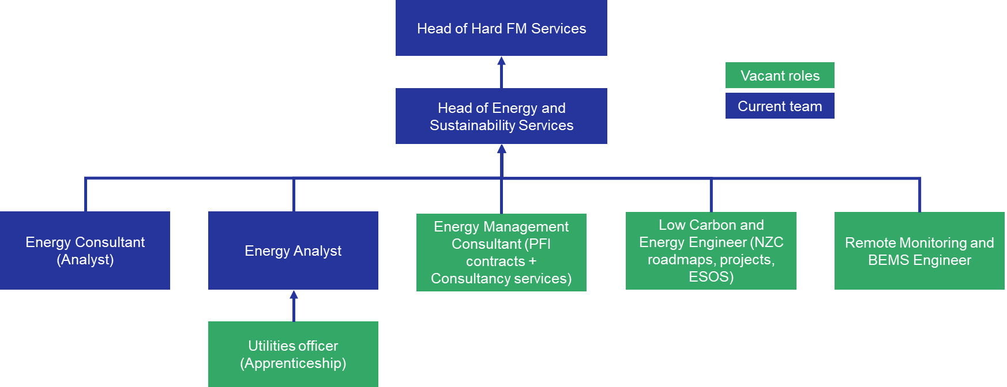

Levels

Received:

Date: Date: 14/08/2023

__________________________________ ________________________________
Zoe Lang
Job holder Immediate Manager

