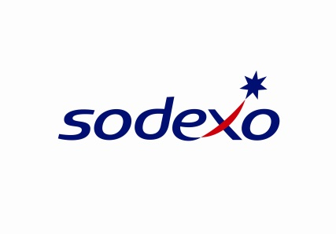

February 2020

**Captive & Insurance Manager – Dublin -** [**https://www.sodexo.com**](https://www.sodexo.com)

As part of Group Finance, the Group Insurance Department is continuously enhancing the insurance coverages across the entire company in order to mitigate existing and future risks and to assist operations in developing business in new services and/or new geographical areas for our On Site Services, Benefits and Rewards Services and Personal and Home Services.

**The role**

Within the Group Insurance Department, the Captive & Insurance Manager is responsible for

handling the insurance policies that are managed through Sofinsod Insurance dac (the “captive”)

as well as supervising the Nordics, Central Europe, Med areas for their assets and interests as

well as the insurance covering its customers or third party or any risk that need to be insured.

Key responsibilities include but are not limited to, the following:

**As Captive Manager, you will:**

* Manage the following group insurance programs: Property, Marine-Cargo & Motor insurance:
* Policy renewals for all lines of coverage including insurer/brokers meetings, collection, aggregation, and collation of all underwriting data, preparation and submission of applications and all supporting documents, negotiation of terms, limits, retentions and pricing, policy issuance and review, and premium invoicing payment and allocation. Verify accuracy of insurance policies and endorsements; follows up with brokers, as necessary, for policies and endorsements
* Claims management including, claims reporting, third party administrator, broker, captive manager and insurer contact and coordination, claims oversight, claims meetings and reviews, litigation support, reserve management, settlement negotiations and authorizations, and claims
* Manage third party administrators and insurance broker relationships and performance
  + - Prepare Board meetings (2 times per year) including financial report analysis and claims trend analysis
    - Perform pricing/funding analyses, valuation of liabilities, captive feasibility, and risk retention optimization

**As an Insurance manager, you will:**

* Support the entities within your geographical scope, including reviewing and advising on various day-to-day issues and concerns involving insurance coverages, claims, certificates of insurance, and policies, programs and procedures.
* Risk assessment, which involves analyzing risks as well as identifying, describing and estimating the risks affecting the business, minimize risk of financial loss
* Providing support, education and training to staff to build risk awareness within the organization
* Create and modify procedures and documents related to insurance policies
* Manage insurance data, claims statistics, administrate the insurance IT tool and ensure insurance reports’ reliability
* Perform insurance acquisition and due diligence analysis

**Skills**

* Demonstrated listening and problem-solving skills, Hands-on orientation.
* Expert understanding of insurance coverage (Policies, Claims Management, etc.); solid understanding of all policy language and coverages
* Strong communication skills
* Good financial data management skills.
* Autonomous.
* Good negotiation skills
* Fluent English is required.

**Education & Experience**

* High Education background in Law or Insurance eventually completed with a Master’s in Risk and Insurance Management with a good knowledge in Liability Law and contractual risk mitigation
* Minimum 10 years of experience (insurance department, legal department or in an insurance broker firm)
* Experience forming and operating a captive insurer, and experience with alternative risk transfer techniques

**Report to:** Sodexo Group Risk & Insurance Manager, Christophe Doray,

**Location : DUBLIN**, Ireland

The job requires to travel occasionally to countries to support implementation mainly Europe

--------------