EXPERTISE
Job description

Function: | Tech and Services
Job | FM System Mobilisation & deployment
Position: | FM System deployment manager
Job holder:
Date (in job since):
Immediate manager  (N+1 Job title and name): | Head of UK&I DigiHub
Additional reporting line to:
Position location: | UK&I Salford Office/Hybrid

1. Purpose of the Job – State concisely the aim of the job.
The purpose of the FM Systems Deployment Manager is to support and manage the FM Mobilisation team to deliver exceptional CAFM solutions to various segments. The FM System Mobilisation & Deployment Manager will be responsible for defining and owning the regional FM Systems deployment strategy and planning. The role will also involve being the
- Manage the FM System Senior Deployment Delivery
- Project Leadership: Leading the end-to-end deployment process, including managing the project schedule, budget, and resources.
- Stakeholder Management: Serving as the primary point of contact for clients, internal stakeholders e.g. Demand Management, Segment Control Towers and vendors. They manage expectations and ensure clear communication throughout the project.
- Strategy and Methodology: Developing and refining deployment strategies and methodologies, often incorporating best practices like agile or waterfall.
- Risk Management: Identifying and mitigating potential risks and issues that could impact the project.
- Team Oversight: Providing guidance and mentorship to the deployment team, ensuring they have the necessary resources and direction to complete their tasks.
- Data and Change Management: Ensuring strict adherence to data and change management protocols to maintain data integrity and a smooth transition for users
- Collaboration throughout the FMi Team
- Reporting on pipeline and demand for Delivery Leadership and SLT

2. Dimensions – Point out the main figures / indicators to give some insight on the “volumes” managed by the position and/or the activity of the Department.
Revenue FY24/15 |  |  | EBIT growth: |  | Growth type: | n/a | Outsourcing rate: | n/a | Region Workforce
 |  |  | EBIT margin:
 |  |  | Net income growth: |  |  |  | Outsourcing growth rate: | n/a | HR in Region
 |  |  | Cash conversion:
Characteristics |  | - Systems supporting £1bn FM revenue.  - Supporting Growth £150M by 2025  - Team includes 10 FTE.  - Team will be managing up to 20 discreet deployment projects at any one time.  - Individual deployments typically last 3 months  - Currently 400 sites with FM Systems deployed
Draft. Version: 27-03-2014
3. Organisation chart – Indicate schematically the position of the job within the organisation. It is sufficient to indicate one hierarchical level above (including possible functional boss) and, if applicable, one below the position. In the horizontal direction, the other jobs reporting to the same superior should be indicated. Please show the job titles not the actual people doing the role, i.e. Finance Manager, Project Manager
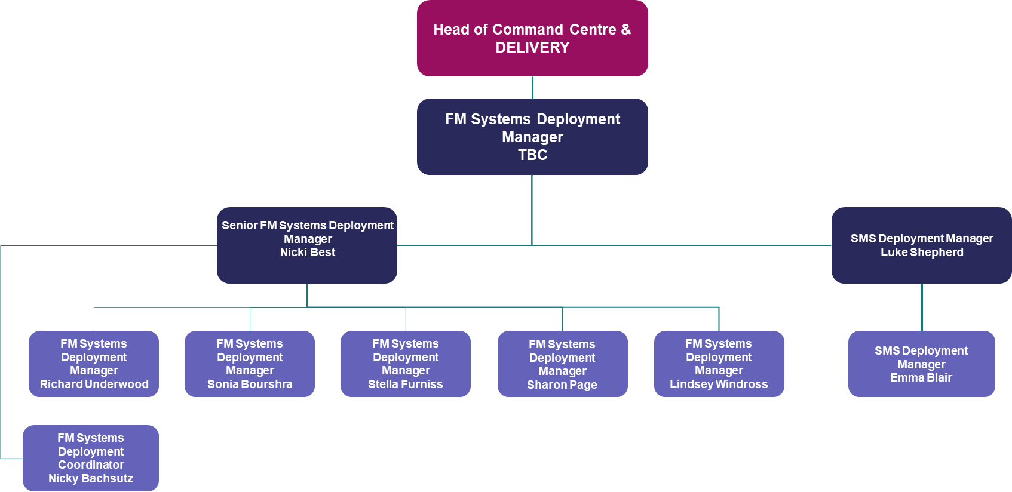

4. Context and main issues – Describe the most difficult types of problems the jobholder has to face (internal or external to Sodexo) and/or the regulations, guidelines, practices that are to be adhered to.
The ideal candidate for this role will have strong PMO skills, exceptional communication skills, and a collaborative mindset. The job description highlights the need for a strategic thinker with a growth mindset who can adapt to changing business needs and prioritize tasks effectively.
Essential skills and competencies include:
- Experience in delivering to planned and unplanned timelines. Demonstrate flexibility in planning.
- Strong influencing and critical decision-making skills.
- The ability to manage pressure and tight deadlines while maintaining a quality-driven approach.
- Experience in growing a team's knowledge, providing training, and planning individual growth plans.
- Excellent communication skills across all media to engage with stakeholders at various levels

- 5. Main assignments – Indicate the main activities / duties to be conducted in the job.
- Collaborate and be the key lead on FM System Deployment & Project Management for the Head of Command Centre DELIVERY for the FMi.
- Provide strong management and leadership for the FM System Deployment Team, push professional growth throughout the team and support individuals personal objectives to success.
- Collaborate with he FMi Leadership team to ensure communication is clear and reports on pipeline, deployments and roadmap items are clearly managed and transparent at all times.
- Identify and support continual improvement opportunities to support the year-on-year growth objective for UK&I
- Support the standard tech mobilisations
- Manage the demand through DELIVERY Team for the FM System Deployment
- Collaborate on the deployment of contracts within the DELIVERY team for excellent customer experience and seamless process
- Handle escalations across the FM Systems Deployment team to ensure agreeable timelines are met.
- Lead by example and delivery for communication on/from the FM Systems Deployment team.

6. Accountabilities – Give the 3 to 5 key outputs of the position vis-à-vis the organization; they should focus on end results, not duties or activities.
- Managing and coordination of regional FM Systems deployment demand into the team and ensuring all recovered costing is accounted and charged.
- Accountable for delivering a seamless end to end stage gate process in line with Sodexo business process and operating models.
- Successful, efficient and effective deployment of FM Systems –
- Excellent, trusted relationships with key stakeholders and contracts
- Ensure a succession plan throughout the FM Mobilisation team for future security and planning.

7. Person Specification – Indicate the skills, knowledge, and experience that the job holder should require to conduct the role effectively
- Developing and executing successful paths to complex problems
- Change management experience
- Effective troubleshooting and analytical skills
- Adapting to changing business needs, prioritizing as necessary and executing tasks independently.
- Strong influencing skills
- Growth mindset and strategic thinker
- Critical decision making
- Have previous experience in the end-to-end delivery of a workstream.
- Ability to deal with a high degree of pressure and tight deadlines, consistently delivering within deadlines and budget constraints.
- Attention to detail, quality driven approach balances with an ability and willingness to take calculated risks.
- Key ability to grow the team’s knowledge, support training and plan individual growth plans across the FM System Mobilisation team.
- Ability to communicate (via all media) to all stakeholders, understand the “why” behind the internal and external messaging.
- Adaptive to change and learning to always ensure best practice and bring learning to the team through experiences throughout the business.

8. Competencies – Indicate which of the Sodexo core competencies and any professional competencies that the role requires
- Project Management Skills | - Commercial Awareness
- Rigorous management of results | - Innovation and Change
- Brand Notoriety | - Business Consulting
- IT / FM Systems Knowledge and experience | - Excellent and professional communication skills

9. Management Approval – To be completed by document owner
Version | 1.0 | Date | 26/08/2025
Document Owner | Natalie Green

10. Employee Approval – To be completed by employee
Employee Name |  | Date

