

Job Description:   
Health & ,Safety Manager

|  |  |  |  |  |  |  |  |  |  |  |  |  |
| --- | --- | --- | --- | --- | --- | --- | --- | --- | --- | --- | --- | --- |
| Function: | | | | Health & Safety | | | | | | | | |
| Position: | | | | Health & Safety Manager | | | | | | | | |
| Job holder: | | | |  | | | | | | | | |
| Date (in job since): | | | |  | | | | | | | | |
| Immediate manager  (N+1 Job title and name): | | | |  | | | | | | | | |
| Additional reporting line to: | | | |  | | | | | | | | |
| Position location: | | | | Dublin | | | | | | | | |
|  | | | | | | | | | | | |
| 1. Purpose of the Job – State concisely the aim of the job. | | | | | | | | | | | | |
| * To promote a positive culture of health and safety and provide solutions across all service lines while ensuring compliance with all Sodexo UK&I Health & Safety, Food Safety, Risk, Business Continuity and Environmental Policy and Processes * Monitoring and providing support, advice and expertise to operational teams with respect to Occupational Health & Safety issues, including statistics and suitable control measure * To lead health & safety across the account. * To drive the implementation of Sodexo Health & Safety and Food Safety Policies and Processes across the account * Undertake environmental, health and safety planning, agreeing priorities and establishing adequate systems for performance management. * Support the achievement of Global, UK&I, Segment and account targets by review of performance data and implementation of initiatives. | | | | | | | | | | | | |
|  | | | | | | | | | | | |
| 2. Dimensions – Point out the main figures / indicators to give some insight on the “volumes” managed by the position and/or the activity of the Department. | | | | | | | | | | | | |
| Revenue : | €tbc | | EBIT growth: | | N/A | Growth type: | n/a | Outsourcing rate: | n/a | Region Workforce | tbc | |
| EBIT margin: | | N/A |
| Net income growth: | | N/A | Outsourcing growth rate: | n/a | HR in Region | tbc | |
| Cash conversion: | | N/A |
| Characteristics | | * Provide direction on HSEQ and risk management matters to operational and management team. * Provide business resilience support to sites | | | | | | | | | | |

Draft. Version: 27-03-2014

|  |
| --- |
| 3. Organisation chart – Indicate schematically the position of the job within the organisation. It is sufficient to indicate one hierarchical level above (including possible functional boss) and, if applicable, one below the position. In the horizontal direction, the other jobs reporting to the same superior should be indicated. |
|  |

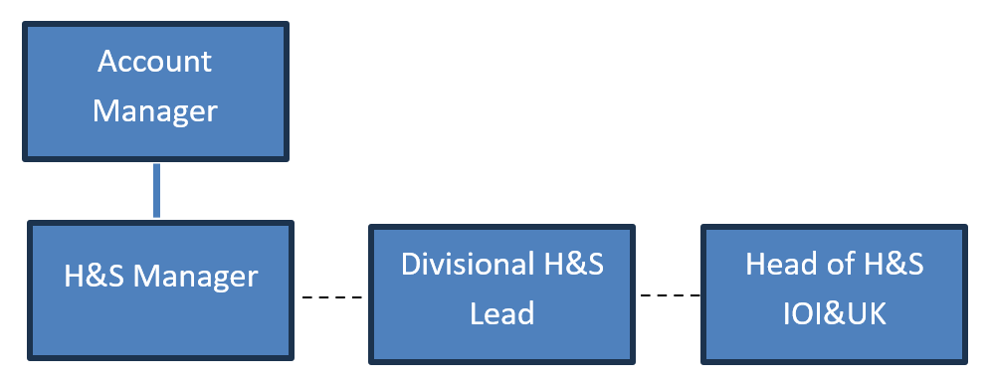

|  |
| --- |
| **4. Context and main issues** – Describe the most difficult types of problems the jobholder has to face (internal or external to Sodexo) and/or the regulations, guidelines, practices that are to be adhered to. |
| * Ensuring Client satisfaction * Zero accident rate across the district * Improved Health & Safety awareness and cultures * Maintain near miss reporting across the account * Engage with the wider HSEQ Community / Professional Family to drive continual improvement across the district * Implement, monitor and review health and safety processes and action plans to ensure compliance with best practice and legislative requirements. * Implementation of the Sodexo Corporate Services Document Management System on sites * Production of site and task specific documentation while site teams maintain service delivery * Support on the development and implementation of Risk Management and Business Continuity Initiatives. |

|  |
| --- |
| 5. Main assignments – Indicate the main activities / duties to be conducted in the job. |
| * Provide safety, health, risk & quality support to Sodexo and client operations in accordance with company procedures and agreed objectives * Assist with the implementation of Health, Safety and Quality systems. * Promote and develop a Safety Culture which secures effective implementation of policy, procedures and responsibilities throughout the Sodexo operational delivery * Support the implementation of behavioral safety change. * Undertake environmental health and safety planning, including the setting of goals, agreeing priorities and establishing adequate systems for performance management. * Implement initiatives to support the attainment of health & safety targets. * Provide a high level of operational service support to management and operational staff, establishing specific requirements, identifying and facilitating the resolution of all specific issues to provide a high level of support and add value to operations. * Production / Approval of Local Operating Procedures. * Develop Risk Registers at Operational and Strategic levels. * Support the development of Business Continuity Plans * Complete full Root Cause Analysis of lost time incidents |

|  |
| --- |
| 6. Accountabilities – Give the 3 to 5 key outputs of the position vis-à-vis the organization; they should focus on end results, not duties or activities. |
| * Provide a high level of operational service support to management and operational staff, establishing specific requirements, identifying and facilitating the resolution of all specific issues to provide a high level of support and add value to operations. * Implementation and delivery of initiatives supporting the achievement of Sodexo and client targets and Safety Culture / Behaviour change. * Ensure full compliance with relevant legislative and company standards * Provide a monthly and quarterly update on performance, to Sodexo and client Account Managers and Director against targets and objectives including the reduction on LTIR. * Ensure the timely reporting of all incidents (Food and HSE) and ensure the timely completion of investigations or all such incidents. |

|  |
| --- |
| 7. Person Specification – Indicate the skills, knowledge and experience that the job holder should require to conduct the role effectively |
| * Diploma or equivalent qualification in an occupation health and safety. * Membership of IOSH * Proven experience within a Hard FM/ M&E environment * Detailed knowledge of current Health & Safety legislation * Experience of Food Safety / HACCP * Experience of working within a high profile organisation. * Experience of Implementing safety and quality systems. * Good organisational /communication skills, able to lead a small team * Ability to prioritise, work to tight deadlines, both prescribed and self-imposed * Ability to establish and maintain good working relationships at all levels |

|  |
| --- |
| 8. Competencies – Indicate which of the Sodexo core competencies and any professional competencies that the role requires |
| |  |  | | --- | --- | | * Cultures innovation | * Ensures accountability | | * Collaborates | * Communicates effectively | | * Decision quality | * Learning and Development | | * Business insight | * Drives results | | * Organisation and planning | * Creative problem solving | | * Quality Focus | * Impact and Influence | | * Employee Engagement | * Leadership and People Management | |

|  |
| --- |
| 9. Management Approval – To be completed by document owner |
| |  |  |  |  | | --- | --- | --- | --- | | Version | 1 | Date | October 2024 | | Document Owner |  | | | |

|  |
| --- |
| 10. Employee Approval – To be completed by employee |
| |  |  |  |  | | --- | --- | --- | --- | | Employee Name |  | Date |  | |