Job Description:
Administration Support

Function: |  |  |  | Service Operations, Workforce Management - RightTime
Job: |  |  |  | Administration Support
Position: |  |  |  | RightTime Administration Support
Job holder:
Date (in job since): |  |  |  | 01.01.2022
Immediate manager  (N+1 Job title and name): |  |  |  | Head of Workforce Management
Additional reporting line to: |  |  |  | None
Position location: |  |  |  | Home based
1. Purpose of the Job – State concisely the aim of the job.
- To provide administrative support to the Workforce Management SME team to manage RightTime Systems access management
- To play a supporting role in the implementation of RightTime in new business and in existing business to maintain systems access for Power App; Power BI and Kronos within the UK & Ireland
- To play a key role in administering and ensuring compliance of all programme governance and management methodology and tools within the Workforce Management RightTime programme
- To support the completion of and version control of documentation including standard and adhoc templates, filing and archiving – utilising Microsoft products (MS SharePoint; MS Office suite and the Power App, Power BI, Kronos system.
- Collation and presentation of data where required
- To support any other RightTime Project Management Office (PMO) activities, such as day to day team administrative duties as requested
2. Dimensions – Point out the main figures / indicators to give some insight on the “volumes” managed by the position and/or the activity of the Department.
Revenue FY13: | €n/a |  | EBIT growth: |  | n/a | Growth type: | n/a | Outsourcing rate: | n/a | Region Workforce | n/a
 |  |  | EBIT margin: |  | n/a
 |  |  | Net income growth: |  | n/a |  |  | Outsourcing growth rate: | n/a | HR in Region | n/a
 |  |  | Cash conversion: |  | n/a
Characteristics |  | - n/a

Draft. Version: 27-03-2014
3. Organisation chart – Indicate schematically the position of the job within the organisation. It is sufficient to indicate one hierarchical level above (including possible functional boss) and, if applicable, one below the position. In the horizontal direction, the other jobs reporting to the same superior should be indicated.
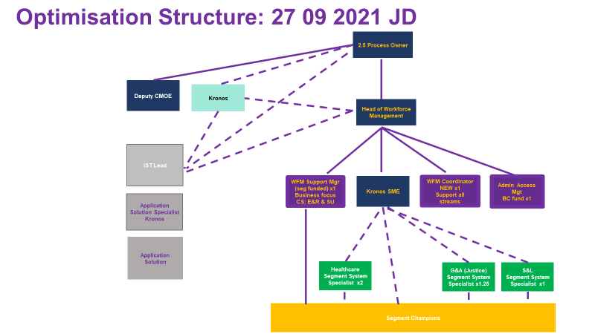

4. Context and main issues – Describe the most difficult types of problems the jobholder has to face (internal or external to Sodexo) and/or the regulations, guidelines, practices that are to be adhered to.
- Support effective governance and reporting mechanisms within Workforce Management Systems – Access Management.
- Support internal networks across the business to maximise outreach and reinforce relationships.
- Maintain strict levels of confidentiality and comply with data protection requirements at all times.
- Demonstrate clear and positive team working
- Motivated self-starter with excellent problem solving skills related to supporting colleagues in accessing systems – where appropriately qualified and appropriate permissions

5. Main assignments – Indicate the main activities / duties to be conducted in the job.
- To support the Workforce Management RightTime in all systems access management – starters, leavers and change in role
- Support users in event of access issues
- Support on Workforce Management administration tasks as requested
- To support and coordinate RightTime Systems access requests for teams involved in mobilisation and new management starters
- To support internal BIGS team meetings
- To ensure RightTime PMO activities are undertaken regularly and efficiently, such as central documentation storage, data protection and GDPR aspects in particular and other RightTime activities as requested
- To manage documentation, templates and plans to ensure compliance to methodology and tools
- To ensure O365 SharePoint space and Kronos admin areas are managed and maintained

6. Accountabilities – Give the 3 to 5 key outputs of the position vis-à-vis the organization; they should focus on end results, not duties or activities.
- Successfully complete allocated deliverables within agreed timescale and quality parameters
- Successfully support the Workforce Management RightTime Team in the smooth running of the process and system and to facilitate team members in achieving service level agreements on maintaining access
- Effectively manage site workbooks, incoming site data packs to ensure access to systems is compliant to data protection, commercial confidentiality and GDPR

7. Person Specification – Indicate the skills, knowledge and experience that the job holder should require to conduct the role effectively
Essential
- Strong administrative experience
- Highly organised and responsive, with ability to deliver under pressure
- Excellent documentation skills
- High levels of computer literacy – Microsoft Office full suite, especially Excel, SharePoint and Outlook
- Excellent communications skills
- Ability to be flexible and agile
- Ability to work openly and collaboratively
- Strong attention to detail
- Willingness to learn

Desirable
- Good knowledge of project planning and coordination
- Experience of a data base management system
- Power App and Power BI experience

8. Competencies – Indicate which of the Sodexo core competencies and any professional competencies that the role requires
- Growth, Client & Customer Satisfaction / Quality of Services provided | - Leadership & People Management
- Brand Notoriety | - Innovation and Change
- Rigorous management of results | - Learning & Development

9. Management Approval – To be completed by document owner
Version | 1 | Date | 08/11/21
Document Owner | Stephen Penniston

10. Employee Approval – To be completed by employee
Employee Name |  | Date

