Job Description:
Senior Sales Manager

Function: |  |  |  | Peyton Events
Position: |  |  |  | Senior Sales Manager
Job holder: |  |  |  | TBC
Date (in job since): |  |  |  | TBC
Immediate_manager  (N+1 Job title and name): |  |  |  | Head of Group Sales and Strategy
Additional reporting line to: |  |  |  | General Manager
Position location: |  |  |  | IWM London
1. Purpose of the Job – State concisely the aim of the job.
This role is responsible for the specific assigned tasks as detailed within above at the Imperial War Museum.

The Senior Sales manager will develop existing business and source new business for its extensive and varied facilities, whilst building and maintaining key relationships with all clients. The Senior Sales manager will build and develop a close relationship with the internal client, as well as additional stakeholders, to ensure a close and mutually beneficial working relationship and positive contract management.

Reporting directly to the Head of Group Sales and Strategy, the Senior Sales manager is a visible member of the management team and will be responsible for accurate and timely reporting to senior members of staff including activities of its two direct reports.

The role with focus upon the proactive development of business & client relationships with key accounts for daytime and evening events business as well as future planning & sales strategy. A highly proactive and targeted role, the role will additionally cross-sell the company and undertake joint sales initiatives with the Sales Managers from the company's other venues as and where needed.

Excellent time management and organizational skills are required within this fast-paced ever-changing environment to be able to deliver the customer visions whilst maintaining Peyton Events ethos and brand whilst also adhering to strict Health & Safety/Site regulations and requirements.

2. Dimensions – Point out the main figures / indicators to give some insight on the “volumes” managed by the position and/or the activity of the Department.
Revenue FY13: | €tbc |  | EBIT growth: |  | tbc | Growth type: | n/a | Outsourcing rate: | n/a | Region Workforce | Tbc
 |  |  | EBIT margin: |  | tbc
 |  |  | Net income growth: |  | tbc |  |  | Outsourcing growth rate: | n/a | HR in Region | Tbc
 |  |  | Cash conversion: |  | tbc
Characteristics |  | - Add point
Draft. Version: 27-03-2014
3. Organisation chart – Indicate schematically the position of the job within the organisation. It is sufficient to indicate one hierarchical level above (including possible functional boss) and, if applicable, one below the position. In the horizontal direction, the other jobs reporting to the same superior should be indicated.
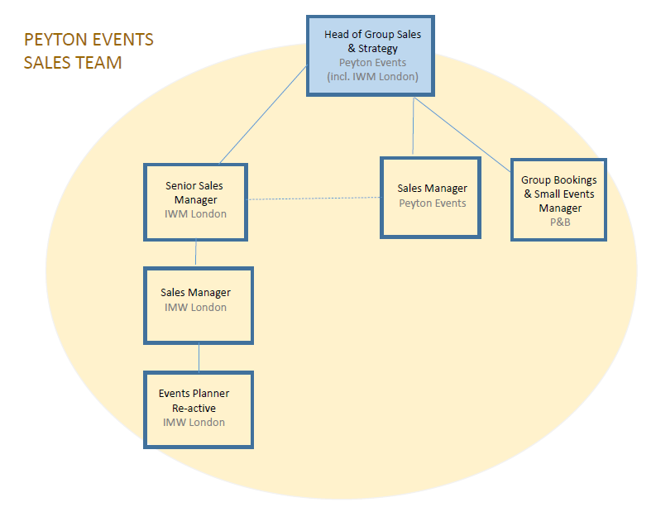

4. Context and main issues – Describe the most difficult types of problems the jobholder has to face (internal or external to Sodexo) and/or the regulations, guidelines, practices that are to be adhered to.
- Balancing Customer, Client, and Employee request
- Financial budgeting and Management
- Event Management
- Adapting to changing internal environment and exhibits
- Pro-active selling and building client relationships

5. Main assignments – Indicate the main activities / duties to be conducted in the job.
Accountabilities

Service Client & Guest Care

- Adhere to company sales values and standards at all points
- To create a culture of guest focus and service excellence
- Ensure all quotes are produced to the agreed high standard in a professional and efficient manner with all quotes sent out on the same day and followed up within 24 hours
- Review all enquiries, provisional and confirmed bookings and ensure effective chase systems are in place in order to increase conversion rates
- Assist in the organization and running of promotional events and sales and marketing activities e.g. showcases, Christmas, telesales
- Organise and attend tastings or show rounds if required, ensuring effective follow up
- Maintain knowledge of all Peyton Event venues for cross selling and communicate the enquiry to relevant member of the team when events not applicable/relevant for IWM London
- Actively develop new business for Peyton Events at the site through pro-active activities such as cold calling and distribution of promotional material, in addition to dedicated marketing campaigns
- Initiate pro-active selling and have a general pro-active approach to identifying new business via appropriate channels and targeting
- To assist the sales and account team in achieving their objective of identifying and gaining new business as well as maintaining and developing existing clients and businesses;
- To monitor sales targets for the team on a regularly basis (weekly appointments, cold calling, fam trips, revenue per account, etc) and to report to the Head of Group Sales & Strategy accordingly.
- To establish and continuously develop key relationships to ensure they reach their maximum potential
- To identify and develop, in liaison with the Head of Group Sales & Strategy, initiatives to ensure the business continuous to grow and develop
- To analyse the company’s performance data in order to identify trends, positive and negative and produce action plans
- Record comprehensively, all record customer reservations and communications data and feedback to provide accurate and meaningful research about our business; both statistical and subjective
- Maintain and conduct training of standards of performance for show rounds, incoming and outgoing telephone calls, administration, and sales approach to junior members of the team; in adherence to the company standards
- Work with client and the operations team to ensure that all events, contracts and project work matches ambition and promise

Leadership and People Management:

- To be accountable for all reports for the sales, and supporting, team
- To Mentor, appraise and review all other colleagues and help create development plans/objectives for each
- To lead, train, develop and motivate their colleagues proactively
- Keep internal client relations professional and friendly at all times
- Ensure professional discretion when working closely with our client in their office
- To conduct Sodexo annual appraisals for direct reports and continuously develop your team through regular quarterly reviews & agreeing quarterly personal goals that are followed through with all team members
- Behave in a proper and professional manner at all times as a representative of Peyton Events
- Working closely with the senior management team to ensure good working relations are maintained and that the best interests of the company are always priority
- Work with the management team to ensure the agreed procedures and policies are faithfully followed
- Carry out any other duties as may be required under the direction of your manager, which is reasonably within your scope and commensurate with your status and duties.
- Work some hours out of normal office hours when required
- Maintain excellent relationships with all internal and external clients

Quality and Detail:

- To take proprietorial responsibility for all hygiene and safety operations within your site, using all company tools provided to ensure
compliance and due diligence
- Liaise effectively with the client to ensure the highest possible standards of safety and presentation in all events spaces, restaurant, café and back of house areas
- Complete secret shoppers In order for us to be aware of competitor products, current offers and services conduct on a regular basis
- Ensure that all venue information is up to date and professionally displayed and always sent out in the correct format
- Prepare all marketing information as necessary in accordance to sales and marketing plans

Financial Management:

- Assist the GM/Head of Group Sales & Strategy in producing the sales budgets for forthcoming years within the timetable set by the group as well as regular updated forecasting
- Analysis of the results by market sectors; service, nationality and other appropriate measures including narrative identifying trends
- Analysis include review of action taken or planned to improve margins
- Ensure no costs are incurred without authority (purchase order, recruitment authority, etc)
- Ensure excellent knowledge of venue including operating costs for each style of event
- To ensure daily cashing-up & financial procedures are completed to company standards by yourself.
- To submit all payroll information accurately on time
- Manage annual budgets in accordance with the groups projections
- Complete accurate monthly forecasts and action plans to ensure budgets are met
- Ensure all required reports are submitted in a timely and accurate manner
- Be commercially minded in every aspect of the business and day to day activity
- To carry out any other reasonable duties and responsibilities as needed
- To work as a team player at all times and be prepared to be flexible in order to ensure that all operations are always as efficient and profitable as possible

6. Accountabilities – Give the 3 to 5 key outputs of the position vis-à-vis the organization; they should focus on end results, not duties or activities.
- Operational Excellence and consistency within site
- Manage all aspects of operations within set financial budgets
- Leading and managing the operational team to success

7. Person Specification – Indicate the skills, knowledge and experience that the job holder should require to conduct the role effectively
- Customer Service Care and guest focused
- Proven track record of building relationships and managing key accounts
- Ability to manage a team but also work as part of one
- Manage the business financials and planning/forecasting
- Diverse Contract Catering and Event Catering experience as well as fixed site/venue experience highly desirable
- Strong personal contact network with London agency and corporate companies
- Influencing and constructive challenging skills
- Pro active behavior towards problem solving
- Strong financial understanding and demonstrable budgeting management
- Experienced in adhering to and driving company initiatives and strategies
- Personal innovation and passion with desire to inspire other
- Strong communication skills
- Excellent organizational and time management skills
- Relevant qualifications and training

8. Competencies – Indicate which of the Sodexo core competencies and any professional competencies that the role requires
- Growth, Client & Customer Satisfaction / Quality of Services provided | - Leadership & People Management
- Financial Awareness | - Innovation and Change
- Health & Safety/Food Hygiene | - Business Consulting
- Commercial Awareness | - P&L Understanding
- Employee Engagement
- Profit

9. Management Approval – To be completed by document owner
Version | V.1 | Date | 10/07/2017
Document Owner | Keniro Miller

10. Employee Approval – To be completed by employee
Employee Name |  | Date

