Job Description: Project Manager - Consulting
Function: | MTS Health Ltd
Position: | Senior Technical Manager
Job Holder: | Vacancy
Date (in job since): | n/a
Immediate Manager: | Fiona Wardil, Head of Equipment Advisory
Additional reporting line to: | n/a
Position location: | Hybrid working covering: Client sites, MTS offices and some home-based working.

1. Purpose of the Job
MTS is a market leading specialist Equipment Planning organisation. We are a wholly owned subsidiary of Sodexo. We operate in the NHS and Private Sector Healthcare industry. We are looking for a Project Manager with Public Sector Procurement experience to work in the Advisory part of the business. The role will provide Project Management and procurement expertise for the delivery of key projects, with opportunity to grow and develop within the organisation.
Deliver project and programme management for key MTS projects with support from key experts such as technical, data and procurement and provide mentoring and leadership to other junior members of the team.

2. Financial Package
£65,000 - £69,000 per annum
All of the below are applicable after 3-month probation:
Death in Service
Sodexo L&G Pension
Staff Rewards Programme

3. Organisation chart
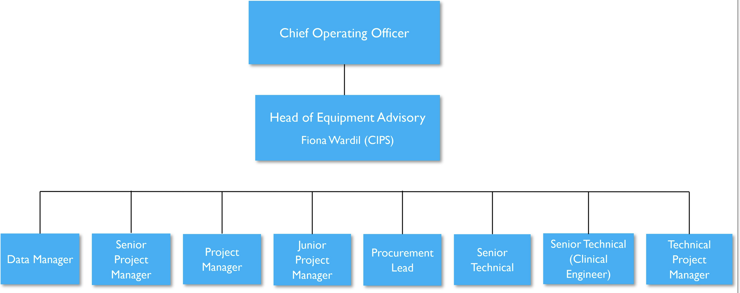

4. Context and main issues
MTS Health are one of the UK’s leading providers of clinical technology management services through our Operational Services Team and the Equipment Advisory Team.
We has been delivering services to the NHS and Private Sector for over 27 years; with a specialist team of Bio-Medical Engineers, Clinical Scientists; MCIPS Qualified Procurement specialists; PRINCE 2 trained Project Managers and Construction Project Management Interface personnel.

MTS has seen recent significant growth and as a result have an exciting opportunity to join our team as a Senior Technical Manager.
The role is within the Equipment Advisory Team, an area of which we are market-leaders. We support the healthcare services at the forefront of business case planning, procurement, delivery and installation of equipment.
This a senior role with growth opportunity, the role will be responsible for the successful delivery of a portfolio of projects from initiation to completion, key skills for a successful output include:
- A good strong communicator who is results and solutions driven.
- Hold a minimum of 5 years project management experience.
- Public Sector Procurement Experience
- Ability to work with a variety of clients providing expertise, advise and solutions.
- From an agreed scope of work create and deliver project work plans.
- Monitor every stage of project progress, setting deadlines and designating tasks.
- From a pool of allocated resource, assign responsibilities to a variety of subject matter experts and project support managers.
- Capable of leading teams both internally and external to deliver the required outputs
- Ability to multitask, supporting the management of a portfolio of projects with different objects, stakeholders and resource.
- Ensure project documents are complete and current
- Ability to identify, understand, manage, document and mitigate project related risks

5. Main assignments
The primary focus of the role is ensuring the successful delivery of redevelopment and new Hospital equipping projects consisting of the following main activities:
Equipping Project Management:
- Good strong communicator, with an ability to relay information, updates and respond to queries both verbally and written to a variety of clients and internally.
- The role will on occasion have conflicting deadlines and will need to manage multiple projects concurrently.
- Bring existing understanding of Healthcare experience and understanding, including acute hospital environment.
- Present and lead stakeholder meetings to provide project status updates, lead discussions to extract the required information
- Ability to review and understand technical drawings and room contents
- Support on creating programmes to meet deadlines.
- Identify equipment requirements of a project and support the development of strategies for managing these requirements in line with the agreed project scope.
- Ability to understand the infrastructure within a room required to support equipment and advise clients accordingly
- Understand set budgets and develop options for managing and reporting on progress
- Liaise with all members of the internal and external project teams and the stakeholders to manage the flow of information and achieve project outcomes.
- Advise on specifications for the equipment from the suppliers whilst ensuring governance arrangement are in place (Trust SFIs, Tender limits, meeting minutes, risk register & budgetary control)
- Understand and guide on procurement routes based on type and spend
- An understanding on how to identify, manage and mitigate risks and issues
- Support on providing specialist advise on equipment procurement and commissioning issues including use of tendering and frameworks
- Engage with and manage suppliers to obtain best value, working with Trust procurement teams to raise orders
- Support on the management and co-ordinate logistics and commissioning plans for multiple vendors within a tight timeframe
Undertake other duties as are necessary from time to time as identified by your line manager

6. Accountabilities
- Head of Equipment Advisory

7. Person Specification
Essential:
- Result and solutions driven
- Manage your own time in relation to prioritising deliverables
- Experience of implementing change, or delivering improvement programmes and the use of skills to facilitate change
- Able to manage and direct people without direct line management responsibility
- Flexibility to work in a variety of locations and with diverse groups and on several projects concurrently
- Ability to move around a construction site (with appropriate training)
- A high level of computer literacy with the ability to use such systems as Excel, Microsoft project and Power Point for the delivery of presentations and data.
- Good communication skills both written and oral, including report writing and presentation
- Ability to work to tight deadlines
- Methodical, organised and good time management skills
- Excellent interpersonal skills and the ability to communicate effectively with customers, suppliers, clients and internal team members at all levels of the business including Sodexo
- Ability to work and react quickly in a fast-moving ever-changing environment
- Ability to work as part of a team but also using their own initiative
- IT Literate – particularly able to use Excel effectively, as well as communicate to a high standard and accuracy in Outlook and Word.
- Experience working with the NHS and its core governance structure
- Understanding of NHS procurement processes
Desirable:
- Worked within Capital Equipping and Project Management
- Experience in equipping hospitals

8. Competencies
- Leadership
- Numeracy and Accuracy
- Communication
- Ability to learn new systems
- Commercial Awareness

9. Management Approval
Version | 2 | Date | 21/07/2026

10. Employee Approval – To be completed by employee
Employee Name |  | Date

