
Job Description:
Painter and Decorator

Function: | Sodexo Government (Justice Services)
Position: | Painter and Decorator
Job holder:
Date (in job since):
Immediate manager  (N+1 Job title and name): | Hard Services Manager
Additional reporting line to: | Head of Facilities Management
Position location: | HMP Peterborough
1. Purpose of the Job – State concisely the aim of the job.
Delivery of varying painting/decorating/MAF and PPM Reactive. This role will also include the requirement for the completion of reactive helpdesk tickets & assistance in the completion of painting project related tasks and other requests.

Draft. Version: 27-03-2014
2. Organisation chart – Indicate schematically the position of the job within the organisation. It is sufficient to indicate one hierarchical level above (including possible functional boss) and, if applicable, one below the position. In the horizontal direction, the other jobs reporting to the same superior should be indicated.
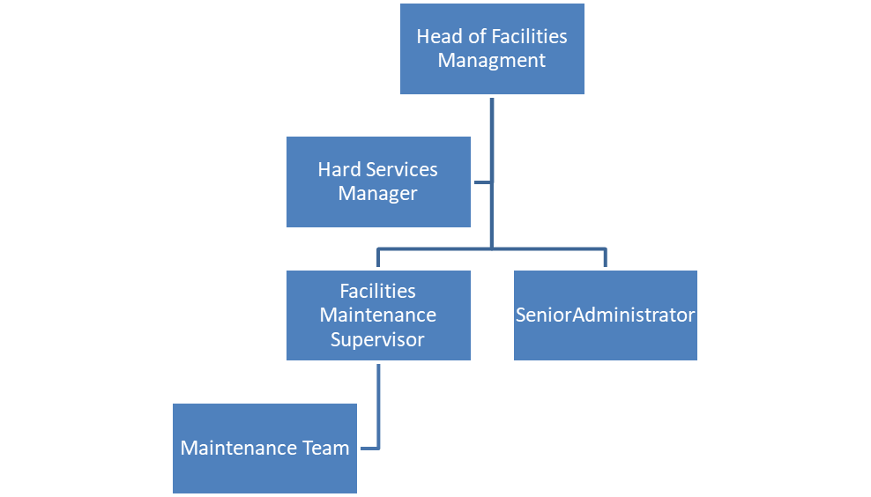

3. Context and main issues – Describe the most difficult types of problems the jobholder has to face (internal or external to Sodexo) and/or the regulations, guidelines, practices that are to be adhered to.
HMP Peterborough is one of the major sites within the Sodexo Justice Services portfolio. The role is to provide painting/decorating/MAF/lifecycle/PPM and Reactive task provisions across the site.
- Ownership of areas, tasks and plant, deliver service with pride
- Liaise with internal and external customers, the client and engineers at all levels.

4. Main assignments – Indicate the main activities / duties to be conducted in the job.
- Carry out painting/decorating/MAF/PPM and reactive task work in line with task list requirements.
- Close work orders and raise corrective work orders in line with SOP requirements
- Communicating with the customer.
- Maintain a safe, secure, and healthy work environment by following and enforcing local site standards and procedures whilst complying with legal regulations
- Breakdown of the Meaning:
  - Painting/Decorating – This includes general painting, wallpapering, or other aesthetic improvements to surfaces and interiors.
  - PPM - Planned Preventative Maintenance and reactive painting maintenance across site.
  - MAF (Minor Alteration & Fabrication) – Small-scale construction, repair, or modification works that do not require major structural changes. This can involve: partitioning, installing or modifying fixtures and fittings, small carpentry or metalwork tasks, adjustments to layouts
- Application in a Facility/Prison Environment:
  - In a prison or facility management context, this would mean carrying out a mix of maintenance and improvement works, such as: Repainting cells, communal areas, and offices, repairing or altering internal walls, ceilings, and fittings, installing or modifying furniture, security barriers, or shelving.
- Hours of work: Section 6.1 of your contract of employment - 37.5
- Duties: Section 3.3 of your contract of employment – shift patterns will vary, and reasonable notice will be given (2 weeks minimum) and will be the following times but may vary from time to time.
08:00 – 16:00
11:30 – 19:30
22:00 – 06:00

5. Accountabilities – Give the 3 to 5 key outputs of the position vis-à-vis the organisation; they should focus on end results, not duties or activities.
- Delivery of a consistent level of service, within the Company's standards, to the contract specification and service offer.
- Compliance with company policies and statutory regulations relating to safe systems of work, health & safety, hygiene, cleanliness, fire and COSHH.
- Develop an effective and structured relationship with both internal and external clients/suppliers
- Client satisfaction.

6. Person Specification – Indicate the skills, knowledge and experience that the job holder should require to conduct the role effectively
- Painting skills
- PASWA, IPAF and other licenses and or training to complete assigned works
- Experience working in the building services industry
- Fantastic customer service experience.
- Strong customer services skills and experience
- Service orientated attitude combined with innovative thinking
- Strong team player within a high-quality customer service operation
- Communicate effectively with a wide range of customers and multi-service team service personnel to achieve results.
- Knowledge and experience of a range of painting activities.
- Have NVQ or City & Guilds or equivalent.

7. Competencies – Indicate which of the Sodexo core competencies and any professional competencies that the role requires
- Growth, Client & Customer Satisfaction / Quality of Services provided | - Leadership & People Management
- Rigorous management of results | - Innovation and Change
- Brand Notoriety | - Business Consulting
- Commercial Awareness | - HR Service Delivery
- Employee Engagement
- Learning & Development

8. Management Approval – To be completed by document owner
Version | 2 | Date 28-02- 25
Document Owner | Mark Thompson

