

Job Description:
Area Lead – UK&I (Microsoft)

Function: | Global Strategic Accounts, Corporate Services
Position: | Area Lead (Microsoft)
Job holder:
Date (in job since):
Immediate manager  (N+1 Job title and name): | EMEA Area Lead (Microsoft)
Additional reporting line to: | Operations Director, Corporate Services
Position location: | No fixed place of work – with regular travel within Cluster Area
1. Purpose of the Job – State concisely the aim of the job.
- Responsible for managing the delivery of multiple IFM services to a cluster of sites within the account, ensuring outstanding service delivery at all times and that on-site services are delivered to the standards/SLA(s) in the contract.
- Delivering the strategic goals for Sodexo & Microsoft, including the achievement of key financial and operational performance measures.
- Business, service delivery and client risks managed in a controlled and structured manner and service standards across the sites are in line with or above the client’s expectations and reviewed on an ongoing basis.
- Bring added value to the client by delivering expected transformation of their IFM model and services through effective deployment of initiatives and plans stemming from the Transformation Programme.
- Drive innovation, continuous improvement, and Operational Excellence across the cluster.
- Based on performance reviews led by the Operations Lead support site and/or country/cluster level performance improvement, planning and oversight of performance improvement programmes.
- Lead the operational definition and design of all workplace activities.
- Point of escalation and issue resolution for all issues within the cluster.
- Client development and retention through proactively developing and building client relationships.
- Establish and effectively lead a highly capable team who will deliver against the strategic objectives.
- Act as the key interface between our client(s), Sodexo in-country Directors/Single Points of Accountability (SPOA’s) and functional delivery teams developing a cluster community of best practice, including providing expertise as & when required to other strategic accounts.
2. Dimensions – Point out the main figures / indicators to give some insight on the “volumes” managed by the position and/or the activity of the Department.
Revenue FY27: circa £17m / €20m

- Microsoft only
Characteristics ✓ 14 sites across UK & Ireland
- Matrix operating platform
- Number of direct operational reports: 2
- Potential growth in role to manage dining services in the UK & Ireland

3. Organisation chart – Indicate schematically the position of the job within the organisation. It is sufficient to indicate one hierarchical level above (including possible functional boss) and, if applicable, one below the position. In the horizontal direction, the other jobs reporting to the same superior should be indicated.

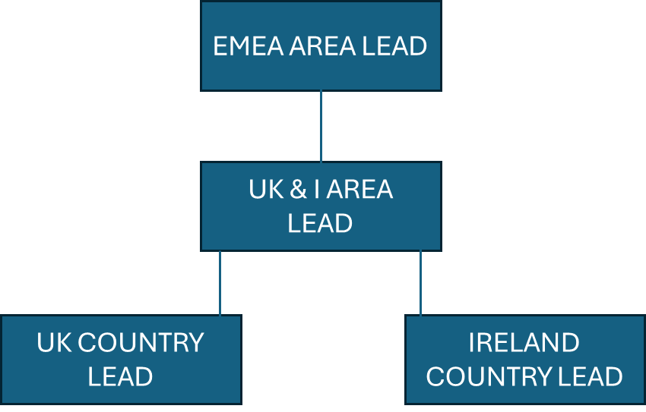

4. Context and main issues – Describe the most difficult types of problems the jobholder has to face (internal or external to Sodexo) and/or the regulations, guidelines, practices that are to be adhered to.
- Leadership – Providing confident, visible leadership, ensuring standards are set and delivered, talent and resources are utilised optimally, client relationships are nurtured and developed and all opportunities for best practice and capability growth are leveraged.
- Delivering on Financial and Operational Targets – Ensuring that committed targets are met or exceeded and that costs and revenues are closely managed over the course of the financial years to ensure clarity on performance and provide the means to respond rapidly to any threats to financial performance. Measures include revenue growth, profitability, contract KPI’s, and HSE targets.
- Team Management – Selecting, managing, engaging and developing highly performing and diverse account team, with right skills and capabilities, particularly hospitality/technical/professional skills are acquired and developed in line with account, client and segment needs.
- Client Relationship Management – Engaging with key clients on a routine basis and lead by example in providing excellence in account/relationship management.
- Transformation – Effective deployment of Transformation Programme initiatives and plans across the cluster. Acting as the lead for innovation, continuous improvement, and Operational Excellence in the cluster.
- Delivery of Excellence in Risk, Compliance and Quality Management – Ensuring protocols, processes and capabilities are in place to deliver all technical/regulatory requirements for the safe and commercial ongoing management of the account.
- Effective Management of Internal Resources – Partnering effectively with the Sodexo countries, support functions/service operations and provide clear business briefs on support and services required. Establish networks (industry inclusive) to ensure continuous improvement and provide insight through effective use of market data and operational delivery techniques.
- Contract Management – Pioneer the use of best practice account management to ensure achievement against all contractual business plans. Review contract KPIs and results achieved with the performance of other account teams and competitor benchmark/performance.

5. Main assignments – Indicate the main activities / duties to be conducted in the job.
Growth, Client and Customer Satisfaction
- Commercial and financial management of the contract with focus on looking forward and analysis of future trends.
- Take overall cluster responsibility for ensuring that the contract is operated within its contractual terms. Ensure the standards across the sites are in accordance with the SLAs and KPIs specified in the contract.
- Ability to interpret and understand the contract, managed with an ability to negotiate within the boundaries of the contract.
- Assisting the business to grow revenue streams by innovation, training, and complying with local marketing and purchasing initiatives to drive sales and consumer participation.
- Development and execution of growth strategies with regards to workplace management and product offering across all service lines.
- Support country teams with the early engagement of new workplace projects; ensuring that service definition is understood and offers support during the project execution phase.
- Contribute & attend governance requirements in line with the account & client expectations.

Rigorous Management of Results
- Take overall responsibility for ensuring the cluster performs to budget and achieve the business plans and improve financial performance utilising nominated suppliers, maximising labour productivity in line with Sodexo models, policies and procedures and controlling costs.
- Contribute to the development and implementation of the account strategy and ensure own business area plans are in line with segment objectives and delivers against Sodexo expectations.
- Set and agree overall annual budgets with finance and develop unit business plans and local area plans which link to the overall account & segment strategy and objectives.
- Analyse and review all financial measures and tools to ensure positive financial performance through accurate forecasting and account management.
- Seek new ways to drive revenue and maximise sales by implementing innovative ideas.
- Maximise the profitability of the account within the cluster and deliver the required financial and service level results using the principals of contract design and management.
- Take overall accountability for delivering services to the agreed specification and service level agreements/standards required by the account within your assigned area.
- Continually seek ways to maximise profitability and enhance service quality by driving excellence and innovations in service delivery and pushing for more efficient service delivery and cost efficiencies.
- Ensure analysis of indicators adhere to processes and implement coaching to embed good practice.
- Ensure continuous oversight of all business continuity plans within the cluster and ensuring they are connected with wider Sodexo plans to maximise efficiencies.

Service Delivery
- Ensure all sites are delivering prompt and efficient service of all activities as laid down in the SLA and to the satisfaction of clients, customers and Sodexo.
- Act as the Area point of contact for account level processes, programmes, and initiatives related to innovation, continuous improvement, and Operational Excellence. Plan and coordinate implementation of cluster and/or country level innovations, improvements, and programmes working closely with the Transformation Programme Manager and the Operations Lead.
- Work with the Central Account Team, Sodexo countries, Service Operations, Transversal Functions, Segment operational & functional teams to ensure a standardised, consistent and compliant approach is implemented across the region (e.g. HR, Communications, Technical Services, EHS, OE).
- Continuously seek ways to enhance quality through innovation and cost efficiency by monitoring performance against existing standards.
- Drive innovation and continuous improvement of people, systems, processes and offer.
- Assist with the mobilisation and deployment of new business growth.
- Creation of internal networks and forums for sharing best practice at technical, business, sector and client levels
- Drive thought leadership in terms of innovation and operational excellence.

Leadership and People Management
- Establish and effectively lead a highly capable team who will deliver against the strategic growth objectives.
- Recruit, induct, motivate, manage, train and develop all employees in alignment with Sodexo HR policy and guidelines.
- Coach managers to ensure that employee performance is managed through the Sodexo performance management processes and talent development and succession planning activities take place.
- Manage the team and provide them with guidance on operational issues to ensure the business objectives are met by effectively guiding team members performance by a structured process of target setting, performance management, rewarding and development plans.
- Ensure that the appropriate training and development plans are in place for all employees within the business to ensure that statutory requirements are met and development training activities are carried out and recorded to assist with career development and succession planning.
- Role model behaviours to improve engagement, enhance performance. Communicate employee engagement results and compile a robust action plan for the cluster to drive continuous improvement.
- Hold regular team meetings with managers to ensure the cascade of information down to unit level employees.
- Be a proactive member of the regional dedicated Microsoft Account Team; drive defined regional initiatives within the cluster.
- Motivate and lead employees to perform their roles to a high standard and in alignment to Sodexo policies and procedures.
- Build personal effectiveness in all situations.

Brand Notoriety
- Promote Sodexo as the preferred employer, internally and externally, adhering to the Sodexo recruitment policies and raise the profile of Sodexo in local communities, building relationships with key stakeholders.
- Promote the health and well-being of employees.
- Live the Sodexo values and promote brand standards as an ambassador.
- Drive all aspects of service excellence across the business area including brand integrity, quality, compliance, Sodexo’s corporate social responsibility and service standards.

Compliance, Environment, Health and Safety and Risk Management
- Ensuring that all aspects of the business are conducted in accordance with all relevant statutory requirements and Codes of Practice.
- Ensure that Health and Safety is given the number one priority. Lead where appropriate, and take part in management and employee briefings to deliver safety information to include: Food Safety, Health and Safety, Fire Safety, First Aid and any statutory, client or site specific safety requirements.
- Ensure the business complies with all Sodexo and Microsoft policies and procedures/site rules and statutory regulations and that licences and qualifications are met and retained, and consequences managed appropriately.
- Take overall accountability for Health and Safety and training plans within the cluster.
- Carry out regular service audits at all sites across the cluster.
- Assist with the implementation and maintenance of all statutory and Sodexo policies and procedures, communicating it to all staff and ensuring full compliance.

Client Relationship Management
- Grow strong relationships with clients to ensure a profitable long-term partnership.
- Lead by example in providing excellence in account and relationship management.
- Manage relationships and key interfaces with the client and the clients' key decision makers.
- Seek feedback and validation of service from all levels within the account.

6. Accountabilities – Give the key outputs of the position vis-à-vis the organization; they should focus on end results, not duties or activities.
- All GOP and other financial targets exceeded (margin, budgets, etc.).
- Growth of profitable services.
- 100% client retention.
- Services delivered within budgets with savings achieved, innovations and initiatives appropriately captured in the change process.
- Compliant delivery and performance of services as measured through performance management systems, SLAs and monthly management information reports.
- Sites are performing to SLAs and budget and costs are being controlled by promoting cross-departmental efficiencies to assist in the control of labour costs.
- Engagement rate of the team exceeded and development plans in place.
- Services are delivered to the required level across all service portfolio, service excellence as standard.
- Measurably strong client perception and satisfaction with services delivered.
- Safety, Health and Environmental compliance in all activities.
- The Microsoft account is recognised by client and Sodexo as a benchmark for service excellence within the cluster and wider Sodexo operation.
- Client retention and contract extension opportunities identified and converted through positive working relationships with clients.
- Successful mobilisation of new sites or new services sold. Successful demobilisation of closed sites.
- All standards in the operational audits are effectively passed.
- Developed and mature industry, sector and client networks with evidence of influence and advocacy.

7. Person Specification – Indicate the skills, knowledge and experience that the job holder should require to conduct the role effectively
Essential
- Client business language is English – therefore must have excellent oral and written English.
- Experience of having operated successfully within an outsourced integrated facilities management environment.
- Proven experience in working across international geographical boundaries and building diverse teams.
- Demonstrable track record of developing successful operational strategies across a broad portfolio of services.
- Development of commercially viable solutions based on rigorous techniques to understand client needs and price products/services accordingly.
- Considerable experience in sector contracting and sector technical service delivery.
- Proven experience in identifying new business.
- Proven experience in managing multi-site operations.
- Proven track record of leading and managing experienced operators and large numbers of employees
- Exceptional communication skills, both written and verbal with excellent active listening skills.
- Excellent influencing and facilitation skills.
- Ability to analyse complex data and make decisions.

- Capable of developing and implementing business plans and growth strategy.
- Ability to interpret and utilise financial and commercial information in order to drive sales growth
- Customer and quality focused; highly effective at building and improving customer relationships.
- Excellent organisational and time management skills, ability to plan and deliver objectives within an agreed timeframe.
- Proven ability to create a sense of community amongst the team members.
- Challenges the status quo, innovative, ‘can do and improve’ attitude.
- Self-motivated and able to work on own initiative within a team environment.

Desirable
- Facilities, Engineering, Technical, Business and other relevant degree/qualifications.
- Knowledge of Sodexo systems and processes.

Other Relevant Information
- Regular travel and overnight stays will be required.
- To relieve and assist in other establishments in certain circumstances.
- To attend meetings and training courses as requested.
- This job description is intended to give the post holder an appreciation of the role envisaged and the range of duties and responsibilities to be undertaken. It does not attempt to detail every activity. Specific tasks and objectives will be agreed with the post holder at regular intervals. The post holder will be required at all times to perform any other reasonable task, as requested by the Line Manager in order to meet the operational needs of the business.

8. Competencies – Indicate which of the Sodexo core competencies and any professional competencies that the role requires
 | Client Growth and Customer Satisfaction | Innovation and Change
 | Rigorous Management of Results | Brand Notoriety
 | Leadership and People Management | Planning and Organising
 | Analysis and Decision Making
 | Industry Acumen

