
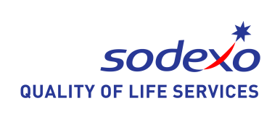

EXPERTISE
JOB DESCRIPTION

Function: | UK Government & Energy - Services Team
Position: | Business Improvement & Optimisation Manager
Job holder:
Date (in job since):
Immediate manager  (N+1 Job title and name): | UK Government & Energy Head of WFM - Stephen Penniston
Additional reporting line to: | UK Government Services Director - Jane Jay
Position location: | Home based, with travel across UK&I as required

1. Purpose of the Job – State concisely the aim of the job.
Responsible for providing business improvement support across UK Government & Energy. This includes contract management, workforce management and operational excellence. The role involves activities within bidding, mobilisation and day-to-day contract delivery. Supporting the monitoring of contracts, identifying opportunities to implement innovations and drive efficiencies for our contract operations. Supporting the deployment of the annual Business Improvement Management Program and subsequent CMOE collective action plans. Involvement in the deployment of CMOE (contract management operational excellence) systems and processes.

The function will manage the company strategic ambition of Improving our Competitiveness by driving process and behavior that will have a positive impact on growth. Provide training and actively support activities across all sub segments to ensure financial and operational success.

2. Dimensions – Point out the main figures / indicators to give some insight on the “volumes” managed by the position and/or the activity of the Department.
 |  |  |  |  | Outsourcing rate: | n/a | Region Workforce | 9,000
Revenue FY25: | €TBC  bn |  | Growth type: | New Development & Cross Sell
Revenue FY25: | €TBC  bn |  | Growth type: | New Development & Cross Sell | Outsourcing growth rate: | n/a | HR in Region | Yes
Characteristics |  | - The position holder has a target to identify potential benefit of €500K per year in profit / risk avoidance  - People: Coach and develop others, develop rapport at all levels to collaborate and influence change  - Growth: Contribute towards the Shift & Grow strategy, working across all 3 pillars to support and prepare for DSFM

3. Organisation chart – Indicate schematically the position of the job within the organisation. It is sufficient to indicate one hierarchical level above (including possible functional boss) and, if applicable, one below the position. In the horizontal direction, the other jobs reporting to the same superior should be indicated. Please show the job titles not the actual people doing the role, i.e. Finance Manager, Project Manager
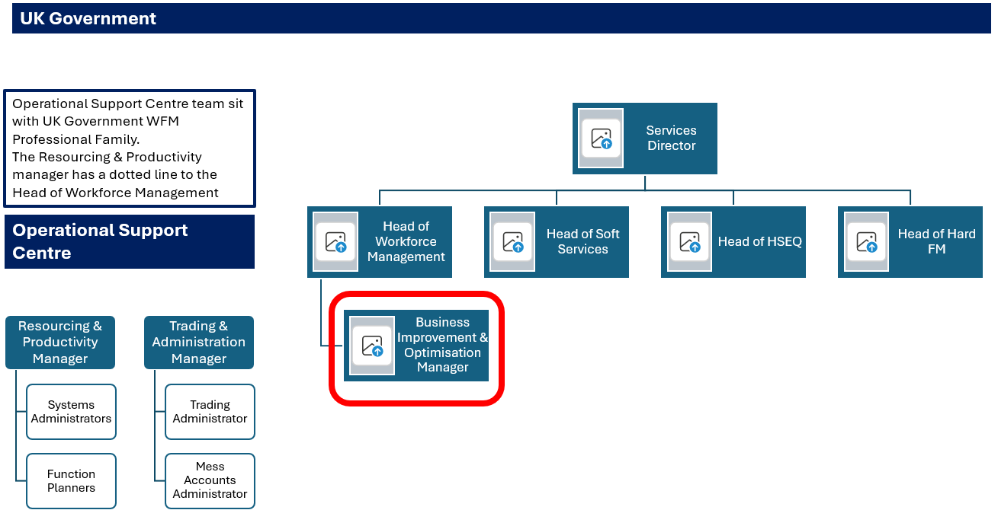

4. Context and main issues – Describe the most difficult types of problems the jobholder has to face (internal or external to Sodexo) and/or the regulations, guidelines, practices that are to be adhered to.
Sodexo is a large, complex, matrix structured business, meaning standardizing how we work is difficult
- There are many differing stakeholders to engage and satisfy
- There are many competing demands on people’s time, meaning time to focus on change is scarce
- Culturally, accepting the need to change and accepting ways of working created elsewhere
- The matrix structure breaks up activities across demand, build and deploy, creating disconnects
- Communication can be unstructured with unclear ownership, creating significant gaps
- Low consequence management culture.
- Improving efficiency while maintaining service delivery and colleague engagement.
- Balancing short-term operational demands with structured planning processes.
- Operating within legislation, contractual requirements, and internal governance frameworks.
- Optimised contract execution (Improved profitability and scope) Extensive travel within country
- Being able to influence management without authority
- Direct Interface with Account Directors and Managers, Clients at Contract level
- Bring broader market best practice in given service lines to the table to drive new innovations and thinking utilising Operational Excellence tools and methodology

5. Main assignments – Indicate the main activities / duties to be conducted in the job.
- Working with the segment Services Team to delivery transformation and change initiatives that support new business opportunities, specifically DSFM.
- Identify opportunities to implement new innovations to drive value and efficiencies in readiness for DSFM
- Identify opportunities to improve profitability on the contract without impacting experience
- Delivers training and onsite deployment of the CMOE tools
- Utilises the regional CMOE action plans to track live activity and outcomes.
- Shares best practices in all service lines and drives consistency in approach
- Adheres to and drives compliance with Company and customer/client policies and procedure.
- Ensures confidentiality of materials and information
- Works collectively to achieve business objectives whilst promoting collaboration, co-ordination and team­work

6. Accountabilities – Give the 3 to 5 key outputs of the position vis-à-vis the organization; they should focus on end results, not duties or activities.
- Realisation of qualitative and quantitive benefits against agreed plan
- Driving performance of contracts operationally and financially
- Strategic focus on improving business performance across a portfolio of clients
- Strong internal relationships within the business and able to communicate effectively at all levels

7. Person Specification – Indicate the skills, knowledge and experience that the job holder should require to conduct the role effectively
- Demonstrable experience of working in an operational role within facilities management at comparable level with proven ability to manage multiple services to agreed specification and within agreed financial parameters
- Knowledge and understanding of site operations to recommend, implement and complete projects
- Knowledge and experience of labour optimisation
- Knowledge and understanding of Lean and Six Sigma principles or similar qualifications is an advantage but not essential
- Able to demonstrate a good understanding of the importance of contract compliance, a degree education in any field will be considered an advantage but is not essential
- Effective communicator both orally and in writing, with the ability to influence without formal authority. The role may require strong negotiation skills and the ability to convey complex and/or detailed information to various stakeholders.
- Ability and willingness to develop employees and support career growth
- Demonstrates good inter-personal skills and develops relationships based on mutual respect and professionalism
- Good financial acumen, able to interpret and analyse financial information. This includes a good understanding of the key drivers (both internal and external) that shape company performance
- Pro-active, demonstrating initiative and anticipates needs
- Constantly raises the standard and quality of work, benchmarking against best practice Demonstrates discretion and ability to deal with confidential issues
- Has a good understanding of contract law and the ability to negotiate key contract terms

 | 8. Competencies – Indicate which of the Sodexo core competencies and any professional competencies that the role requires
 |  | Growth, Client & Customer Satisfaction / Quality of Services provided  (Strategy & Implementation) |  |  | Leadership & People Management  (Leading for Excellence)
 |  | Rigorous management of results (De- livery of Stretched Results) |  |  | Innovation and Change (Personal & Influencing Skills / Driving for Change)
 |  | Brand Notoriety (Promotion of Brand) |  |  | Business Consulting and Transformation Program Design & Delivery
 |  | Commercial Awareness |  |  | Employee Engagement
9. Management Approval – to be completed by document owner
 | Version |  | 1 | Date |  | 18 August 2026

10. Employee Approval – to be completed by employee
 | Version |  | Date

