
Job Description:
WFM Analyst

Function: |  |  |  | Tech & Services
Job: |  |  |  | WFM Analyst
Position:
Job holder:
Date (in job since):
Immediate manager  (N+1 Job title and name): |  |  |  | Head of Workforce Management
Additional reporting line to: |  |  |  | n/a
Position location: |  |  |  | Mobile
1. Purpose of the Job – State concisely the aim of the job.
- Performs routine assignments. Support Workforce Management analytical, reporting and administrative needs including, but not limited to, business review preparation, standard reporting, ad-hoc analysis, financial close support and budget/forecast review/processing.
- To work closely with other Workforce Management specialists to drive standardization and creating an environment that encourages knowledge sharing and the development of transferable skills.
- Partner with Master Data Management (MDM) and Business Intelligence team to identify and prioritize key financial data points, converting appropriate analysis into standardized enterprise views (i.e. dashboards, reports, etc.)
- Use conceptual knowledge of theories, practices and procedures in own discipline typically acquired through a college or university degree or the equivalent work experience.
- Use existing procedures to solve routine or standard problems. Receives instruction, guidance and direction from more senior level roles.
2. Dimensions – Point out the main figures / indicators to give some insight on the “volumes” managed by the position and/or the activity of the Department.
Revenue | €tbc |  | EBIT growth: |  | n/a | Growth type: | EBIT improvement | Outsourcing rate: | n/a | Region Workforce | tbc
Revenue |  |  | EBIT margin: |  | n/a
Revenue |  |  | Net income growth: |  | n/a | Growth type: | EBIT improvement | Outsourcing growth rate: | n/a | HR in Region | tbc
Revenue |  |  | Cash conversion: |  | n/a
Characteristics |  | Working within Tech & Services – Workforce management team, this role has a UK&I remit across all segments, with the potential for extensive UK travel  Support of the end to end workforce management process  Support as directed segment business improvement and operational managers to increase gross profit in contracts by facilitating savings plans from robust contract analysis  To be able to influence operational teams to achieve results without authority  Software Systems and tools operational application skills and knowledge  Scope of support is across all segments and to a payroll cost in the UK of £700 million
Draft. Version: 27-03-2014
3. Organisation chart – Indicate schematically the position of the job within the organisation. It is sufficient to indicate one hierarchical level above (including possible functional boss) and, if applicable, one below the position. In the horizontal direction, the other jobs reporting to the same superior should be indicated.
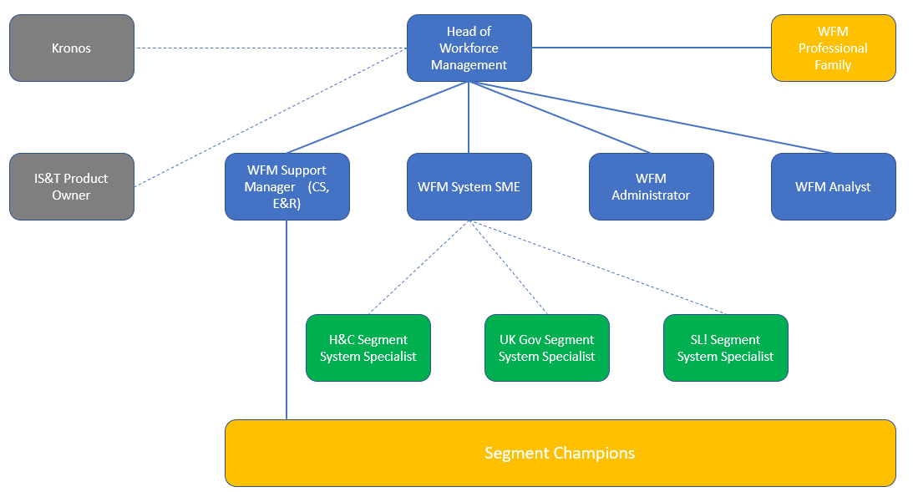

4. Context and main issues – Describe the most difficult types of problems the jobholder has to face (internal or external to Sodexo) and/or the regulations, guidelines, practices that are to be adhered to.
- Support the use of workforce management resource planning, WFM Systems Kronos and analytical dashboards – across core operational processes. The WFM Analyst will support colleagues in the achievement of full compliance and understanding of all workforce management related quality, health, safety and environmental company risk, reporting and governance processes.
- Proactively work with the Workforce Management team to analyse operational compliance with KPI’s across all WFM systems

5. Main assignments – Indicate the main activities / duties to be conducted in the job.
- SME on use of Workforce Management Analytics across all services and systems and able to work independently in supporting reviews being undertaken by the WFM team
- SME on operational use and interpretation of Workforce Management Analytics Dashboards
- Participate in course delivery as a Subject Matter Expert in Workforce Management Analytics
- Support the segment “champion” network, ensuring that all candidates are suitably supported in their understanding of Workforce Management Analytics
- Provide practical and effective guidance to the WFM team through business analysis of labour and service delivery
- Coach operational management in Workforce Management Analytics
- Support the Head of Workforce Management in the development and continuous improvement of tools to control resource allocation and related workforce management processes
- Actively support segments - regional/account/site management in the completion of robust annual/on-going action plans to deliver workforce management productivity and compliance targets and achieve “sign off” of plans with account management
- Maintain effective working relationships with other service operations specialists, understanding the wider UK business environment and working proactively and professionally, in developing integrated and focussed continuous improvement and a unified Sodexo brand.
- Champion Workforce Management initiatives across the business area and ensure that all services are aligned to client and customer needs and deliverable within budget
- Lead by example and demonstrate the company values at all times with company, client and peers.

6. Accountabilities – Give the 3 to 5 key outputs of the position vis-à-vis the organization; they should focus on end results, not duties or activities.
- Contribution to gross profit and improvements to budget performance
- Audit compliance scores for contract deployment of workforce management programme
- Value of workforce management initiatives, using appropriate financial/non-financial analysis.
- Improved employee engagement figures within segment through support of business awareness.
- Continued professional development in industry sector

7. Person Specification – Indicate the skills, knowledge and experience that the job holder should require to conduct the role effectively
- Experience of Workforce Management processes and applications – ideally resource allocation planning and Time and Attendance Systems and change management
- Advanced Microsoft applications; MS Project, SharePoint, and advanced knowledge of Word, Excel, PowerPoint
- Excellent verbal and written communication skills, with a proven experience of managing client and/or customer relationships
- Experience of Workforce Management processes and applications – ideally resource allocation planning and Time and Attendance Systems and change management
- Knowledge of excellence programmes and continuous improvement (e.g ISO 9001:2008/Six Sigma/LEAN/BNP disciplines

8. Competencies – Indicate which of the Sodexo core competencies and any professional competencies that the role requires
- Growth, Client & Customer Satisfaction / Quality of Services provided | - Leadership & People Management
- Rigorous management of results | - Innovation and Change
- Brand Notoriety | - Business Consulting
- Commercial Awareness | - Employee Engagement
 | - Learning & Development

9. Management Approval – To be completed by document owner
Version | 1.0 | Date | 10 01 2024
Document Owner | Stephen Penniston

