on-site services
JoB description

Position Title | Ward Host/ Hostess supervisor | Department | Catering
Generic Job Title | Food Service Assistant | Segment | Healthcare
Team Band | Frontline Staff | Location | Leicester
Reports to | Business Manager Catering | Office / Unit name | Leicester Nuffield

ORGANISATION StRUCTURE

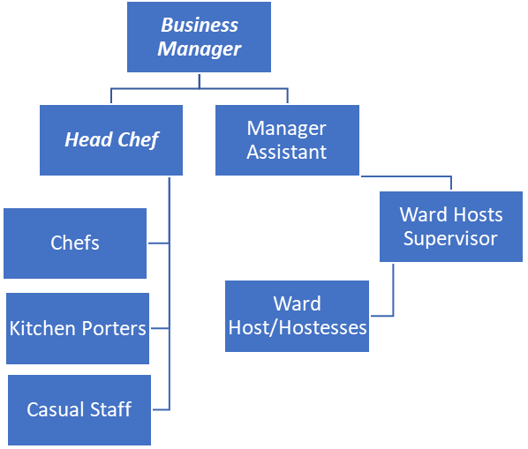

Job Purpose
- To work in conjunction with ward and kitchen team to develop and provide a high quality, helpful and courteous service to patients and staff

Accountabilities or “what you have to do”
- To assist in the preparation of patient food in a hygienic manner following all instructions given.
- To engage with the patients to feel welcome and relaxed with their time in our care.
- Communicate with the kitchen to ensure that all food orders are made and are what are required by the patient/visitor.
- Keep the pantry clean and tidy at all times to stay in the condition laid out in service level agreement and to meet all legal and company responsibilities.
- Assist the manger and supervisor to achieve service level agreements, health and safety requirements.
- Complete all audit and quality standards documentation as required.
- Ensure that patient’s dietary requirements are provided for.
- Ad-hoc duties as and when required

Key Performance Indicators (KPIs) or “What it will look like when you are doing the job well”
- Good PSS results on monthly basis
- Client satisfaction
- Safegard audit rating green
- Maintain a 5 star food hygiene rating by EHO

Skills, Knowledge and Experience

Essential
- Good Communication skills
- Great customer service skills
- Ability to work well within a team
- Good literacy and numeracy skills
- Ability to understand and adhere to legislation at all times
- Ability to understand detailed instructions.

Desirable
- Food hygiene level 2 or above

Contextual or other information
- During the course of his/her duties the post holder may have access to private and confidential information which must not be divulged to any unauthorised person or relative at any time.

Version |  | Date | 23/4/25
Document owner | Belinda smith

