EXPERTISE
Job description

Function: | Corporate Services
Position: | Fabric Engineer
Job holder: | Technical Services Manager
Date (in job since): | n/a
Immediate manager  (N+1 Job title and name): | Lead Engineer
Additional reporting line to: | TSM
Position location: | London & Surrounding Areas

1. Purpose of the Job – State concisely the aim of the job.
Planned Preventative Maintenance and reactive maintenance of general building fabric. Working predominantly in Central London (Soho) with occasional travel to Bishops Stortford. You will have experience / expertise in diagnosing faults and rectifying them. Ensuring all statutory requirements are adhered to.

2. Organisation chart
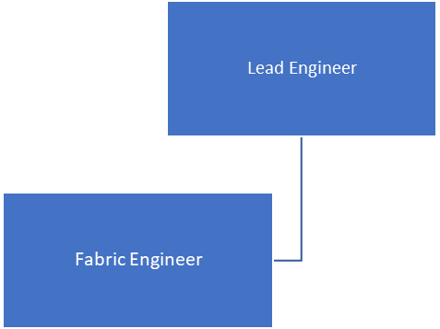

3. Context and main issues – Describe the most difficult types of problems the jobholder has to face (internal or external to Sodexo) and/or the regulations, guidelines, practices that are to be adhered to.
Work as part of the M&E team ensuring all PPM and reactive maintenance in completed in line with the contract and KPls.
Draft. Version: 27-03-2014
4. Main assignments – Indicate the main activities / duties to be conducted in the job.
- Undertaking Preventative Planned Maintenance (PPM) tasks, e.g. Weekly sprinkler tests, fire doors, smoke vents
- First line response to any associated work orders
- Carry out minor adaptations to the environment, i.e., putting up shelves, notice boards, hand sanitising stations
- Decoration and refurbishment
- Minor plumbing works (unblock sinks, toilets and drains, repair leaks, fit new tap washers)
- Building fabric repairs, i.e. tiling, ceiling tiles, flooring etc
- Adjust doors, tighten hinges, change or fit locks and door closures
- Assist other service lines (front of house/security/cleaning etc) where required
- Monday to Friday, 40 hours per week, shifts between 7am and 7pm.
- Mandatory overtime one weekend in five to cover out of hours PPM’s/reactive works and host contractors
- Be part of the on call Rota
- Any other duties as required as per business requirements

5. Accountabilities – Give the 3 to 5 key outputs of the position vis-à-vis the organization; they should focus on end results, not duties or activities.
- Customer satisfaction
- Team spirit
- Compliance
- Innovations
- Service delivery
- No complaints
- Job satisfaction

6. Person Specification – Indicate the skills, knowledge and experience that the job holder should require to conduct the role effectively
Essential
- Experience of PPM and reactive work/tasks for a company
- Good computer skills (MS Office, PDA’s etc)
- Driving Licence and own transport required
- Physically fit as lifting may be involved & must be able to work in restricted and at height
- A good knowledge of health and safety
- Ability to handle tools correctly and safely
- Must be able to work some flexible hours to suit the needs of a busy site
Desirable
- PASMA/IPAF trained
- Asbestos awareness
- L8 / Potable Water awareness
- Recognised apprenticeship or NVQ

7. Competencies – Indicate which of the Sodexo core competencies and any professional competencies that the role requires
- Growth, Client & Customer Satisfaction / Quality of Services provided
- Brand Notoriety
Innovation and Change
- Employee Engagement
- Learning & Development

