Job Description

Function: |  |  |  | Craft Operations
Position: |  |  |  | Lead Baker
Job Holder:
Start Date:
Immediate Manager: |  |  |  | Terrace Café manager
Additional Reporting Line: |  |  |  | Susan Holligan
Position Location: |  |  |  | RBGE
- Purpose of the job

1 | To be the Craft lead for the Café bakery operation, supporting the whole RBGE estate
2 | Set and maintain an exceptionally high standard of food service.
3 | Create and maintain a working environment which meets all current legislative responsibilities.
4 | Ensure effective and acceptable lines of communication between the Bakery and all other catering staff.
5 | To ensure the highest standards of cleanliness, tidiness and maintenance in areas of responsibility at all times.
6 | Create and maintain a safe, happy and committed working environment for the team, with an emphasis on development for all staff.
7 | Assist and support the Retail General Manager on key financial aspects within the P&L to achieve budget, and look to improve budget where possible.
8 | Provide innovation and new product ideas, and where practicable, use and promote local ingredients and suppliers.

- Commercial remit

Revenue: FY | £ tbc | EBIT growth | tbc |  | Growth Type |  | Outsourcing Rate |  |  |  | Region Workforce
Revenue: FY | £ tbc | EBIT margin | tbc
Revenue: FY | £ tbc | Net income growth | tbc |  | Growth Type |  | Outsourcing Growth Rate |  |  |  | Outsourcing Growth Rate
Revenue: FY | £ tbc | Cash Conversion | tbc
Characteristics |  | Financial
 |  | Other

3. Organisation Chart
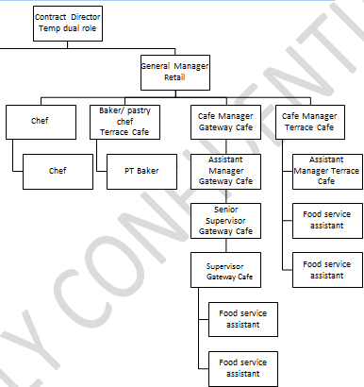
- Context and main issues

1 | Ensure the bakery delivers a high-quality product at all times
2 | Ensure that financial targets are met or exceeded each month
3 | Deliver, maintain and improve the HPL food ethos
4 | Ensure the communication of all necessary product knowledge and allergen information to allow them to pass on to customers on request

- Main assignments

1 | Provide an exceptional bakery produce to the specifications agreed
2 | Ability to demonstrate a wide range of skills in order to create a diverse and interesting range, with an expansive repertoire of non-gluten containing, dairy free and vegan dishes.
3 | Ensure a focus on customer needs and feedback and ensure that any food queries or complaints are dealt with promptly and professionally
4 | Collaboration with Retail development chef on Bakery offer development

- Accountabilities

 | 1 | Ensure that all members of the team are fully aware of and achieve any set objectives
 | 2 | Ensure a focus on client needs and feedback, and ensure that any food queries or complaints are dealt with promptly and professionally
 | 3 | Ensure all equipment under your supervision is maintained in working order and kept clean, has clear operations instructions, is safe and secure with any issues being reported at the first available opportunity, and that all staff are regularly retrained on use of equipment
 | 4 | Ensure that all Health & Safety legislation is carried out correctly and recorded as necessary. This includes all HACCP,Saf3gard/ EHO visits, Fire Evacuation Procedure, First Aid at Work and safe working practices at all times. Maintain a focus on food allergens and customer information.
- Person Specification

1 |  |  | Natural creative and innovative flair with a genuine love of food and an eye for detail
2 |  |  | Excellent people management skills, with a desire to share knowledge and best practises
3 |  |  | Knowledge of Excel, Word and Microsoft Outlook
4 |  |  | Industry awareness from high street to high end cafes, and be aware of competitors for benchmarking purposes, current and upcoming trends
5 |  |  | Ability to multi-task
6 |  |  | Professional, motivated, driven, flexible and enthusiastic
7 |  |  | Ability to innovate solutions and prioritise workload

- Competencies

. | HIgh level of bakery relative skills | . | Computer Literate
. | Team Player | . | Commercial Awareness

