
Job Description:
Sustainability & Workplace Culture Team Coordinator

Function: | Sustainability & Workplace Culture – HR Transversal
Position: | Sustainability & Workplace Culture Team Coordinator
Job holder:
Date (in job since):
Immediate manager  (N+1 Job title and name): | Social Impact Manager – Emilie Wright
Additional reporting line to:
Position location: | Hybrid
1. Purpose of the Job – State concisely the aim of the job.
- To provide efficient and professional coordination and administrative support across the Sustainability & Workplace Culture leadership team, helping ensure the smooth operation of the function and enabling leaders to focus on strategic priorities.
- The role will support diary management, travel arrangements, meeting coordination, event planning, stakeholder engagement, governance activities and communications. It will also play an important role in identifying opportunities to improve ways of working through effective use of digital tools and systems including AI.

5. 2. Main assignments – Indicate the main activities / duties to be conducted in the job.
Team Coordination & Executive Support
- Provide coordination and administrative support to the Sustainability & Workplace Culture Director and wider leadership team.
- Arrange meetings, workshops and team activities.
- Prepare agendas, take notes and maintain action trackers.
- Manage team records, shared folders and key documentation.
- Support team planning and calendar coordination.
- Support delivery of team rewards (Recognising You)
- Assist with team engagement and culture initiatives.
- Provide ad hoc administrative support to the Director and senior leaders.

Event & Engagement Support
- Support the planning and delivery of internal and external events.
- Coordinate invitations, registrations and event logistics.
- Assist with presentations, briefing materials and attendee communications.
- Provide event support before, during and after activities.
- Track follow up actions and outcomes from events.

Travel, Procurement & Budget Administration
- Arrange travel and accommodation bookings when required.
- Raise and track purchase orders and support invoice processing.
- Process expenses in line with company procedures.
- Support budget tracking and administration.
- Liaise with suppliers and external providers.

Stakeholder Coordination
- Act as a point of contact for internal and external stakeholders.
- Maintain stakeholder contact lists and distribution groups.
- Support communications and information sharing across the team.
- Build effective working relationships with colleagues and partners.

Reporting & Governance Support
- Maintain trackers, action logs and governance documentation.
- Assist with reports, presentations and meeting packs.
- Support data collection and submission deadlines.
- Provide administrative support for audits and reviews.

Digital & Continuous Improvement
- Use Microsoft 365 and Copilot to support efficient ways of working.
- Support creation of meeting summaries, presentations and communications.
- Identify opportunities to improve processes and simplify administration.

2. 3. Context and main issues – Describe the most difficult types of problems the jobholder must face (internal or external to Sodexo) and/or the regulations, guidelines, practices that are to be adhered to.
- Operating across a diverse and highly matrixed function covering a number of different business areas requiring effective coordination of multiple stakeholders, priorities and deadlines.
- Supporting the Director and senior leadership team with competing demands, often requiring careful planning, prioritisation and attention to detail.
- Managing multiple diaries, meetings, travel bookings, events and administrative activities simultaneously while ensuring accuracy and responsiveness.
- Liaising with a wide range of internal and external stakeholders, including clients, suppliers, charities, industry bodies and senior leaders, maintaining a professional and customer-focused approach at all times.
- Ensuring confidential and commercially sensitive information is handled appropriately and in accordance with Sodexo policies and procedures.
- Adapting to changing priorities and responding quickly to emerging business needs, often working to tight deadlines.
- Producing accurate documentation, reports, presentations and meeting materials where errors or omissions may impact decision-making, stakeholder experience or team effectiveness.
- Maintaining effective governance and action tracking across multiple projects, meetings and initiatives to ensure commitments are delivered on time.
- Developing confidence in the use of Microsoft 365, Copilot and other approved digital and AI-enabled tools to improve productivity, streamline administrative tasks and support continuous improvement.
- Balancing the demands of a development role, learning new systems, processes and subject areas while delivering a high-quality support service to the leadership team.

4. Accountabilities – Give the 3 to 5 key outputs of the position vis-à-vis the organization; they should focus on end results, not duties or activities.
Efficient Executive and Leadership Support Provide proactive and high-quality coordination support that enables the Sustainability & Workplace Culture Director and leadership team to maximise time spent on strategic priorities, decision-making and stakeholder engagement.
Effective Team Governance and Operational Excellence Ensure key meetings, reporting cycles, action tracking and governance processes are delivered accurately, on time and to a consistently high standard, supporting effective management of the Sustainability & Workplace Culture function.
Professional Stakeholder and Client Coordination Deliver a seamless experience for internal and external stakeholders through effective coordination of communications, meetings, events and engagements, enhancing the reputation and credibility of the function.
Successful Delivery of Leadership Activities and Events Ensure the efficient planning and coordination of travel, conferences, speaking engagements, leadership events and team activities, enabling senior leaders to represent Sodexo professionally and effectively.
Continuous Improvement and Team Effectiveness Identify opportunities to simplify processes, improve administrative efficiency and enhance ways of working across the Sustainability & Workplace Culture team, contributing to a well-organised, high-performing function.

2. 5. Dimensions – Point out the main figures / indicators to give some insight on the “volumes” managed by the position and/or the activity of the Department.
- Primary coordination support for the Sustainability & Workplace Culture Director.
- Secondary coordination support for five senior managers within the function.
- Supports a function comprising multiple disciplines including Sustainability, Social Impact, Culture & Belonging, Health & Safety, Quality, Business Resilience and the Stop Hunger Foundation.
- Regular interaction with internal stakeholders, clients, external partners, suppliers, charities and industry bodies.
- Coordinates multiple activities, meetings and projects simultaneously.
- No direct reports.
- No budget accountability beyond routine expense administration.

6. Job profile – Describe the qualifications (Education & experience), competencies and skills needed to succeed in the position.
Customer & Stakeholder Focus Builds positive relationships and provides excellent support to colleagues, clients and partners.
Collaboration Works effectively with people across teams and functions.
Planning & Organisation Manages multiple activities efficiently and delivers high-quality outputs.
Attention to Detail Produces accurate work and follows through on commitments.
Initiative Takes ownership of tasks and seeks opportunities to improve ways of working.
Adaptability Responds positively to changing priorities and business needs.
Learning Agility Demonstrates curiosity, embraces feedback and actively develops new skills.
Digital Mindset Shows enthusiasm for technology and embraces digital and AI-enabled ways of working.

2. 7. Organization chart – Indicate schematically the position of the job within the organization. It is sufficient to indicate one hierarchical level above (including possible functional boss) and, if applicable, one below the position. In the horizontal direction, the other jobs reporting to the same superior should be indicated.
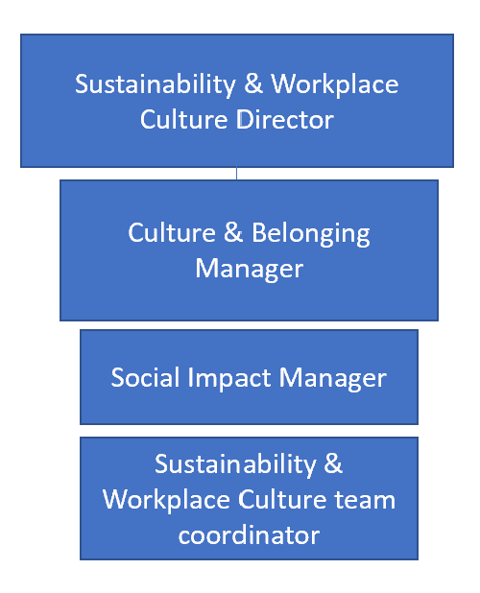
Levels

Received:

Date: Date: 26/08/2026

__________________________________
Job holder Immediate Manager

