
Job Description:
Head of Fire Safety, UK&I

Function: | HSE
Position: | Head of Fire Safety, UK & Ireland
Job holder: | NA
Date (in job since): | NA
Immediate manager  (N+1 Job title and name): | HSE Director
Additional reporting line to: | NA
Position location: | Home base: London/ Salford with UK & Ireland (National remit; regular travel required)
1. Purpose of the Job – State concisely the aim of the job.
The purpose of the role is to lead the UK&I fire safety strategy, development of governance and assurance frameworks as well as ensuring assessment of competency for fire-related post holders across the business.

The role is required to act as the “Competent Person” for the purposes of the Regulatory Reform (Fire Safety) Order 2005 and provide assurance to the business that all fire safety legislative requirements are met. The role augments local capability within individual contracts across the UK and Ireland business and will be responsible to report on the suitability of arrangements following corporate fire strategies.

The role should provide senior leadership, technical authority, and strategic direction for fire safety across Sodexo UK & Ireland ensuring a compliant, resilient, and future‑proof fire safety framework aligned with regulatory, insurer, and client expectations.

5. 2. Main assignments – Indicate the main activities / duties to be conducted in the job.
- Lead and implement the UK&I fire safety strategy and roadmap.
- Own, develop and maintain the fire safety governance model.
- Set clear standards and guidance for the operational business as part of the fire strategy.
- Define and maintain competency standards for all fire safety roles supporting business segments; measuring the effectiveness of resources allocated for fire safety.
- Provide authoritative technical support across high‑risk environments within the UK & I business assisting segment specific resource,
- Provide assurance in relation to fire risk mitigation effectiveness via frameworks, audits, compliance controls, and corrective actions.
- Act as senior escalation point for the Fire Authorising Engineer and Fire Safety Advisors.
- Support mobilisation, bids, PFI handbacks, and operational transitions.
- Maintain strategic relationships with the Primary Authority, regulators, insurers, and industry bodies. There are a range of fire safety regulators such as CPFSI, HSE, Local Fire Authorities and MoD based upon the client site/ contract arrangements.
- Lead a zero-harm fire safety culture, ensuring fire safety best practice networks.

2. 3. Context and main issues – Describe the most difficult types of problems the jobholder must face (internal or external to Sodexo) and/or the regulations, guidelines, practices that are to be adhered to.
- The diverse operational portfolio requires tailored governance, expert oversight, and robust assurance appreciating the nuances of local contracts and need.
- High external scrutiny from regulators, insurers, and clients necessitates robust governance, procedures and processes.
- Irish regulatory frameworks differ from the UK, requiring locally informed governance.
- Organisation requires competence, governance, and scalable support according to business needs

4. Accountabilities – Give the 3 to 5 key outputs of the position vis-à-vis the organization; they should focus on end results, not duties or activities.
- Deliver a robust, compliant, and assured fire safety framework.
- Embed consistent governance and technical standards across all segments.
- Enable clear, risk‑based decision‑making.
- Strengthen regulatory approach via stakeholder engagement.
- Improve organisational resilience and reduce fire‑related operational risk.

2. 5. Dimensions – Point out the main figures / indicators to give some insight on the “volumes” managed by the position and/or the activity of the Department.
- National remit across multiple high‑risk and regulated environments
- Oversight of fire safety competence, assurance programmes, and audit cycles.
- Strategic engagement with regulators, Primary Authority, insurers, and industry bodies.

6. Job profile – Describe the qualifications (Education & experience), competencies and skills needed to succeed in the position.
Qualifications

Membership of the Institution of Fire Engineers or Institute of Fire Safety Managers.
(At least at the level of Member grade)
A qualification in fire prevention or fire safety, e.g., a combination of both the NEBOSH National Certificate in Fire Safety and Risk Management and NEBOSH General Certificate or an equivalent level 4 RQF accredited fire risk assessment course.

Experience

Strategic experience of fire safety assurance at a senior management level across a complex and multi-site organisation. This should include development and leadership of fire strategies and setting assurance and governance frameworks.

Development of fire strategies and related policies to assure organisations that fire related duties are being discharged, improving fire safety compliance and developing progressive cultures.

The post holder should have a detailed knowledge and understanding of fire legislation as well as building regulations and building fire precautions.

Success Factors
  - Ability to influence stakeholders to adopt fire safety best practice, building relationships and networks.
  - Capable to authoritatively act as the organisations competent person for fire safety related matters.
  - Skills to convey complex technical and legislative requirements into operationally focused guidance.
  - Ability to implement comprehensive reporting to validate fire safety assurance via associated governance and assurance frameworks.

2. 7. Organization chart – Indicate schematically the position of the job within the organization. It is sufficient to indicate one hierarchical level above (including possible functional boss) and, if applicable, one below the position. In the horizontal direction, the other jobs reporting to the same superior should be indicated.
The post holder reports into the HSE Director, it does not have any direct reports however there are a number of functional touchpoints with subject matter experts across the organisation to ensure the effectiveness of fire arrangements across a range of geographically spread contracts in the UK and Ireland. The role is part of the wider HSEQ function leading a zero harm approach to health, safety, food and fire.
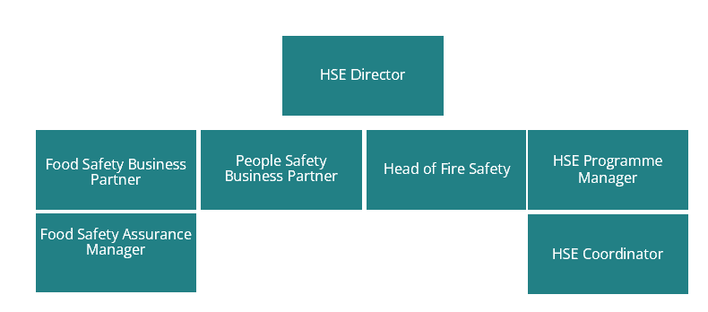

Levels
- Stakeholder Engagement
- Growth Mindset
- Influence
- Technical competence
- Collaboration and clarity

Received:

Date: 11 March 2026 Date:

__________________________________ ________________________________

Job holder Immediate Manager

