
Job Description:
Snr Cyber Security Specialist

Function: |  | Service Operations / IS&T
Job: |  | [Enter generic job title] Refer to Invent Position Title Guidance
Position: |  | Snr Cyber Security Specialist
Job holder: |  | Vacant
Date (in job since):
Immediate manager  (N+1 Job title and name): |  | Head of Cyber GRC
Additional reporting line to: |  | N/A
Position location: |  | Salford DC / Homeworker
1. Purpose of the Job – State concisely the aim of the job.
- Drive the reduction of vulnerabilities across Sodexo and its suppliers by developing and maintaining enterprise processes, procedures and tools
- Deploy and maintain security solutions (antimalware, EDR, MFA, etc.)
- Monitor the evolution of the threat landscape and propose countermeasures
- Increase operational security domain efficiency by automating ineffective processes
- Prioritisation of workload for SecOps function

2. Dimensions – Point out the main figures / indicators to give some insight on the “volumes” managed by the position and/or the activity of the Department.
Characteristics | - Act as a subject matter expert on security solutions covering an estate comprising:  - 13,000 users  - 12,000 workstations  - 8,000 mobile phones  - 300 on premise servers  - 2,000 interconnected sites and networks with varying security needs and connectivity  - 100-200 of SaaS solutions accessed remotely  - 100 technology suppliers providing support and maintenance to systems deployed on site  - Deal with hundreds of vulnerabilities
Draft. Version: 27-03-2014
3. Organisation chart – Indicate schematically the position of the job within the organisation. It is sufficient to indicate one hierarchical level above (including possible functional boss) and, if applicable, one below the position. In the horizontal direction, the other jobs reporting to the same superior should be indicated.
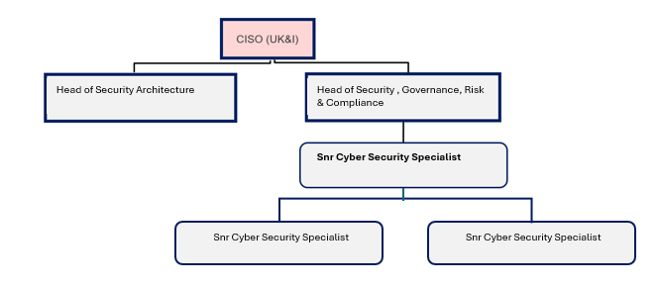

4. Context and main issues – Describe the most difficult types of problems the jobholder has to face (internal or external to Sodexo) and/or the regulations, guidelines, practices that are to be adhered to.
- Interact with multiple stakeholders across IS&T (infrastructure, applications, PMO, security, etc.) and the wider business when needed
- Influence decisions and actions without direct authority
- Deal with resistance to change
- Develop an automate first approach in a very manual landscape
- Work with legacy environments and assets and find suitable workarounds to standard remediation procedures
- Work with external suppliers on their remediation activities without direct IT oversight
- Work with Head of GRC and SecOps team to prioritise demand

5. Main assignments – Indicate the main activities / duties toe conducted in the job.
- Operational Security
  - Act as the Subject Matter Expert on security solutions (antimalware, vulnerability scanner, EDR, MFA, etc.) and work as solution owner
  - Be the spokesperson and referent for the deployment of security solutions
  - Provide expertise and implement technical security protocols (encryption, DMARC, etc.)
  - Support activities in the security architecture domain to ensure security is adequately implemented in architecture design
  - Assist with security incidents at a local level
  - Review change requests and provide technical recommendations as needed
- Continuous improvement
  - Contribute to pilots and proof of concepts to enhance IT & Cyber Security capabilities
  - Automate manual processes to gain in efficiency and reduce errors
  - Support the Operational Security domain in developing new processes, procedures, and tools
  - Stay up to date with evolving threats and mitigation techniques
  - Assist the GRC team in collation of statistics, reporting risk and providing remediation plans
- Vulnerability Management
  - Define and maintain a vulnerability testing programme across Sodexo and its suppliers to ensure vulnerabilities are timely identified and handled adequately
  - Monitor vulnerabilities for the whole estate covering on premise assets but also external SaaS and public Cloud assets as needed
  - Lead the penetration tests and technical security audits schedule (source code review, architecture review, etc.), report findings, manage stakeholders and lead the remediation program
  - Support business stakeholders, suppliers when needed, and the wider IS&T department in defining appropriate action plans
  - Prioritise vulnerability management remediation activities to ensure a sound approach to continuously improve the vulnerability management procedures and process

6. Accountabilities – Give the 3 to 5 key outputs of the position vis-à-vis the organization; they should focus on end results, not duties or activities.
- Ensure vulnerabilities are identified and communicated to business stakeholders, and appropriate action plans are implemented to reduce risks
- Ensure security solutions are in place and operating as expected
- Provide technical security expertise for ad-hoc requests or projects for new security solutions
- Automate any security process possible
- Provide demand prioritisation to the SecOps team

7. Person Specification – Indicate the skills, knowledge and experience that the job holder should require to conduct the role effectively
- Demonstrated experience of driving reduction of vulnerabilities within an enterprise
- Experience with risk-based vulnerability management and a solid understanding of exploitable vulnerabilities
- Experience of establishing and maintaining operational security solutions management processes, procedures, and tools at enterprise level
- Hands-on experience of selecting, deploying and maintaining a variety of security solutions such as vulnerability appliances/agents, EDR, antimalware, MFA, etc.
- Hands-on experience in network/server and security operational roles
- Experience in automating manual processes in line with DevOps/DevSecOps
- Experience of communicating technical information to a non-technical audience to define relevant action plans with the business and IS&T
- Proficiency in core information security principles (access control, operating system security, vulnerability management, etc.)
- Knowledge of MITRE, NIST and OWASP frameworks
- Knowledge of Microsoft Enterprise access model and AD tier model
- Resilient, Rigorous and organised
- Experience of managing penetration testing engagements with a third party

8. Competencies – Indicate which of the Sodexo core competencies and any professional competencies that the role requires
- Rigorous management of results
- Innovation and Change
- Business Consulting

9. Management Approval – To be completed by document owner
Version | 1.0 | Date | 30 December 2025
Document Owner | Regional CISO UK&I

