
Job Description:
[Porter]

Function: |  |  |  | HEALTHCARE
Job: |  |  |  | PORTER / LOGISTICS
Position: |  |  |  | PORTER
Job holder:
Date (in job since):
Immediate manager  (N+1 Job title and name): |  |  |  | Caroline Carr
Additional reporting line to: |  |  |  | Porter Manager
Position location: |  |  |  | All Clinical Areas of the Hospital
1. Purpose of the Job – State concisely the aim of the job.
To provide a service to meet the needs of the Trust and to ensure that patient records, materials and equipment are safely and appropriately transferred both at the Hospital Site and all other areas used by the Trust. To direct patients, staff and visitors to all area’s of the hospital, within the requirements of the specification.
2. Dimensions – Point out the main figures / indicators to give some insight on the “volumes” managed by the position and/or the activity of the Department.
Revenue FY13: | €tbc |  | EBIT growth: |  | tbc | Growth type: | n/a | Outsourcing rate: | n/a | Region Workforce | tbc
Revenue FY13: |  |  | EBIT margin: |  | tbc
Revenue FY13: |  |  | Net income growth: |  | tbc | Growth type: | n/a | Outsourcing growth rate: | n/a | HR in Region | tbc
Revenue FY13: |  |  | Cash conversion: |  | tbc
Characteristics |  | - Add point
Draft. Version: 27-03-2014
3. Organisation chart – Indicate schematically the position of the job within the organisation. It is sufficient to indicate one hierarchical level above (including possible functional boss) and, if applicable, one below the position. In the horizontal direction, the other jobs reporting to the same superior should be indicated.
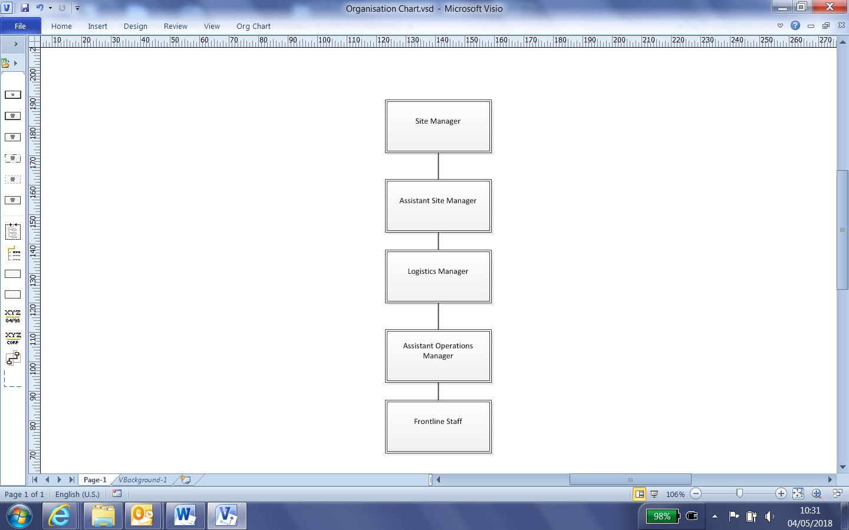

4. Context and main issues – Describe the most difficult types of problems the jobholder has to face (internal or external to Sodexo) and/or the regulations, guidelines, practices that are to be adhered to.
- Transfer patients in a safe and appropriate manner to/from wards, departments and theatres via means of walking, wheelchair, trolley or beds including assisting patients to be “Pat Slide”. Assist in the transfer of seriously injured patients from the helicopter to the A&E department.

- Convey blood specimens in a safe manner from wards/departments to Pathology department; utilising the designated blood tracking system for the benefit of both patient and the department.

- Conveyance of patient notes and x-rays to and from wards/departments.

- Removal of deceased bodies from wards/departments to the mortuary in a safe and dignified manner. Accept coroners cases into the mortuary and assist in viewing, in the absence of the mortuary technician

- Replace medical gasses where necessary on wards/departments for the requirement of patients. Re-stock oxygen banks as required.

- Assist in the distribution of drugs from pharmacy to wards/departments.

- Remove equipment from wards/departments as required

- Removal of clinical / non-clinical waste and laundry from departments as required.

- Attend adult/child emergencies collecting resus equipment and taking to site of emergency.

- Attend emergencies called through ‘fast bleep’ system as instructed e.g. fire, child abduction, security issues as laid down in the Trust Policies and Procedures.

- Control of all urgent/non-urgent goods inwards completing essential records ensuring all goods received are in a sound condition.

- Any additional duties required by the Line Manager in line with business needs

5. Main assignments – Indicate the main activities / duties to be conducted in the job.
- Safe transportation of Patients, Equipment, Post etc.
- Safe transportation of Blood Products
- Safe transportation and changing of Medical Gas Cylinders

6. Accountabilities – Give the 3 to 5 key outputs of the position vis-à-vis the organization; they should focus on end results, not duties or activities.
- Professional Attitude at all times
- Follow Procedures and Training
- Empathy with Patients and Visitors

7. Person Specification – Indicate the skills, knowledge and experience that the job holder should require to conduct the role effectively
Essential:
- Manual Handling training
- Empathy with patients and visitors
- Ability to follow instructions
- Effective communication and customer care skills
- High standards of personal hygiene
- Ability to deal with stressful situations
- Basic literacy skills

Desirable
- Ability to work on their own or part of a team
- Flexible approach and has a good work ethic
- Ability to follow instructions
- Effective communication and customer care skills
- High standards of personal hygiene
- Ability to deal with stressful situations
- Basic literacy skills

8. Competencies – Indicate which of the Sodexo core competencies and any professional competencies that the role requires
- Growth, Client & Customer Satisfaction / Quality of Services provided | - Rigorous management of results
- Brand Notoriety | - Commercial Awareness

9. Management Approval – To be completed by document owner
Version | 1 | Date | November 2021
Document Owner | Caroline Carr

Signed by Employee………………………………………………

Date ………………………………………………

