
Job Description:
Regional Safeguarding Lead

Function: | Central HR [Labour Relations]
Position: | Regional Safeguarding Lead
Job holder: | XXXXX
Date (in job since): | XXXXXX
Immediate manager  (N+1 Job title and name): | Labour Relations & Policy Director
Additional reporting line to:
Position location: | Salford/Hybrid
1. Purpose of the Job – State concisely the aim of the job.
The purpose of the Safeguarding Lead is to champion a safe, respectful, and inclusive working environment across Sodexo UK&I. This pivotal role will oversee statutory safeguarding practices and lead on areas such as but not limited to Child Protection & Vulnerable Adults, Sexual Harassment, Domestic Violence, Online Safety & Digital Safeguarding, Prevent Duty / Counter-Extremism, Mental Health & Wellbeing, Modern Slavery & Exploitation, Safeguarding in Recruitment & Vetting, Incident Management & Case Review.

The Safeguarding Lead is a subject matter expert in safeguarding within healthcare, and educational settings, bringing deep knowledge of sector-specific risks, regulatory frameworks, and best practices to inform our commercial safeguarding strategy. The role will be accountable for ensuring Sodexo meets and exceeds its legislative obligations and sets best practice across all safeguarding domains.

5. 2. Main assignments – Indicate the main activities / duties to be conducted in the job.
- Leads the establishment of a Safeguarding Centre of Excellence within Labour Relations, laying the foundation for long-term strategic safeguarding capability and organisational compliance
- Develop and implement safeguarding policies and procedures tailored to a commercial environment in conjunction with specialist areas such as HR Policy, L&D, Culture & Belonging and Segments.
- Integrate sector-specific safeguarding insights from healthcare, and education into company-wide practices.
- Write and lead risk assessments and ensure safeguarding measures are embedded across all business functions, setting the bar for best practice.
- Ensure the company meets and exceeds its legislative obligations relating to safeguarding, harassment, whistleblowing, and employee welfare.
- Lead on safeguarding strategy, ensuring integration into broader operational plans.
- Demonstrates expert knowledge of safeguarding legislation across the UK and Republic of Ireland, ensuring compliance with jurisdiction-specific frameworks and fostering cross-border policy alignment.
- Act as the safeguarding lead for company support on bids and tenders, providing expert input to meet client safeguarding requirements and demonstrate best practice.
- Be ready to engage directly with clients and customers to represent the company’s safeguarding approach and respond to external queries or audits.
- Report on compliance, escalate risks to the HRLT, Labour Compliance Forum alongside recommendations for mitigation.
- Liaise with external agencies (e.g., local authorities, police, health services) on safeguarding matters.
- Represent Sodexo, as appropriate, in safeguarding forums and networks.
- Develop KPIs and metrics to assess safeguarding performance.
- Lead safeguarding audits and reviews.
- Report safeguarding outcomes to senior leadership and external regulators.

2. 3. Context and main issues – Describe the most difficult types of problems the jobholder must face (internal or external to Sodexo) and/or the regulations, guidelines, practices that are to be adhered to.
- The external safeguarding landscape is set to become more complex with new areas of legislation and expansion of Sodexo’s workplace duties and obligations including sexual harassment, domestic abuse and young workers.
- Increasingly clients are requesting visibility of and contact with a safeguarding lead as part of Sodexo’s service proposition/delivery.

4. Accountabilities – Give the 3 to 5 key outputs of the position vis-à-vis the organization; they should focus on end results, not duties or activities.
- Act as the subject matter expert on safeguarding in both statutory (children & vulnerable adults) and broader matters.
- Provide consultancy and guidance to internal teams on sector-specific safeguarding risks and responses.
- Stay abreast of regulatory changes and emerging trends in safeguarding and advise stakeholders accordingly.
- Where relevant, translate public sector safeguarding standards into commercial best practice.
- Identify and report risk through appropriate channels and provide recommendations on mitigation.

2. 5. Dimensions – Point out the main figures / indicators to give some insight on the “volumes” managed by the position and/or the activity of the Department.
- Financial: The Safeguarding Lead plays a critical role in mitigating financial risk by ensuring compliance with safeguarding legislation and best practice, reducing exposure to litigation, regulatory fines, compensation claims, and reputational damage. This includes oversight of safeguarding-related incidents across a workforce of approximately 30k+ employees.
- Staff: Indirect central support to colleagues performing aspects of safeguarding compliance within Segment particularly Health & Care and Schools & Universities and also Justice where required. Centre of excellence support to entire organization.

6. Job profile – Describe the qualifications (Education & experience), competencies and skills needed to succeed in the position.
- Proven experience in safeguarding, HR, compliance, or a related field. Level 4 Award for Designated Safeguarding Lead or equivalent for ROI
- A current and clean enhanced DBS check
- Demonstrable expertise in safeguarding.
- Strong understanding of UK safeguarding legislation in the employment context
- Familiarity with global safeguarding and whistleblowing standards.
- Exceptional interpersonal skills, with the ability to handle sensitive issues with empathy and discretion.
- Experience conducting investigations and conducting sensitive and complex cases.
- Relevant qualifications in safeguarding, social work, education, or HR.
- Proven ability to influence senior stakeholders and lead organisation-wide cultural change that embeds safeguarding as a strategic priority.
- Confidence in engaging with external clients and partners on safeguarding matters. Experience working with external safeguarding agencies (e.g., social services, police).
- Strong knowledge of safeguarding legislation and frameworks across UK nations and the Republic of Ireland, with the ability to apply them in a multi-jurisdictional context.

2. 7. Organization chart – Indicate schematically the position of the job within the organization. It is sufficient to indicate one hierarchical level above (including possible functional boss) and, if applicable, one below the position. In the horizontal direction, the other jobs reporting to the same superior should be indicated.
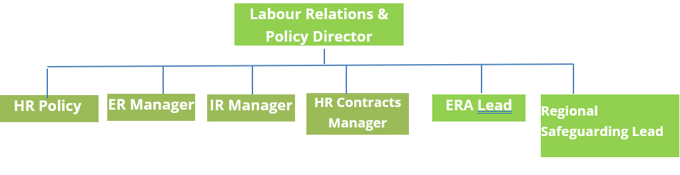

Levels
- RLT - 2

Received:

Date: Date:

__________________________________ ________________________________

Job holder Immediate Manager

