Job Description

Function: | Operations
Position: | Regional Operations Manager
Job Holder: | N/A
Start Date:
Immediate Manager: | Executive Director
Additional Reporting Line:
Position Location: | North Fort Street Head office

- Purpose of the Job

1 | Lead, develop and manage direct reports across the venue cluster
2 | Be responsible for building long-term relationships with clients that add value and are based on mutual trust
3 | Identify growth and development opportunities within contracts which deliver commercial success and strengthen venue partnerships
4 | To ensure a safe environment for our employees and customers, compliant to food safety and H&S standards, across venue portfolio.
5 | Maintain a customer focused approach to offer development that is defined by the quality of food and experience
6 | Drive innovation and continuous improvement of people, systems, processes inline with our mantra of “Never Standing Still”
7 | Maximise the profitability of the contracts within area of responsibility, achieving financial and service level targets
- Dimensions

Revenue: FY |  | £ tbc | EBIT growth | tbc | Growth Type |  | Outsourcing Rate |  |  | Region Workforce
 |  | £ tbc | EBIT margin | tbc
 |  | £ tbc | Net income growth | tbc | Growth Type |  | Outsourcing Growth Rate |  |  | Outsourcing Growth Rate
 |  | £ tbc | Cash Conversion | tbc
Characteristics |  |  | Financial
 |  |  | Other

- Organisation Chart

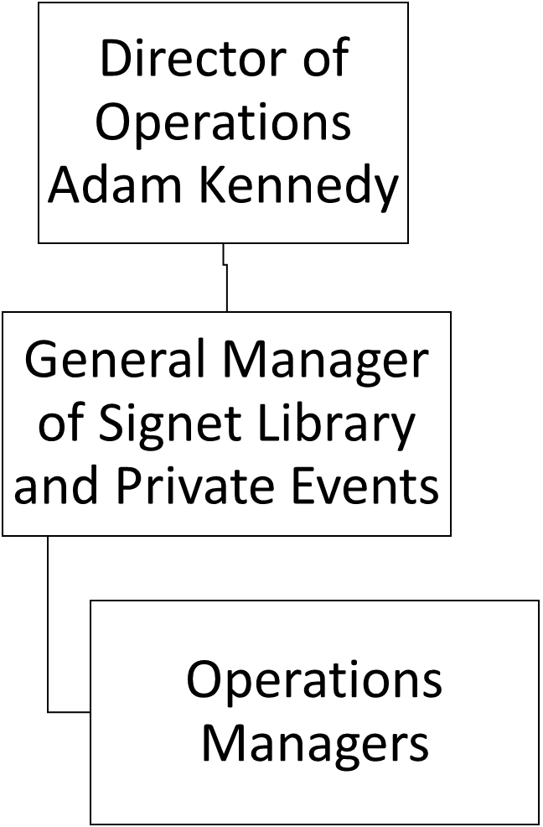
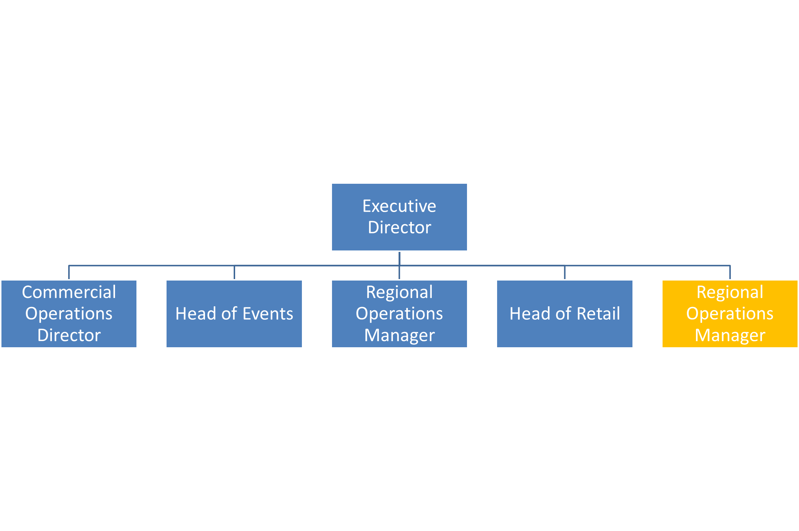

- Context and Main Issues

1 | Attracting and retaining talent in a competitive labour market
2 | Consistency in service delivery with a creative, innovative F&B proposition, in line with the standard we set across our venue portfolio.
3 | Exceed client expectations while achieving internal objectives
4 | Balance service excellence with achievement of financial targets
- Main Assignments

1 |  | Maintain high performing teams, demonstrated through annual appraisal, high retention rates, talent and succession planning processes and staff engagement surveys
2 |  | To recruit, train and develop team members as appropriate to their job role and development plan
3 |  | Financial objectives achieved through management of performance, detailed analysis of monthly results, accurate and considered forecasting, delegation of responsibility to direct reports
4 |  | Identify opportunity to improve performance through shared efficiencies within venue cluster
5 |  | Client retention and contract extension opportunities identified and converted through positive working relationships with clients
6 |  | Liaise with clients to understand their objectives and build venue specific strategies to align our activities to support them
7 |  | Promote a zero harm mindset to health and safety within you team, managing quality control, health, safety and hygiene standards inline with company policy.
8 |  | Report immediately any incidents or accidents, fire, theft, loss, damage or H&S issues and take action according to company policy
9 |  | To adhere to all contractual obligations and operate business portfolio within the agreed contractual terms
10 |  | Continuously seek ways to enhance quality through innovation and cost efficiency and living our core belief of “Never Standing Still”
11 |  | Operational support and delivery as directed
- Accountabilities

1 | Retaining, developing and motivating a high performing management team
2 | Achieving financial results that surpass company targets
3 | Retention of all key contracts across the portfolio
4 | Maintaining HPL’s position as market leader in Scotland
- Person Specification
Essential
1 |  | Minimum of 5 years’ experience managing a team in the events industry
2 |  | Strong commercial background with responsibility for managing multisite P&L
3 |  | A passionate interest in the catering industry – knowledge of current trends and interest in the hospitality world
4 |  | Demonstrable experience in a high-volume hospitality and retail catering environment
5 |  | A competent communicator and ability to present to colleagues, peers and clients
6 |  | Evidence of being organised and possess excellent planning skills
7 |  | Ability to competently use Microsoft Word, Excel , Power point and Email
8 |  | Proven record of managing a team encompassing operations, culinary, coordination and finance
9 |  | Ability to motivate a team of mixed abilities and personalities

Desirable
1 | Experience and understanding of event costings and design of events
2 | Staff training experience or qualification
3 | Experience in assisting to create a sales and marketing plan
4 | Capability to identify and highlight revenue maximising opportunities
5 | Ability to produce accurate work to tight deadlines under pressure
6 | Polished appearance, speech & demeanour
7 | First aid and personal alcohol licence qualifications
8 | High degree of dependability & self-reliance

- Competencies

. | Leadership and people management |  | Innovation and Change
. | Commercial awareness |  | Employee Engagement
. | Learning and development

