
Job Description:
Food Service Assistant

Function: |  |  |  | Universities
Position: |  |  |  | Food Service Assistant
Job holder:
Date (in job since):
Immediate manager |  |  |  | Retail Manager (Assistant Manager)
Additional reporting line to: |  |  |  | Nick Hayter – Account Manager
Position location: |  |  |  | Solent University
1. Purpose of the Job
Support of front and back of house restaurant services, ensuring excellent customer service and provision of service officers.

2. Dimensions
Revenue FY19 |  |  | £375,000
Characteristics |  | - Student - Staff and Public clientele
Draft. Version: 27-03-2014
3. Organisation chart –
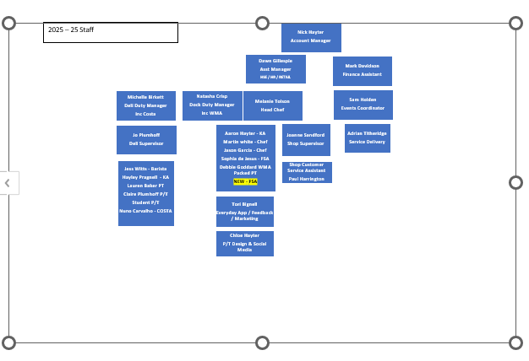

5. Main assignments – Indicate the main activities / duties to be conducted in the job.
- General Food Production
- Food Service
- Cleaning of Responsible Areas
- Customer Service
- Reporting into Head Chef and Restaurant Manager

6. Accountabilities –
- Working with the Kitchen and Front of House Team
- Basic Food Production and Item construction
- H&S and Food Safety – daily management
- Cleaning

7. Person Specification
- Honesty. In public relations, your reputation is key.
- Knowledge and research
- Relationship-building skills. ...
- Multi-tasking in a high-pressure work environment.
- Attention to detail.
- Adapts to change.
- Strategic thinking.
- Must be able to multitask.

8. Competencies –
- Basic Food Preparation
- Adaptability
- Can work under pressure

9. Management Approval –
Version |  | Date | 09/04/2025
Document Owner | Nick Hayter

