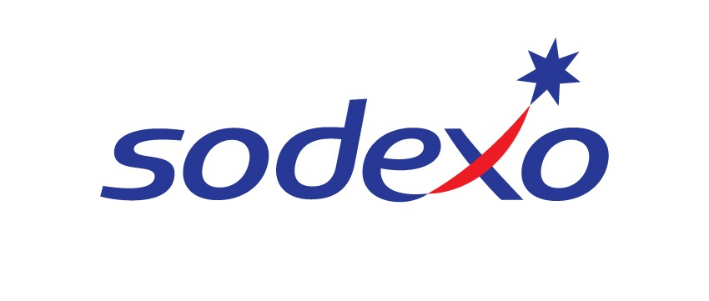
JOB DESCRIPTION

Soft FM General Operate

Place of work: Backweston Campus

Scope and purpose: To assist with maintenance of hygiene standards and the cleaning of the establishment to the Company’s standard and the client’s satisfaction.

Responsible to: Liesl Viglino

Liaise with: All facilities team, clients, customers and delivery personnel.

MAIN DUTIES
- To undertake all necessary cleaning to the Company’s standard as directed including walls (up to 6 feet), floors, fixtures & fittings,
- To ensure a high standard of personal hygiene, cleanliness and neatness ensuring full Sodexo uniform is worn at all times;
- To comply with statutory and company regulations the work place
- To ensure you act in the interests of your own safety and the safety of others as all times;
- To assist as directed with all aspects of preparation and presentation of the site as per Company’s standard;
- To receive any training that is necessary to maintain and improve the standards of the establishment;
- To ensure all areas are kept clean at all times
- To attend to any reasonable request by management.
- To assist in catering and hospitalities when needed to include driving the hospitality vehicle
- To assist in reception duties when needed
INFREQUENT DUTIES
- To prepare and assist in any special functions, which may sometimes be outside normal working hours;
- To report and take action on customer and client complaints or compliments and any incidents of accident, fire, theft, loss, damage, and unfit food or other irregularities;
- To attend meetings and training courses as may be necessary from time to time;
- To carry out reasonable periods of overtime as may be required from time to time.

NB. Whilst every effort has been made to ensure the details of this job description are correct – due to the varied requirements of the support services industry, this job description cannot be exhaustive. Therefore, the jobholder may be required from time to time to carry out other tasks as required by management in order to meet the operational needs of the business.

SIGNED BY EMPLOYEE: ______________________________________

DATE : ______________________________________

SIGNED ON BEHALF OF SODEXO: ______________________________________

PRINT NAME: ______________________________________

PRINT TITLE: ______________________________________

DATE: ______________________________________

