
Job Description:
Technical Supervisor

Function: | Justice Services
Position: | FM Technical Supervisor
Job holder:
Date (in job since):
Immediate manager  (N+1 Job title and name): | Deputy Head of Facilities
Additional reporting line to: | Head of Facilities
Position location: | HMP Altcourse
1. Purpose of the Job – State concisely the aim of the job.
To deliver a high-quality professional Facilities Management service which supports the needs of the Facilities manager in ensuring that the Prison remains secure, effective, and fit for purpose on a day-to-day basis and that statutory and contractual compliance is maintained.

Reporting to the Deputy Head of Facilities Management, the post holder will assist the Deputy Head of FM providing the day-to-day operational delivery of Hard Services through in-house teams and specialist contractors assisting in the reporting and delivery of all daily PPM and reactive maintenance.

To support staff development and training requirements of the team.

Must also be prepared to train/mentor and supervise prisoners as part of Sodexo’s rehabilitation philosophy.

5. 2. Main assignments – Indicate the main activities / duties to be conducted in the job.
- Ensure safe working practices are implemented and take corrective actions where required.
- Report unsafe practices or conditions.
- Take an active interest in staff welfare, engagement, and development.
- Demonstrate a genuine interest in the rehabilitative aims of the Prison.
- Conduct a quality check of 20% of works undertaken by the team each month, implementing corrective actions as necessary and Recognising successes.
- Review the CAFM system and that all PPM & Reactive maintenance is completed with the Statutory and Contractual agreements.
- Assist in the maintenance of accurate records of all preventative maintenance and repair work carried out by the team and report in detail any substandard or defective equipment.
- Provide accurate reports and contribute to reports within required timeframes using Microsoft Word, Microsoft Excel, and Microsoft PowerPoint.
- Manage email and telephone communications.
- Manage model office alongside Senior Admin (Online and paper based)
- Line management of the Maintenance team – carry out 1-2-1s, Mid & End of year reviews.

2. 3. Context and main issues – Describe the most difficult types of problems the jobholder must face (internal or external to Sodexo) and/or the regulations, guidelines, practices that are to be adhered to.
- To work alongside Deputy Head of FM to ensure all agreed Statutory Compliance, Planned Preventative Maintenance are delivered on time, to budget and to the agreed quality standard in accordance with Sodexo Justice Services and contractual requirements.

Support the Facilities Management in ensuring that:

- The Prison is kept in good structural and decorative order.
- The external areas are safe and presentable.
- All works and maintenance activities comply with current statutory legislation and Codes of Practice and that the Prison site and its buildings remain secure, effective, and fit for use.
- Management of health and Safety policies for Internal and external resources
- Auditing safe systems of work within the service delivery team and contractors.
- Compliance with ISOQAR 9001 and 14001 for Facilities Maintenance and Environmental Assurance is maintained.
A sound system of internal control is maintained for Facilities Management annual OPEX budgets.

4. Accountabilities – Give the 3 to 5 key outputs of the position vis-à-vis the organization; they should focus on end results, not duties or activities.
- All Planned and Reactive tasks are completed and signed-off in a timely and compliant manner.
- CAFM WO logs and statuses are updated daily to reflect timely and correct statuses of all tasks.
- Ensure that all tradesmen are trained, qualified and motivated to carry out their tasks.
- Ensure all training and qualifications are kept up to date.
- Provide weekly/monthly Work Order status and KPI reports as necessary.
- Ensure all necessary PPE, ladders, tools and vehicle checks are carried out and recorded.
- Provide accurate records of time taken for tasks, materials used, and any other information required to ensure efficient service delivery.
- Complete training and competency assessments
- Promote staff engagement through 121s, Personal Development Reviews and Team Huddles with direct reports.
- Effectively contributes to achieving successful audit results.
- Promote a high level of Health and Safety

2. 5. Dimensions – Point out the main figures / indicators to give some insight on the “volumes” managed by the position and/or the activity of the Department.
- To ensure all agreed Statutory Compliance, Planned Preventative and reactive Maintenance are delivered on time, to budget and to the agreed quality standard in accordance with Sodexo Justice and contractual requirements.
- To be part of the Maintenance team carrying out PPM and Reactive maintenance when required.

6. Job profile – Describe the qualifications (Education & experience), competencies and skills needed to succeed in the position.
- Experience of operating within a diverse engineering and FM environment
- A progressive, dynamic, and flexible approach to delivery of Maintenance Services
- Knowledge of BMS, CAFM and other in-house software packages following appropriate internal training.
- Demonstrable experience of successfully managing complex operations and projects within tight timeframes.
- Experience working in a 24/365 operational environment an advantage (e.g. hospitals, universities, prisons, etc.)
- Awareness of the HASAWA 1974 and their own legal obligations.
- Awareness of British Standards.
- City & Guilds qualification within an engineering discipline
- Able to communicate and work as part of a team and use own initiatives, knowledge, experience and professional judgment to act quickly in any emergency and to safely respond and make safe decisions regarding unsafe situations.
- Excellent communications both written and verbal.
- Numerate and computer literate (Excel, Word and Outlook).
- Hold very good awareness of equipment and associated maintenance skills.
- A good team player with a flexible approach in achieving the targets/work plans.

2. 7. Organization chart – Indicate schematically the position of the job within the organization. It is sufficient to indicate one hierarchical level above (including possible functional boss) and, if applicable, one below the position. In the horizontal direction, the other jobs reporting to the same superior should be indicated.
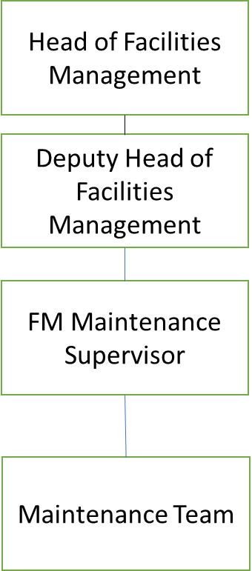

Levels
- Focusing on the client and Customer
- Continuous improvement
- Promoting the brand values
- Intellectual agility and eagerness to learn
- Focus on health and safety
- Professional standards

Received:

Date: Date:

___________________________________ Joe Roberts_______________________________

Job holder Immediate Manager

