
Job Description:
Commercial Contract Manager with QS

Function: | PPP Projects Ireland (Corporate Services Ireland
Position: | Commercial Manager/ QS
Job holder: | New Role
Date (in job since):
Immediate manager  (N+1 Job title and name): | Andrew Renwick Commercial Director UK&I Corporate Services
Additional reporting line to: | Deirdre Saunders divisional director Noel Cleary PPP contract director
Position location: | Leinster
1. Purpose of the Job – State concisely the aim of the job.
The Commercial Manager is responsible for the effective and efficient Commercial Management, of all contractual obligations, and provides skilled and quality leadership to the Contract Management team on all Commercial requirements.

This is an exciting and dynamic role within the PPP Contract portfolio, with a focus on managing the compliant service delivery of all Commercial matters within the contract requirements. The Commercial Manager shall oversee company needs through constantly communicating and negotiating with clients or business associates.

The Commercial Manager continuously working to strategically expand, preserve or improve the company’s procedures, standards or policies while sticking to business edicts and regulatory guidelines.

The job holder will monitor Sodexo objectives by supporting and delivering against Estates policies and compliance with legislative and departmental requirements. This will include playing a key role in identifying opportunities for innovation and modernization, to meet operational performance targets and Sodexo objectives.

The role shall include a review and of our Supply Chain Management procedures with a requirement to plan, develop and implement a robust Performance Measured based Supply Chain service delivery model combined with a lean way of procuring services and components to enable successful delivery of our contractual obligations.

The Commercial Manager shall be the gatekeeper and owner of all Risk Registers and shall work with internal and external customers to assure all Risk is managed and controlled.

5. 2. Main assignments – Indicate the main activities / duties to be conducted in the job.
- Working with the Contract Director and UK&I Commercial Manager Director..
- Explicit knowledge of the Project Agreement, O&M Contract, and Interface Agreement particularly Schedules 10, 14, 15, 26 and 28 to the Project Agreement and application of the commercial and operational deliverables.
- Manage all Commercial procedures associated with the O&M Contract focusing on Hard Services and Schedule to the Project Agreement.
- Manage existing supply chain contracts for delivery of planned preventative maintenance, reviewing, and completing contract amendments and liaising with supply chain in conjunction with Procurement team to deliver best value for money and compliant service delivery.
- Manage the procurement requirements of the reactive maintenance through a thorough selection of appropriate supply chain in conjunction with Procurement team to deliver best value for money and compliant service delivery.
- Assure supply chain processes, procurement and controls are in place to ensure compliance with the company's and Health & Care’s procedures.
- Manage the Commercial processes associated notification of Defects to PPP Co and Works Co.
- Manage the Commercial processes associated with the Interface Agreement Notifications.
- Manage the Commercial processes associated with Schedule 14 reports to the Authority.
- Identify commercial and operational risks, manage risks via Sodexo risk portal JCAD.
- Identify, manage, reduce, and drive out unnecessary costs and inefficient activities.
- Establish relationships with the wider organization departments - Commercial, Legal and Compliance teams.
- Working with the Operational Leads, enable processes which supports self-delivery of planned maintenance activities wherever possible and sub-contractors only where required.
- Anticipate, plans & enables Change Management requirements of Commercial resource within all projects.
- Ensure that the company commercial position is protected using in depth understanding and experience of contractual, commercial, insurance and legal processes.
- Participate in Client (Authority), Consortium (Project Co) and other Service Provider group meetings and forums, delivering professional detail supporting commercial contract compliance.

2. 3. Context and main issues – Describe the most difficult types of problems the jobholder must face (internal or external to Sodexo) and/or the regulations, guidelines, practices that are to be adhered to.
- Management of Sodexo, client and customer expectations regarding all associated contracted activities.
- Identify commercial risk for onsite activity and projects and in conjunction with the Contract Director, weigh up risk vs reward, developing and implementing effective risk mitigation strategies and actions.
- Provide full commercial input, contractual advice and support to Contract Director and operational managers.
- Assure all non-compliance, both Commercial and Technical, is identified and assessed appropriately and plans are developed on achieving compliance in line with the Contract.
- Review of the LOP’s, Internal Governance procedures.
- Support the Projects & Lifecycle delivery to enable a compliant and commercially viable operating model.
- Take responsibility for the commercial and financial management of projects.
- Use data and information in complex forms to dashboard, benchmark, fault find, predict and analyze future maintenance requirements.
- Develop long term strategic Commercial plans to implement organizational objectives for operational and financial improvements.

4. Accountabilities – Give the 3 to 5 key outputs of the position vis-à-vis the organization; they should focus on end results, not duties or activities.
- Communication & Relationships Skills
- Knowledge, Training & Experience
- Analytical & Judgemental Skills
- Planning, Reporting & Organisational Skills
- Financial and Physical Resources management

2. 5. Dimensions – Point out the main figures / indicators to give some insight on the “volumes” managed by the position and/or the activity of the Department.
- Contract Revenue annual circa €14m x 4 contracts. Lifecycle management for 3 contract – circa €3m per annum and Project work as required

6. Job profile – Describe the qualifications (Education & experience), competencies and skills needed to succeed in the position.
- NFQ Level 8 in Quantity Surveying and construction Economics OR SIMILAR, for example
- BSC or similar in Business Management or Engineering Principles.
- Professional Membership: The Society of Chartered Surveyors Ireland (SCSI) or ROCS or similar
- PPP Experience desirable
- Experience in external and internal Customer Management and managing difficulty customer and stakeholder conversations.
- Excellent people management and communication skills.
- Good understanding of Health and Safety at Work regulations.
- Excellent reporting writing skills.
- Be flexible to meet the demands of the diverse geographical PPP Estate
- Must be computer literate preferably with knowledge of Building Management Systems and automated CAFM digital systems.
- Must be able to demonstrate good verbal and written communication skills with good level of mathematical skills.
- Self-motivated and able to adapt to changing priorities.
- Able to demonstrate an aptitude for problem solving using a logical approach.
- Confident and logical under pressure but must understand urgency and respond accordingly.

2. 7. Organization chart – Indicate schematically the position of the job within the organization. It is sufficient to indicate one hierarchical level above (including possible functional boss) and, if applicable, one below the position. In the horizontal direction, the other jobs reporting to the same superior should be indicated.
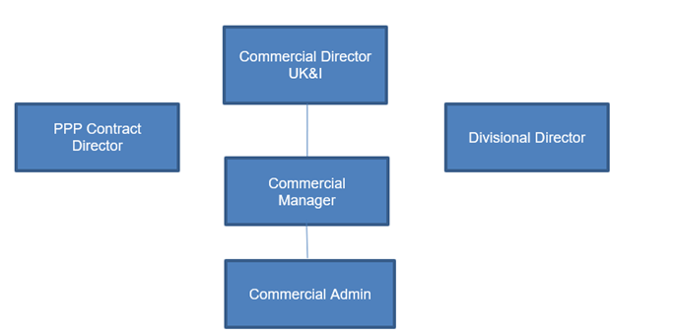

Levels

Received:

Date: 17.06.2025 Date:

__________________________________ ________________________________

Job holder Immediate Manager

