

Job Description: Chivas Brothers
Site Services Support Technician

Function: | To support the Chivas Brother Site Services team with General Maintenance Duties
Position: | Maintenance Support Technician (Handy Person)
Job holder: | New Position
Date (in job since): | N/A
Immediate manager  (N+1 Job title and name): | Elspeth (Beth) Nairn
Additional reporting line to: | Chivas Site Services Team & Helpdesk Function
Position location: | Chivas Brothers main base Kilmalid, Dumbarton.
1. Purpose of the Job – State concisely the aim of the job.
- To assist the Chivas Brothers Site Services Team in the safe operation and repair of all building facilities and fabrication across site including but not limited to general responsive maintenance tasks, joiner tasks, painting, building deep cleans, equipment moves, waste removal, support PPM tasks, etc.
- To provide a core presence at client sites
- Working in line with the Work Authority and Permit to Work System and Risk Assessments and Safe Systems of Work (RAMS) issued to you.
- Use of IT systems (Handheld device) and paper job sheets for work logging as part of the CAFM system.
- When required, to undertake weekend/out of hours working to complete intrusive maintenance activities that cannot be undertaken during normal client operating hours

5. 2. Main assignments – Indicate the main activities / duties to be conducted in the job.
- Complete all assigned tasks promptly and professionally, ensuring timely response to maintenance requests and efficient resolution of minor issues.
- Undertake required training and obtain designation as a Competent Person in relevant disciplines.
- Proactively identify and report faults in building services equipment and take appropriate steps to resolve them.
- Ensure all health and safety concerns are promptly reported or escalated as necessary.
- Maintain flexibility regarding site attendance and tasks within personal competency.
- Stay fully informed of applicable Health & Safety regulations and general legislative requirements.
- Take responsibility for compliance with all relevant Health & Safety legislation and site-specific policies.
- Avoid any actions that could compromise your own safety or that of others.
- Report all accidents and unsafe situations immediately, ensuring incidents are documented and communicated to your line manager.
- Wear personal protective equipment (including clothing and footwear) at all times in accordance with RAMS, and keep clothing and overalls clean.
- Ensure tools and equipment are properly maintained and fit for use.
- Attend health and safety training as directed by your manager or Chivas Brothers to minimize workplace risks.

2. 3. Context and main issues – Describe the most difficult types of problems the jobholder must face (internal or external to Sodexo) and/or the regulations, guidelines, practices that are to be adhered to.
- Training will be required to be undertake for certain aspects of the role.
- This role will be mobile, but site based, and flexibility will be required at times to support other Chivas Brothers sites. When travel is required beyond the base site, your expenses will be covered.
- Capable of working independently and collaboratively within a team environment
- Skilled at managing and prioritizing maintenance activities in response to changing operational needs

4. Accountabilities – Give the 3 to 5 key outputs of the position vis-à-vis the organization; they should focus on end results, not duties or activities.
- Operationally
  - Ensure all planned and reactive maintenance activities under your responsibility are completed within agreed timescales.
  - Comply fully with all health and safety requirements during every task.
  - Complete reports and update handheld devices accurately, ensuring all required information is included and presented to a high standard.
- Performance & Approach
  - Consistently achieve set goals, demonstrating a proactive and resourceful attitude when faced with challenges.
  - Show commitment to delivering tasks efficiently and effectively, with a self-driven and constructive approach.
- Teamwork & Communication
  - Maintain positive relationships and deliver excellent service, earning constructive feedback from management and key stakeholders.
  - Work collaboratively as part of a team, sharing ideas and information openly.
  - Respond promptly and courteously to requests for assistance or information.

5. Job profile – Describe the qualifications (Education & experience), competencies and skills needed to succeed in the position.
- Education & Certifications
  - NVQ or SVQ Level 2/3 in Carpentry and Joinery (or equivalent trade qualification) preferable but not essential.
  - Basic Health & Safety certification (e.g., IOSH, CSCS card).
  - Additional certifications in maintenance disciplines (electrical, plumbing, etc.) are an advantage.

- Technical Skills
  - Proficient in carpentry and joinery techniques (cutting, shaping, assembling, and repairing wood structures
  - Ability to read and interpret technical drawings and plans.
  - Basic knowledge of building maintenance systems (electrical, plumbing, HVAC).
  - Skilled in using hand tools, power tools, and woodworking machinery safely.

- Experience
  - Previous experience in general maintenance and joinery work (typically 2+ years).
  - Experience working in industrial environments.

- Core Competencies
  - Strong problem-solving and troubleshooting skills.
  - Ability to prioritise tasks in a fast-paced, changing environment.
  - Capable of working independently and as part of a team.
  - Good communication and customer service skills.

2. 6. Organization chart – Indicate schematically the position of the job within the organization. It is sufficient to indicate one hierarchical level above (including possible functional boss) and, if applicable, one below the position. In the horizontal direction, the other jobs reporting to the same superior should be indicated.
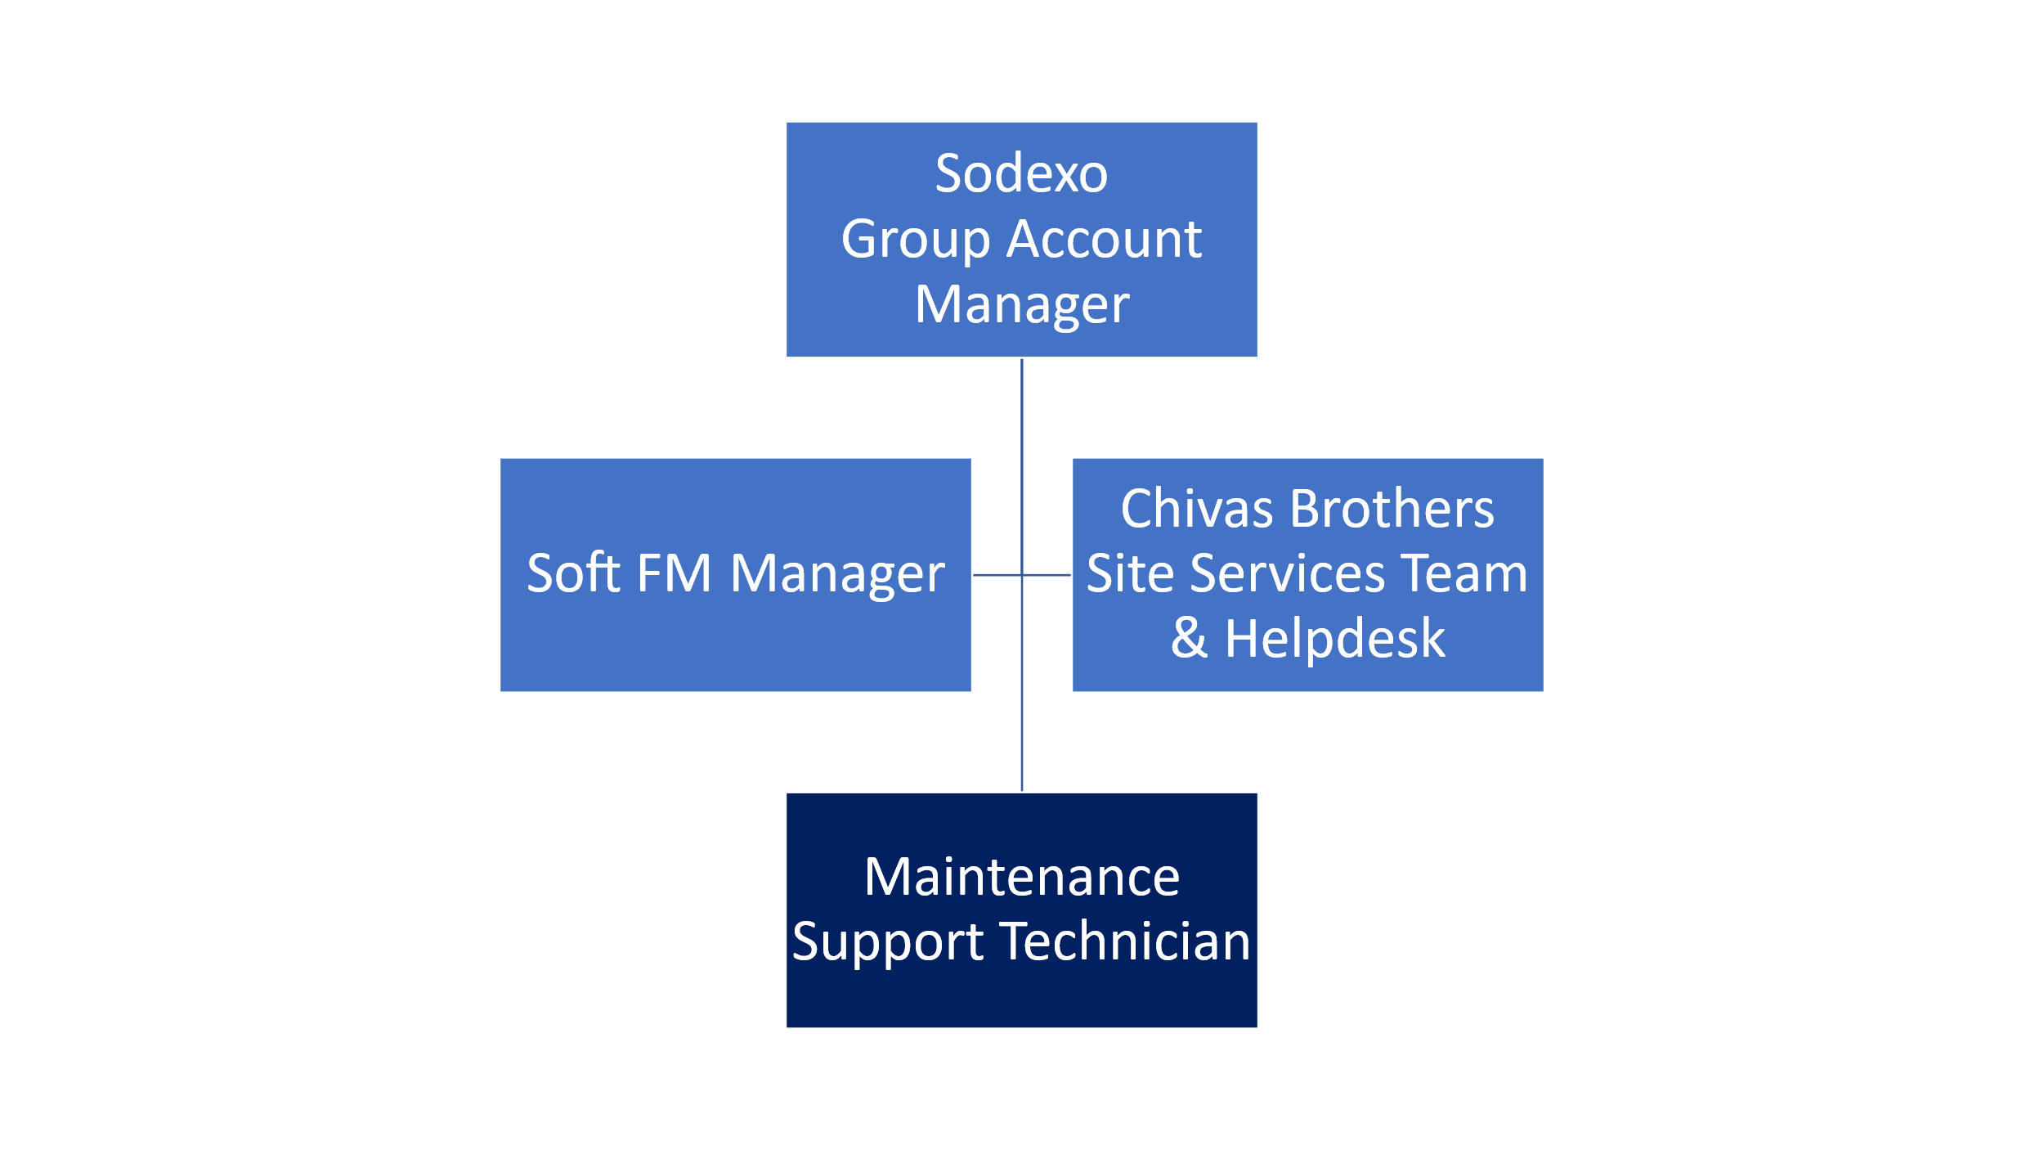

Received:

Date: Date:

__________________________________ ________________________________

Job holder Immediate Manager

