JoB description

Position Title | Sales Support  Administrator | Department | Business Development
Generic Job Title | Bid Production  Administrator | Segment | Defence
Team Band |  | Location | Office based
Reports to | Sales Programme  Manager | Office / Unit name | Tidworth, Wiltshire

ORGANISATION StRUCTURE
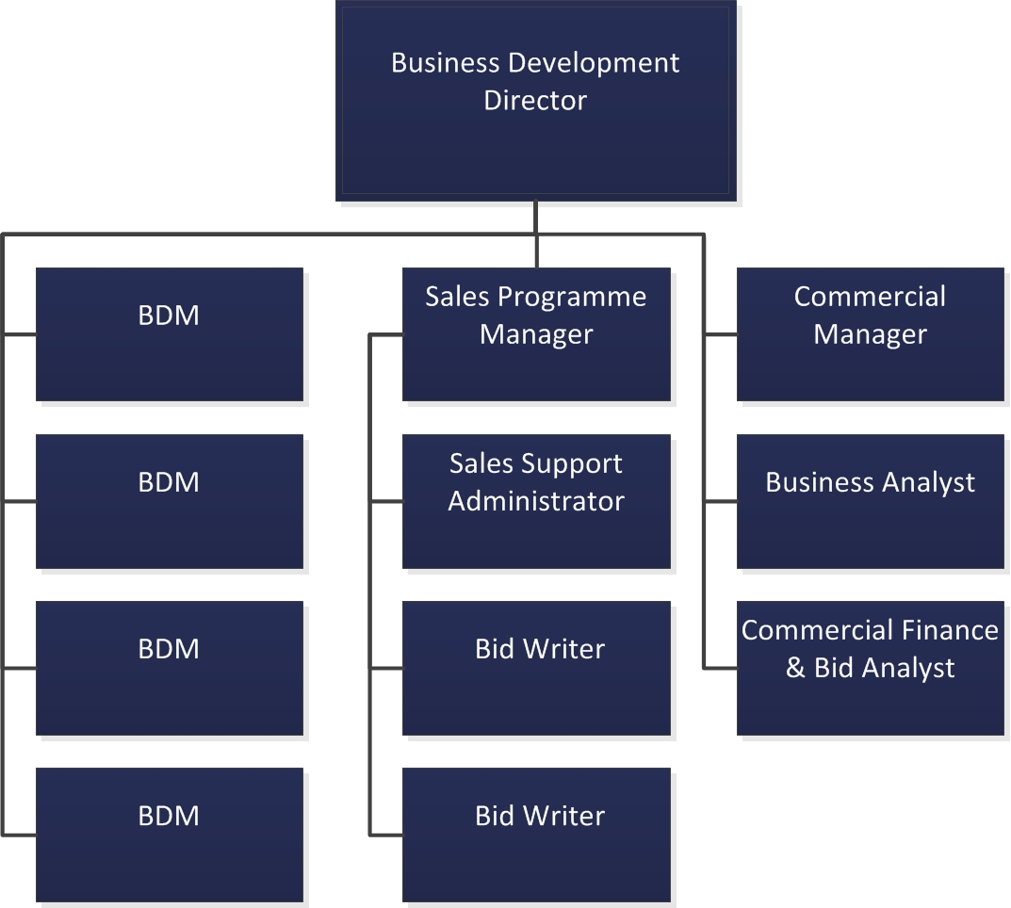

Job Purpose
- To manage the day to day functioning of the business development team for the Defence and Government Services segment, ensuring that systems and processes are adhered to, output is presented professionally and consistently and that all project activities are completed fully within the set criteria and deadlines working closely with the Business Development Director, Sales Programme Manager and Business Development Managers.

Accountabilities or “what you have to do”
- Maintain standard systems and processes to enable the business development team to function consistently and effectively
- Maintain competitor and market intelligence
- Format and produce hard copy documentation consistently and professionally in a variety of formats – MS visio, word, powerpoint
- Create graphics to support internal and external submissions
- Provide administration support to the Business Development team and in the company CRM system as required to ensure the effective running of the department
- Act as point of contact with clients for onward distribution to the team
- Coordinate and manage a repository of information that will support bid opportunities
- Work closely with bid writers to source, archive and improve current bid material
- Collate company information for inclusion in submission documents
- Liaise and effectively communicate with internal stakeholders by all relevant channels
- Support the Sales Programme Manager with planning project timescales, highlighting key issues and supporting with escalation procedures
- Quality check documentation and with a constant strive to improve formatting, graphical illustrations and drive consistency throughout the final bid material

Key Performance Indicators (KPIs) or “What it will look like when you are doing the job well”
- Documentation will look, be stored and managed consistently and records will be up to date and accurate, delivering a consistent and high quality service
- Business development and bid processes will be understood, followed and opportunities to improve the way the team works will be identified
- You will be an enthusiastic member of the team and integral to its smooth running

Dimensions
Financial | No financial responsibility
Other | Flexible to work outside of normal working hours on weekdays and weekends on occasion when required
 | Develop positive relationships with key stakeholders across all areas of the business to be built in a timely manner and maintained effectively
Competencies | Focus on client and customer, intellectual agility & eagerness to learn, personal and influencing skills, project management

Skills, Knowledge and Experience

Essential
- Proven administration support experience, ideally within business development / sales function
- Advanced knowledge in Microsoft Office products (Word, Excel, Power Point, Visio and design packages)
- Good written skills
- High degree of co-ordination, organisation and administration
- Confident and effective communicator
- Attention to detail, quality driven approach
- Able to work individually or part of the wider sales team
- Flexibility and adaptability
- The desire to learn a basic level of understanding of Sodexo software - for example, CRM and SoProject.

Desirable
- Conversant in Microsoft Project
- Technical ability in all subject areas
- General industry knowledge

Contextual or other information
- The job description is intended to give the post holder an appreciation of the role envisaged and the range of duties and responsibilities to be undertaken. It does not attempt to detail every activity. Specific tasks and objectives will be agreed with the post holder at regular intervals. The post holder will be required at all times to perform any other reasonable task, as requested by the line manager in order to meet the needs of the business.

Version | v.02 | Date | October 2017
Document owner | HE

