
Job Description:
Social Mobility Coordinator

Function: | Sustainability & Workplace Culture – HR Transversal
Position: | Social Mobility Coordinator
Job holder:
Date (in job since):
Immediate manager  (N+1 Job title and name): | Head of Stop Hunger Foundation, Camille Thobois
Additional reporting line to:
Position location: | Hybrid (travel to sites approx. 3 days/week)
1. Purpose of the Job – State concisely the aim of the job.
- Bring Sodexo’s social impact ambitions to life by coordinating volunteering, fundraising and social mobility activity that enables place-based, meaningful impact at a frontline/contract level.
- Partner with site teams, segment leads, the Culture & Belonging team and employee networks to design and deliver inclusive opportunities that strengthen our culture, deepen community connections and improve outcomes for local people.
- Support Sodexo to evidence impact through high-quality activation, consistent storytelling and robust data capture that demonstrates tangible results across UK & Ireland.

5. 2. Main assignments – Indicate the main activities / duties to be conducted in the job.
- Coordinate the planning, promotion and delivery of place-based social impact activity across UK&I, including Stop Hunger volunteering, fundraising and social mobility initiatives.
- Work with site teams, contract managers and segment leads to identify local priorities and create meaningful, practical opportunities that can be delivered at a frontline/contract level.
- Develop and manage an annual calendar of key moments (e.g., Stop Hunger Service Days, social mobility activations, festive volunteering, partner campaigns and the Stop Hunger Dinner) and ensure clear planning and communications for each cycle.
- Lead the end-to-end coordination and delivery of the Stop Hunger Dinner, including project planning, stakeholder management, logistics, partner liaison, comms and on-the-day support.
- Support sites with logistics, risk considerations and partner liaison (including safeguarding where relevant) to enable safe, inclusive and high-quality delivery.
- Oversee digital and physical sign-up processes and provide simple guidance, toolkits and templates so managers can deliver activity confidently and consistently.
- Collaborate with the Culture & Belonging team to ensure activity aligns to the Belong, Act, Thrive ethos and strengthens colleague experience and participation.
- Embed volunteering and social mobility opportunities into employee network programmes (Origins, Generations, Pride, Families, Disability networks, etc.) and support networks to deliver community-impact events aligned to their priorities.
- Maintain strong relationships with charity partners, NGOs, schools/colleges and community groups to broaden opportunities and ensure they are locally relevant and impactful.
- Provide on-the-ground event delivery support where required, ensuring strong representation of Sodexo values and a consistent colleague and partner experience.
- Work with communications teams to capture and share stories of impact, celebrating activity and encouraging colleagues and sites to get involved.
- Capture and maintain accurate data (e.g., volunteering hours, fundraising totals, participation, social mobility outputs/outcomes) and support reporting for Stop Hunger, Social Impact dashboards and external benchmarks.

2. 3. Context and main issues – Describe the most difficult types of problems the jobholder must face (internal or external to Sodexo) and/or the regulations, guidelines, practices that are to be adhered to.
- Supporting site teams and managers to activate Stop Hunger volunteering, fundraising and social mobility activity in a way that is accessible, meaningful, sustainable and deliverable at a frontline/contract level.
- Coordinating delivery of the Stop Hunger Dinner, which requires significant end-to-end planning, stakeholder management and operational support (including logistics, comms, partner liaison and on-the-day coordination).
- Ensuring alignment and collaboration with the Culture & Belonging team, embedding volunteering and social mobility opportunities into the work of employee networks (Origins, Generations, Pride, Women in Sodexo, etc.).
- Maintaining strong relationships with external partners (charities, community groups, schools/colleges where relevant) to create safe, inclusive and high-quality opportunities.
- Managing multiple events and activation cycles simultaneously, ensuring clarity, consistent communication and strong colleague/partner experience.
- Capturing accurate data and stories to evidence place-based impact (hours, fundraising totals, participation and social mobility outputs/outcomes) while maintaining quality and consistency across sites.

4. Accountabilities – Give the 3 to 5 key outputs of the position vis-à-vis the organization; they should focus on end results, not duties or activities.
- Visible, place-based social impact delivered through activated contracts/sites, evidenced by increased participation and a stronger pipeline of volunteering, fundraising and social mobility opportunities.
- Successful annual delivery of the Stop Hunger Dinner, delivered on time and to plan, with strong stakeholder experience and measurable outcomes (e.g., attendance, fundraising and/or partner impact).
- Social mobility activity that creates tangible outcomes for local people (e.g., work inspiration, mentoring, employability or skills activity), delivered safely and consistently with partners.
- High-quality comms and storytelling that increases awareness and uptake—showcasing colleague contribution and community impact across UK & Ireland.
- Accurate, timely reporting that stands up to scrutiny—capturing volunteering hours, fundraising totals, participation and social mobility outputs/outcomes to support dashboards, decision-making and external reporting.

2. 5. Dimensions – Point out the main figures / indicators to give some insight on the “volumes” managed by the position and/or the activity of the Department.
- Scope: UK & Ireland
- Employee Population Influenced: 36,000
- Key Interfaces: Stop Hunger, Culture & Belonging, HRBP community, Employee Networks, Segment leadership teams, Site managers, Charity partners
- Budget Influence: Support with accurate tracking of social mobility metrics and event spend
- Key Activities: Event coordination; network & partner engagement; site-level activation support; comms and storytelling; data reporting

6. Job profile – Describe the qualifications (Education & experience), competencies and skills needed to succeed in the position.
- Proven coordination of complex events and project plans, including large-scale flagship events (e.g., the Stop Hunger Dinner).
- Experience activating programmes across multiple sites/contracts, working with frontline teams to remove barriers and increase participation.
- Understanding of (or strong interest in) social mobility and community impact, with the ability to translate priorities into practical, place-based activity.
- Strong stakeholder management across all levels (site managers, segment leadership, HR/Culture & Belonging, employee networks and external partners).
- Relationship management with external partners (charities, NGOs, and community groups; schools/colleges where relevant), including coordination, responsiveness and professionalism.
- Clear, confident communication and impactful storytelling to promote opportunities and celebrate outcomes.
- Strong organisation and attention to detail, able to manage multiple workstreams and deadlines concurrently.
- Comfortable with data capture and reporting (e.g., participation, volunteering hours, fundraising totals and social mobility outputs/outcomes) with a focus on accuracy and consistency.
- Inclusive, people-centred approach—able to create opportunities that are accessible and engaging for diverse colleague groups.
- Willingness to travel to sites and support events as required.

2. 7. Organization chart – Indicate schematically the position of the job within the organization. It is sufficient to indicate one hierarchical level above (including possible functional boss) and, if applicable, one below the position. In the horizontal direction, the other jobs reporting to the same superior should be indicated.
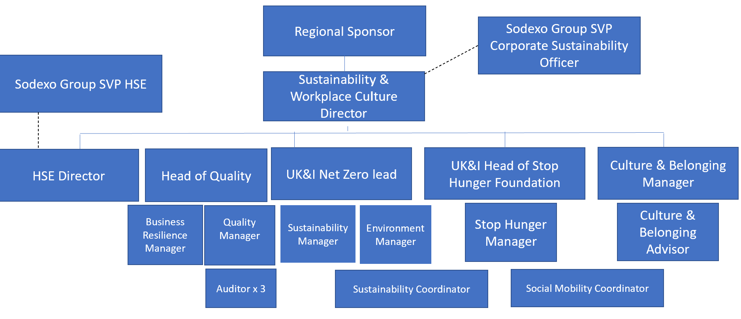
Levels

Received:

Date: Date: 23/04/2026

__________________________________ Camille Thobois
Job holder Immediate Manager

