job description
maintenance assistant - PAT

 | Position Title | Maintenance Assistant – PAT Testing |  | Department | AstraZeneca
 | Generic  Job Title | Maintenance Assistant |  | Segment | CS IFM
 | Team Band | Unbanded |  | Location | UK
 | Reports to | Customer Service Manager |  | Office /  Unit name | Macclesfield Lab Zone
Organisation

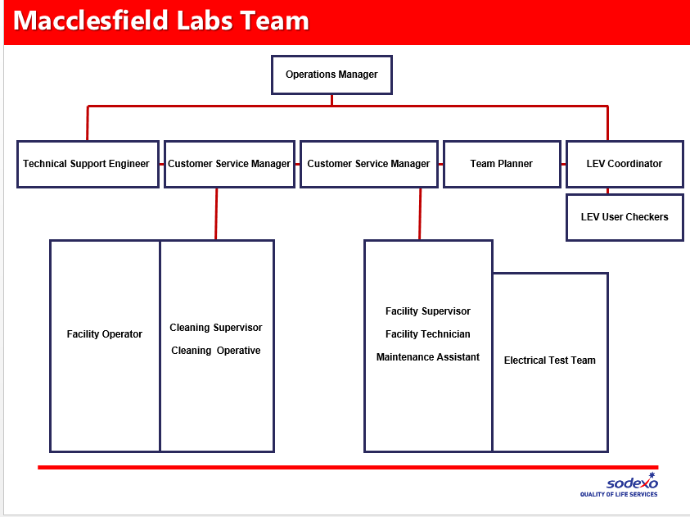
Job Purpose
Provide support to the maintenance function of the Sodexo contract. To carry out Portable Appliance Testing as required. To carry out general maintenance tasks that don’t require a formal qualification or training. To carry out general maintenance tasks that training for has been provided and competency has been proven.
Accountabilities or “What you have to do”
- Carry out Portable Appliance testing to ensure asset compliance.
- Maintain the fabric and grounds of the buildings
- Support the Maintenance function of the building
- Increased availability of scientific facilities / reduction in down time
- To ensure that quotes, repairs, delivery is optimised at all times to deliver “Time for Science”.
- To ensure you operate compliantly to all relevant Lab Health and Safety procedures at all times
- To report all faults and issues identified through the relevant communication stream as directed
- To monitor and review assets and suggest areas for improvement
- Horus Security Clearance for this role is a requirement
- To highlight any safety, health or environment issues through Stop Cards or SHE Reporter
Key Performance Indicators (KPIs) or “What it will look like when you are doing the job well”
- Customers receive a quality experience
- All faults, issues and concerns are logged immediately for action
- No unplanned down time of critical assets
- Audits show full compliance with building regulations
- Work to area maintenance plan
- Sodexo KPI Compliance
- Lead as a Sodexo Brand Ambassador at all times
- Work with service partners as a YFM integrated member
- Validated GMP / GLP practice
- Understanding of COSHH
- Assist continuous improvement and tenacity to overcome issues
- Effective communication
Competencies
- Excellent communicator.
- Ability to prioritise
- Excellent time management skills
- IT Skills
- Attention to detail.
- Ability to work on own initiative.
- Knowledge of engineering maintenance

 | Dimensions
 | Financial
 | Staff
 | Other
Knowledge, skills and experience
- Relevant training, qualifications and experience to deliver services in line with legislative and statutory requirements.
- Experience with focusing on individual customer requirements and care whilst meeting required service levels.
- Awareness of the need to provide services in a sensitive manner such as not to affect AZ’s business, reputation or share value.
- Ability to handle feedback in a calm, structured and professional manner.
- Attention to detail
- Open minded to technological advances
- GMP Validated
- Update IT systems as required
Contextual or other information
This position will be a key part of a one team approach to providing a quality customer experience for the users of AZ buildings. The job description is designed to identify the specifics of the role it does not however limit the post holder to the specific tasks and responsibilities listed. The post holder is equally responsible for the satisfaction of the customers and must therefore ensure that the standards are delivered. This will mean that you undertake activities outside of the job description to ensure that the overall service is maintained.

This job description is intended to give the post holder an appreciation of the role and the range of duties to be undertaken, It does not attempt to detail every activity and it may be changed from time to time to incorporate changing circumstances. Specific tasks and objectives will be agreed with the post holder at regular intervals.
Version |  |  | 1 | Date | 27.01.17
Document owner

